**Zahir Iqbal**

**Model Driven Power app**

Create solutions

Create tables and columns with different data types in Microsoft Dataverse

Create relationships between tables

Create Views

Create Forms

Create business process flows

Make.powerapps.com

<https://admin.powerplatform.microsoft.com/environments>

Create an environment: (For test environment select ‘Trial’

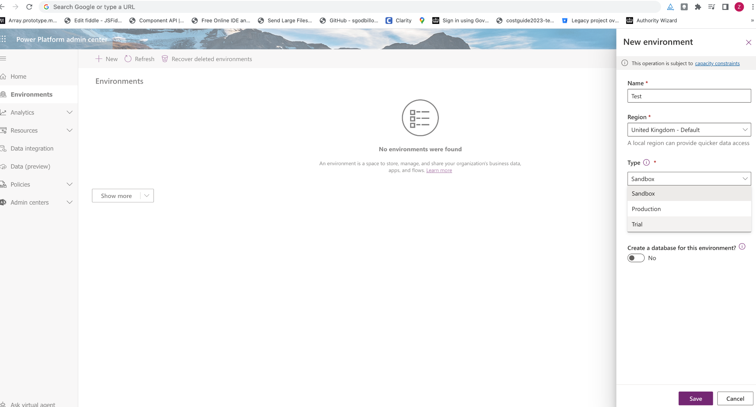

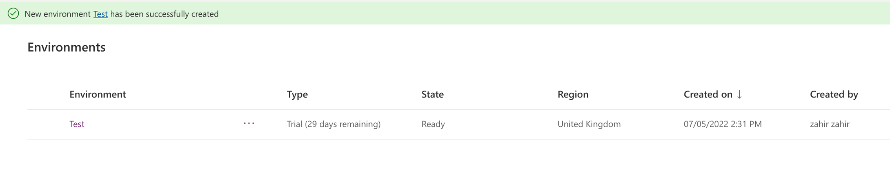

Solutions - New solution

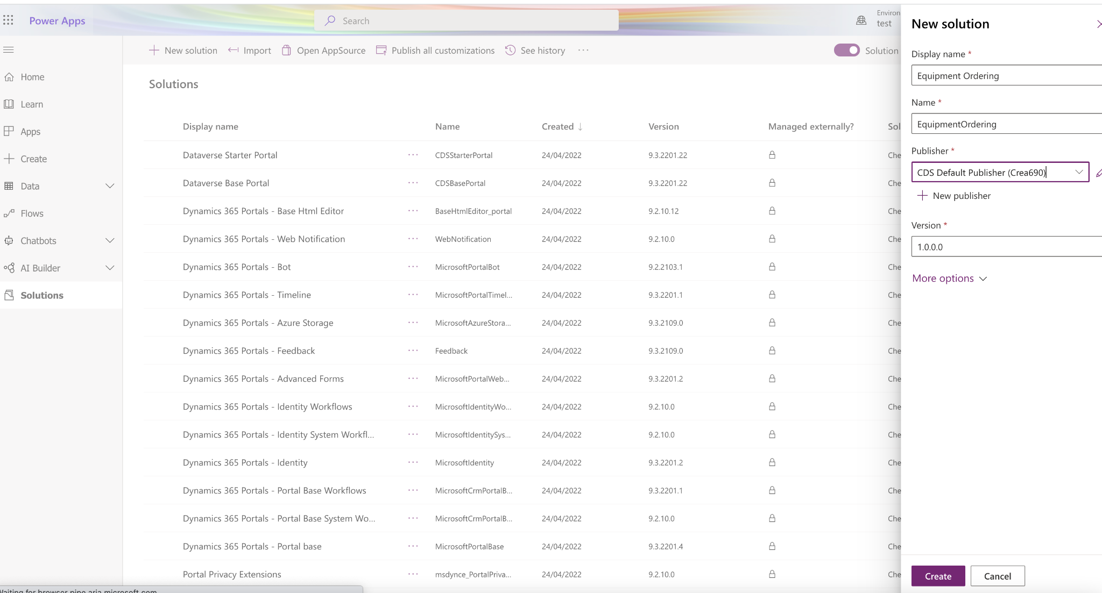

Click on ‘Equipment ordering’

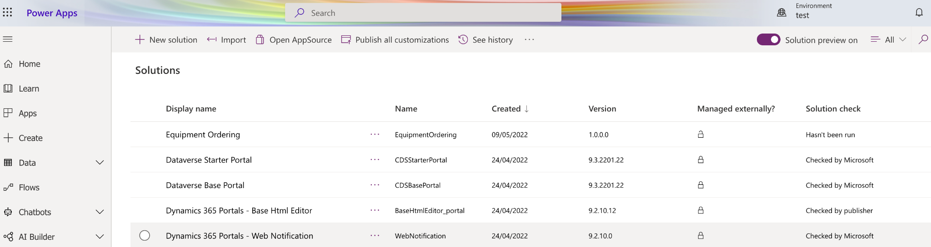

Click on ‘New’ - ‘Table’

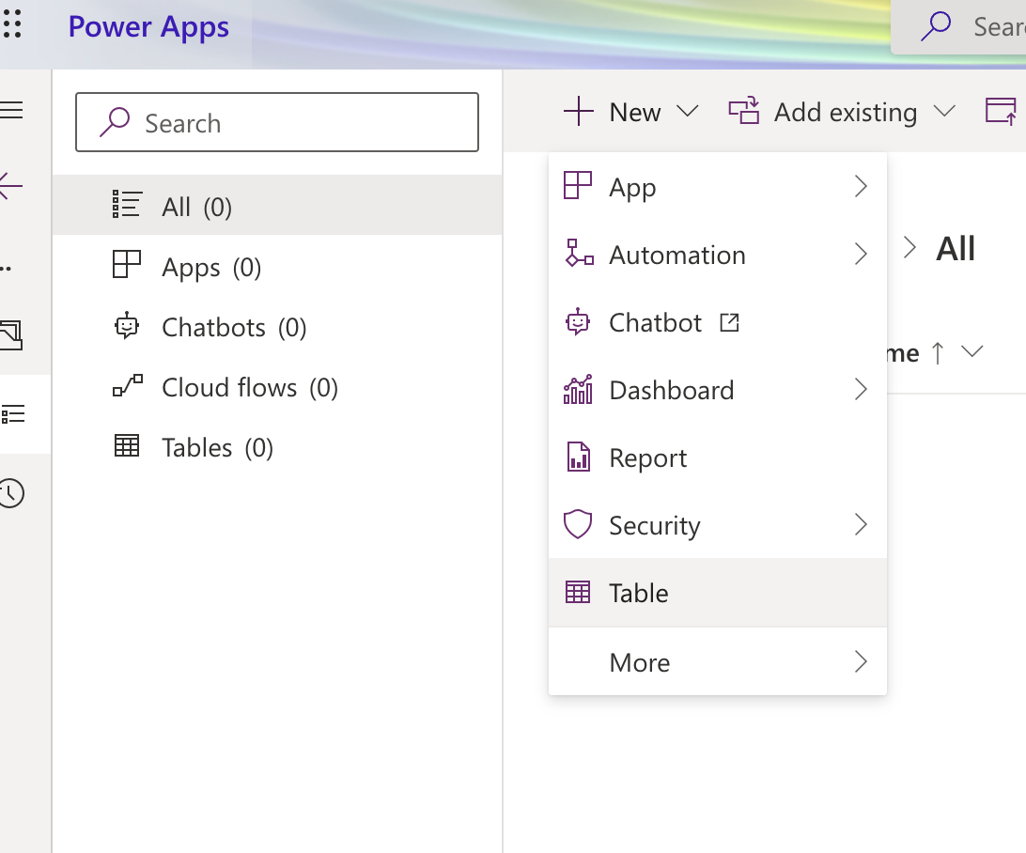

Fill in the Table name

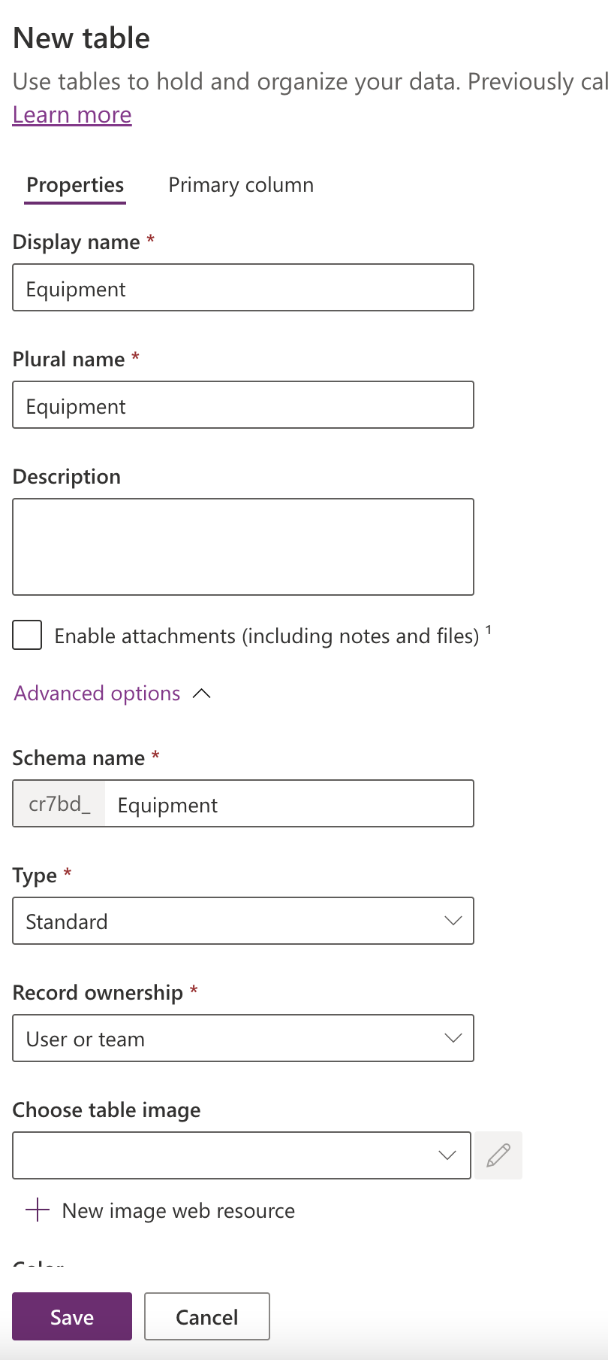

Now you’ll see your table

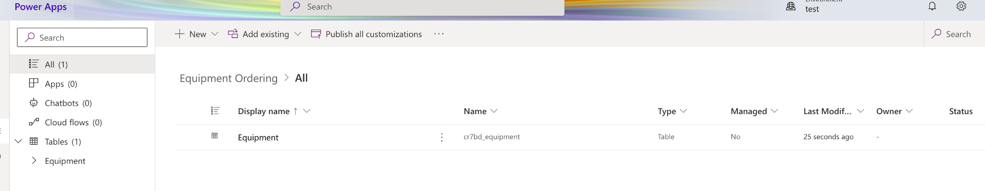

It’ll create Scaffolding columns for auditings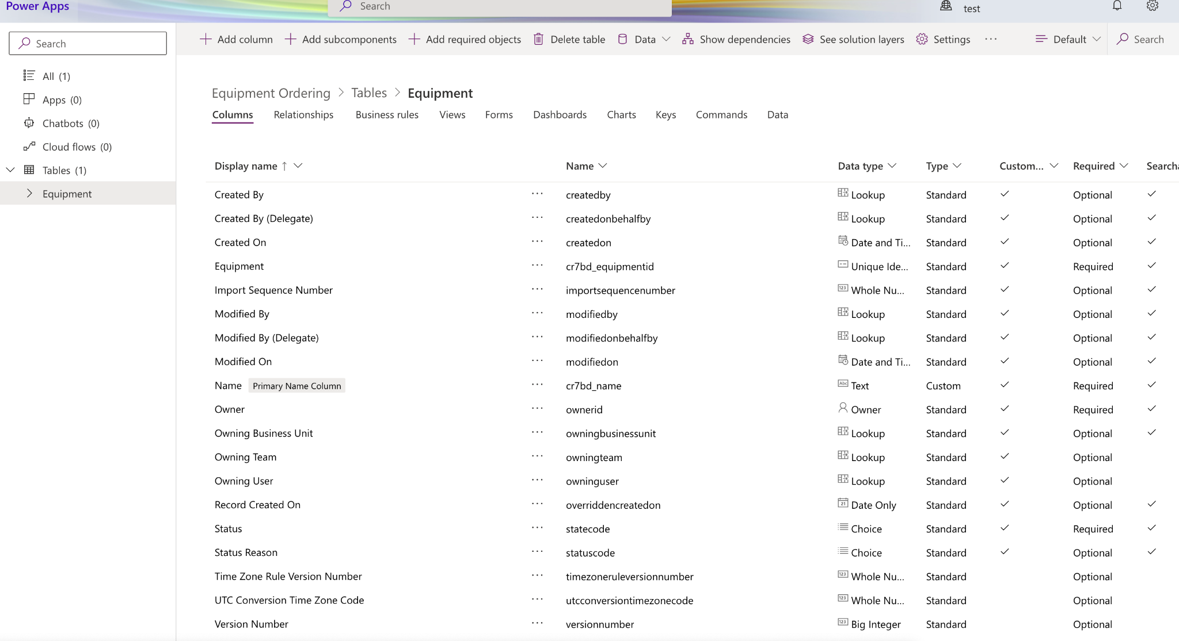

Click on Custom (so you only see what you’re working on)

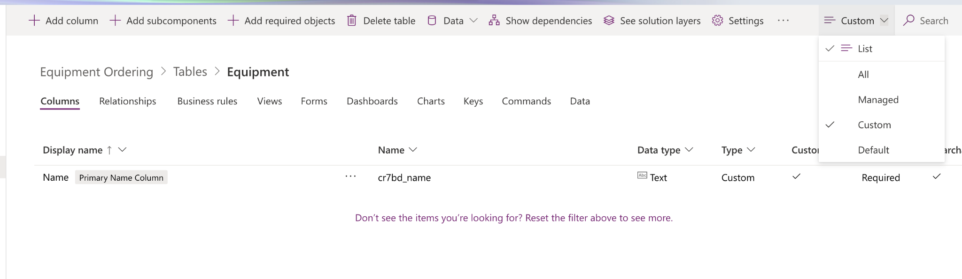

To add a new field click on ‘Add column’ and then make sure you select the ‘Data Type’. Once this is created you CANNOT change the ‘date type’.

Also if you want to make the field mandatory then do so by selecting options in ‘Required’

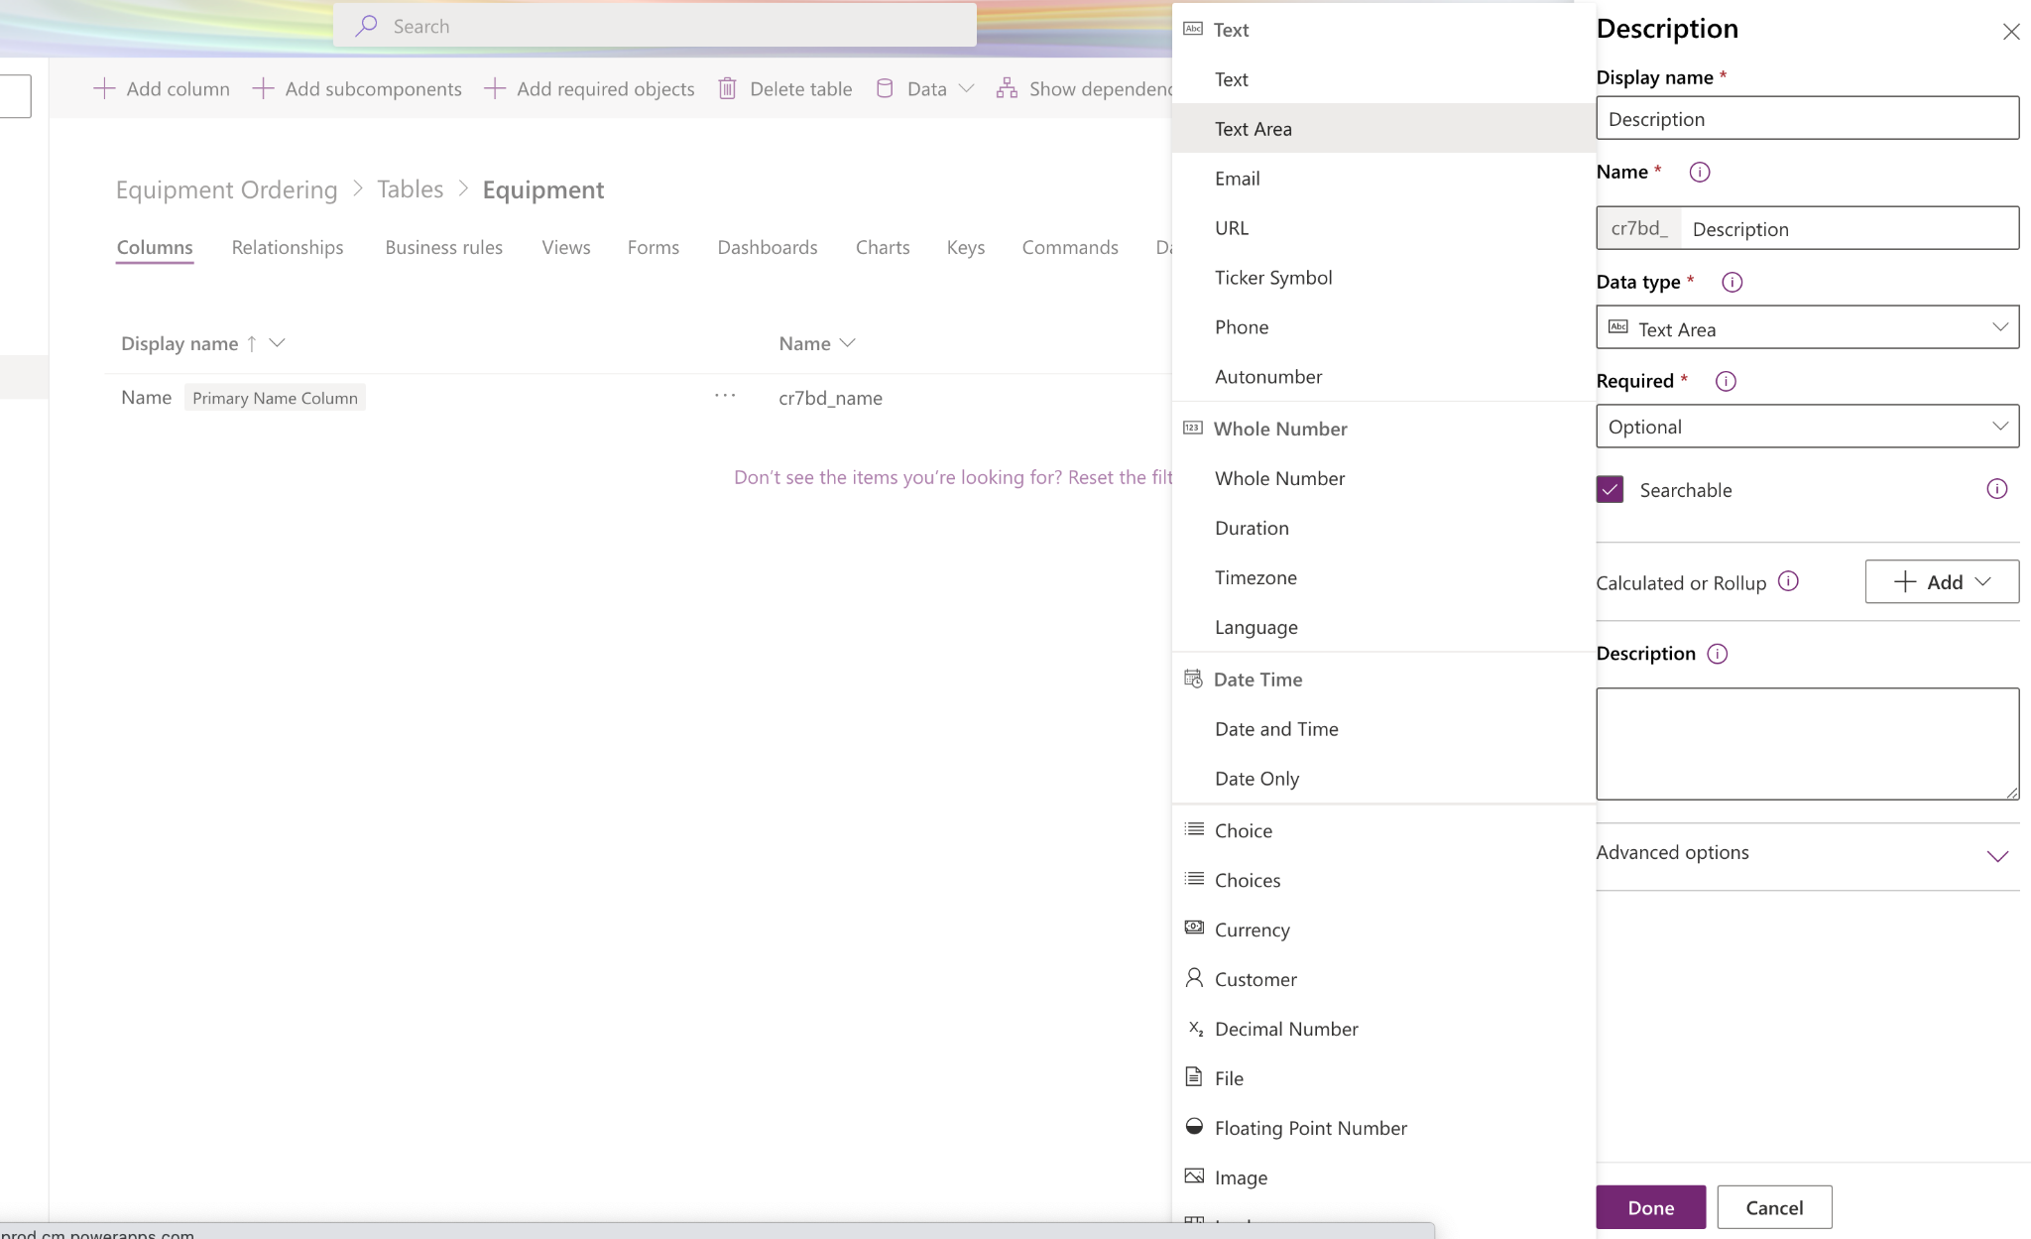

You can click on ‘Advanced Options’ for more settings e.g. ‘Max length’.

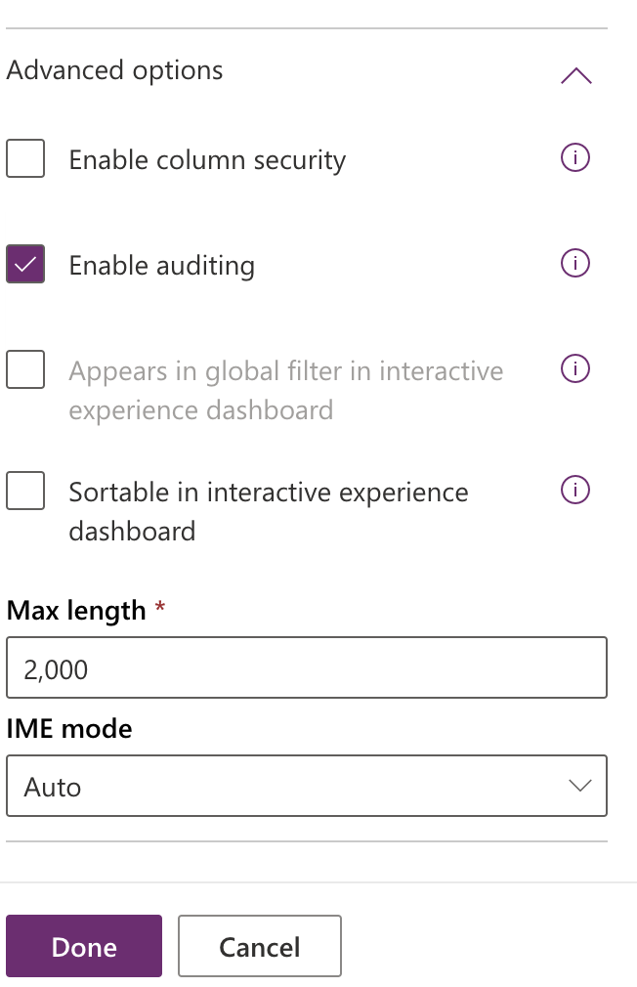

Once it has been created you’ll see ‘Description’ field

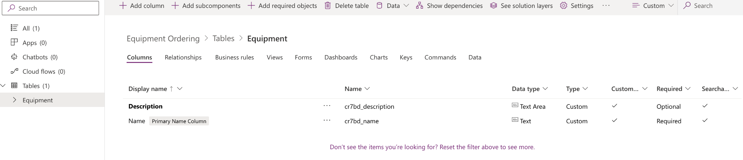

Creating a list of options for a field type:

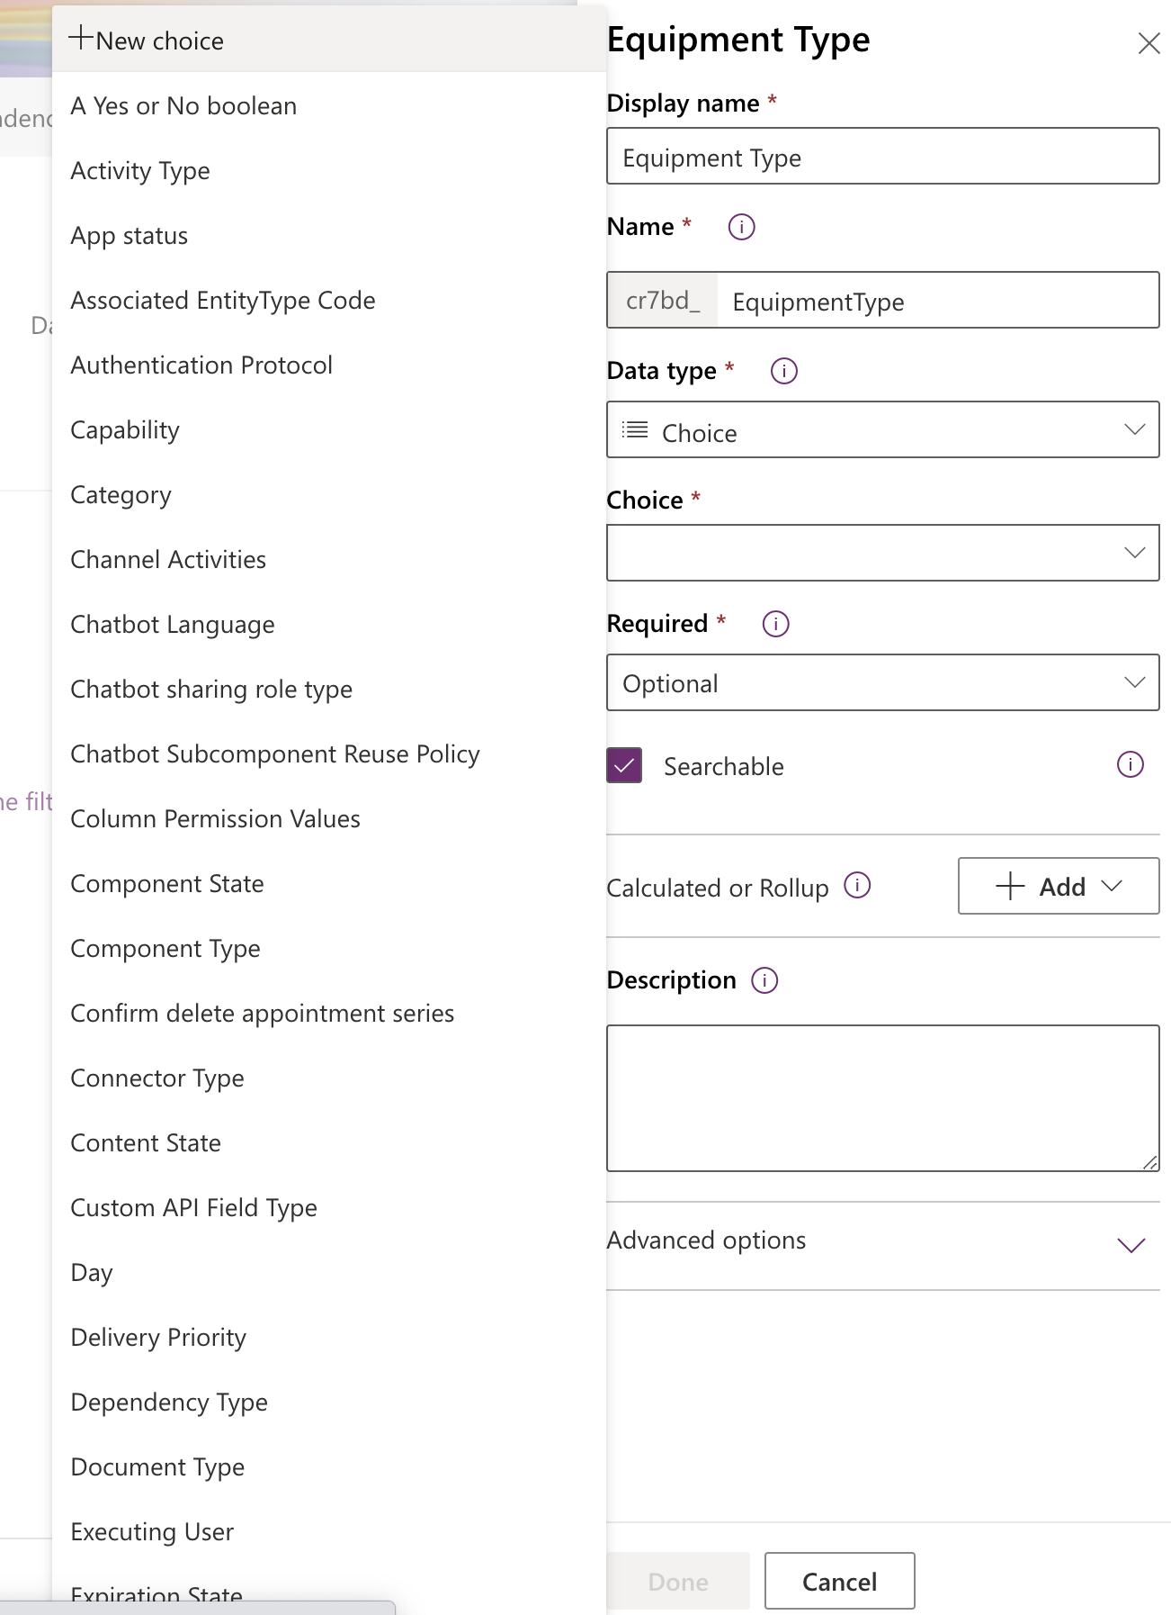

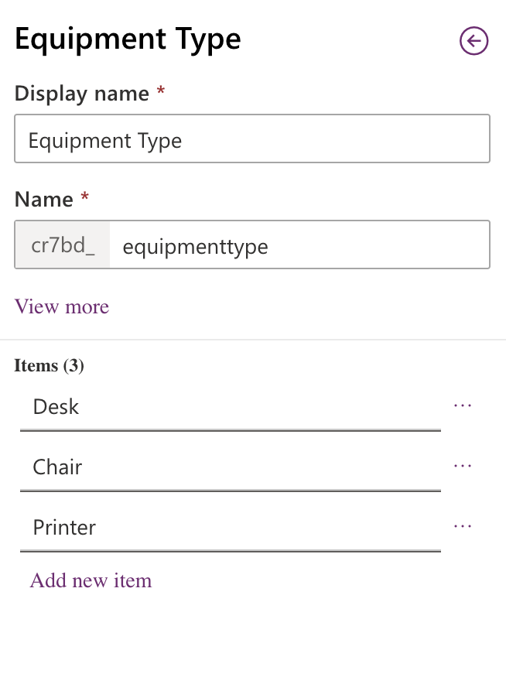

At this Point the Table is NOT SAVED, as the fields are still in bold. So not click on the ‘Save Table’.

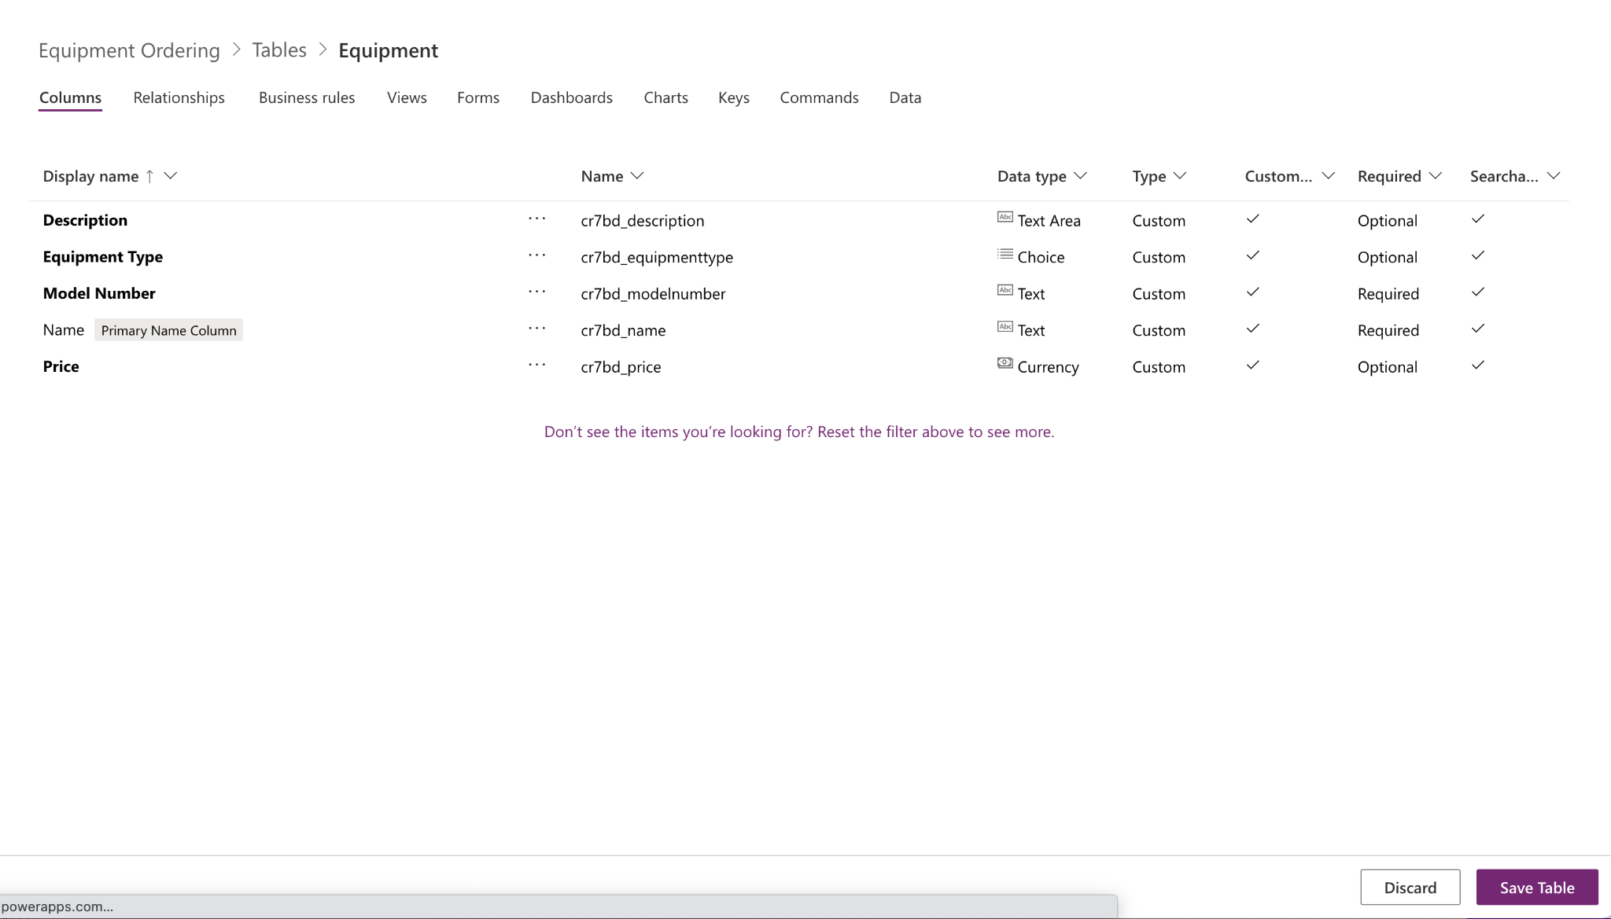

Click on the Views’ and then ‘Active Equipment’

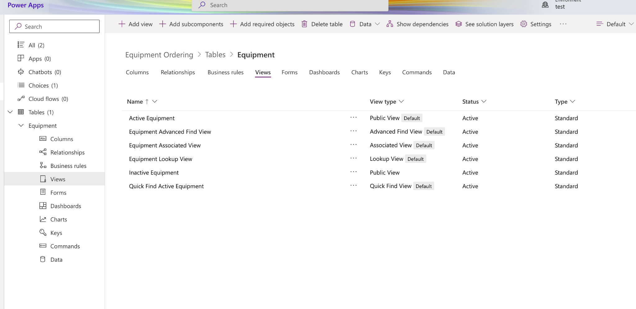

Now you can drag and drop the fields you want to in the middle section.

NOTE: you have an option to ‘Edit filters’ by default its showing only ‘Active’ items.

Once you’ve set you view up click on ‘Save’

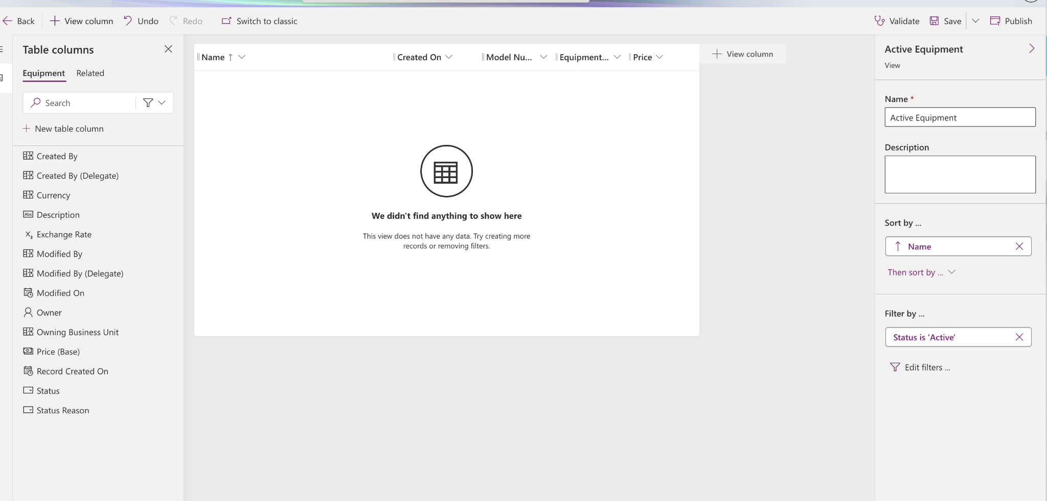

Now click on the ‘Back’ button on top left hand corner and then Click on the ‘Forms’ tab.

Click on the first item (Form Type: Main)

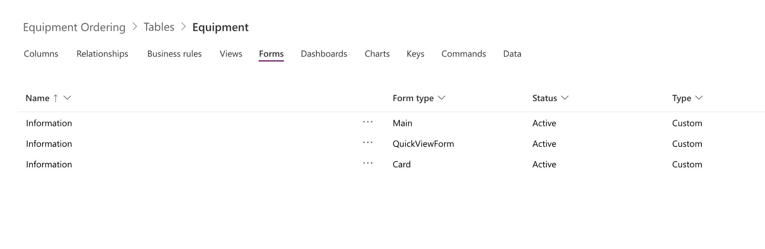

Now lets drag the ‘Owner’ to the top

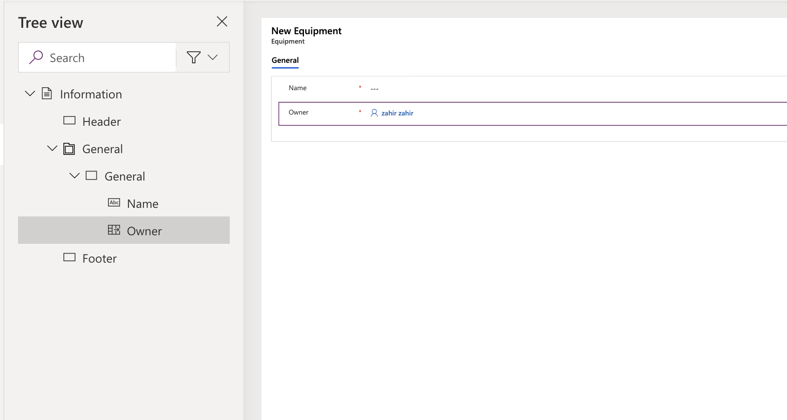

Once you’ve moved the ‘owner’ field, you can see it gives you an option to make the field ‘Read only’ etc.

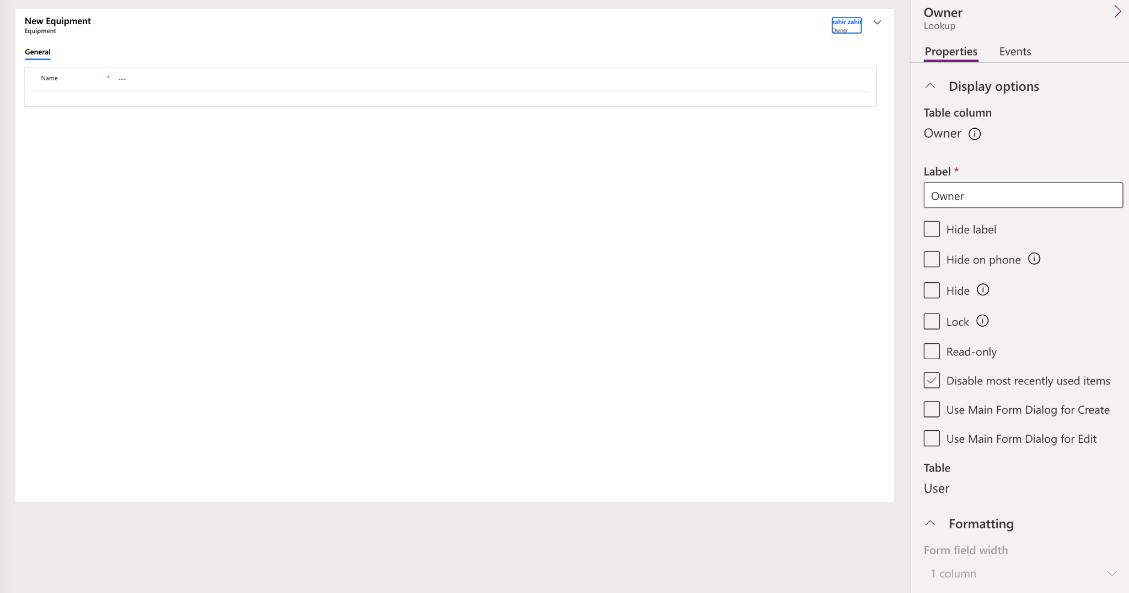

It gives you options to format the page Columns

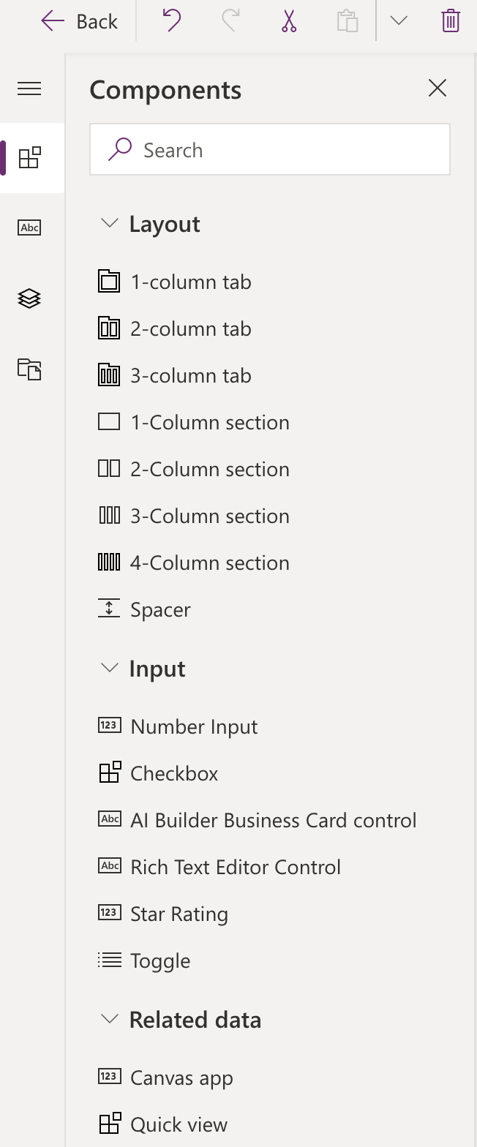

Select the middle section and then on the right select ‘2 columns’

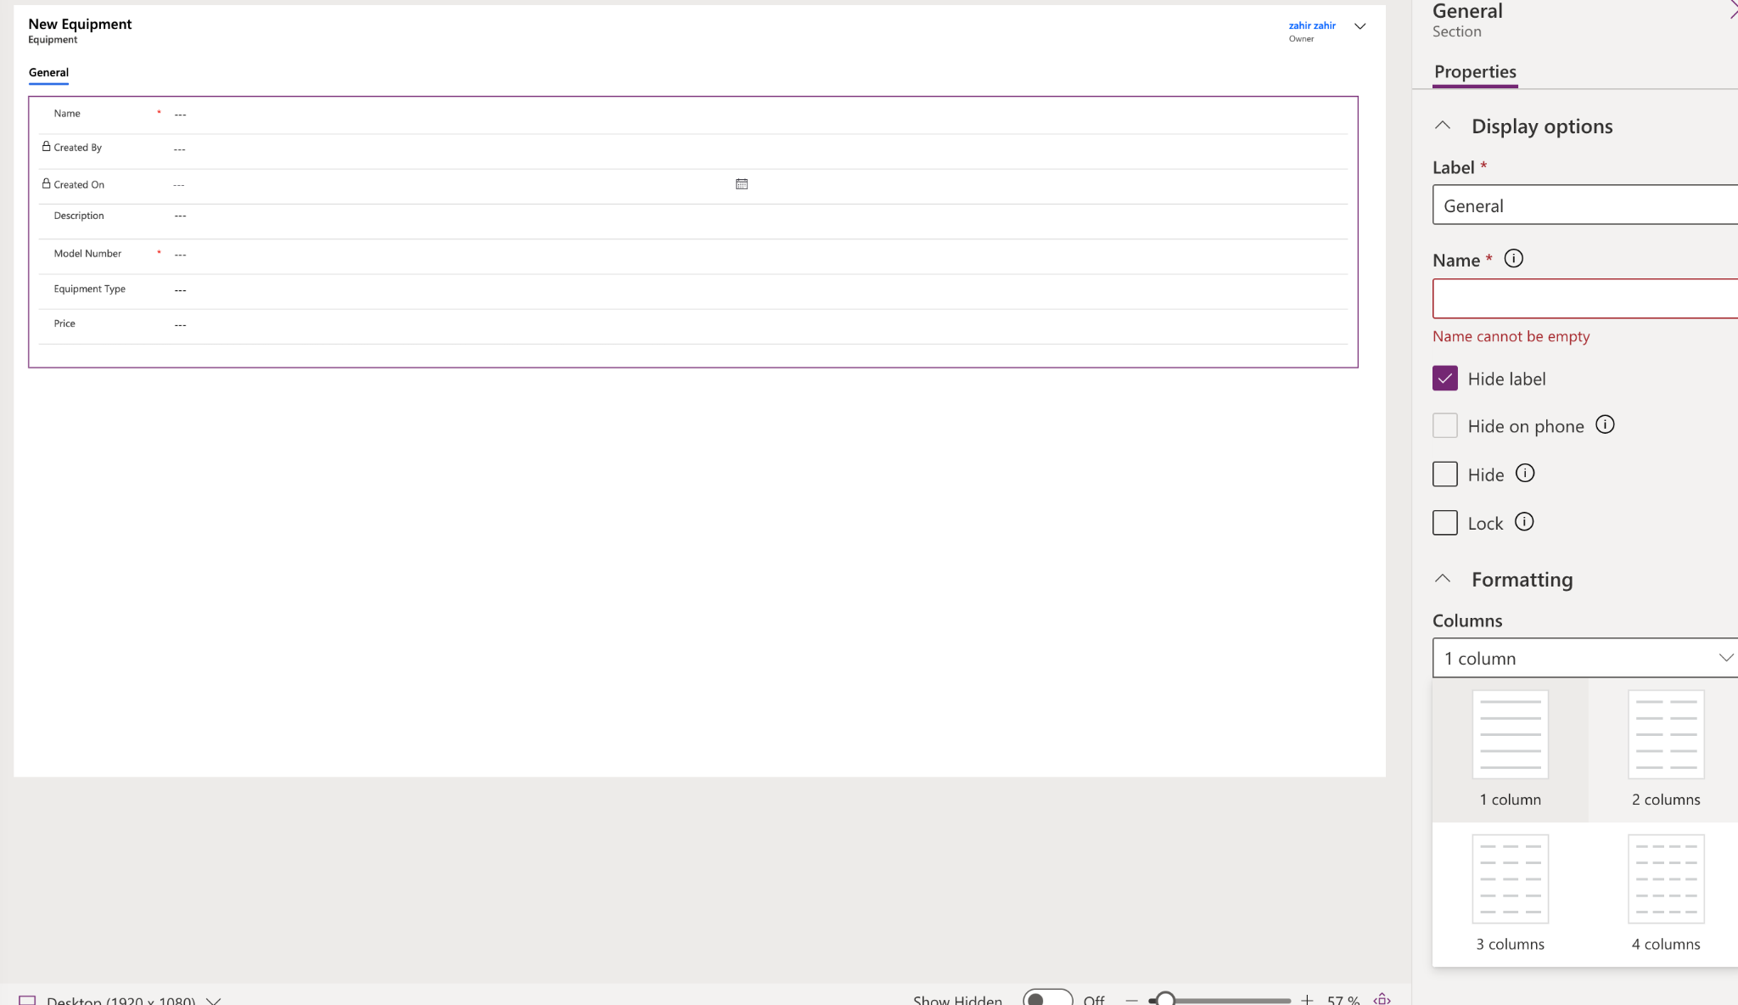

Now drag the fields how you want and click ‘Save’ on top right

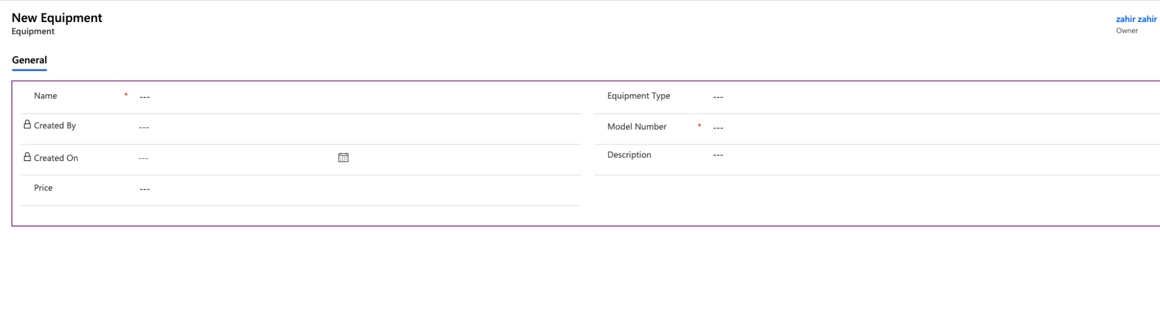

Now go back to the ‘Solutions’ tab and create a new ‘Table’

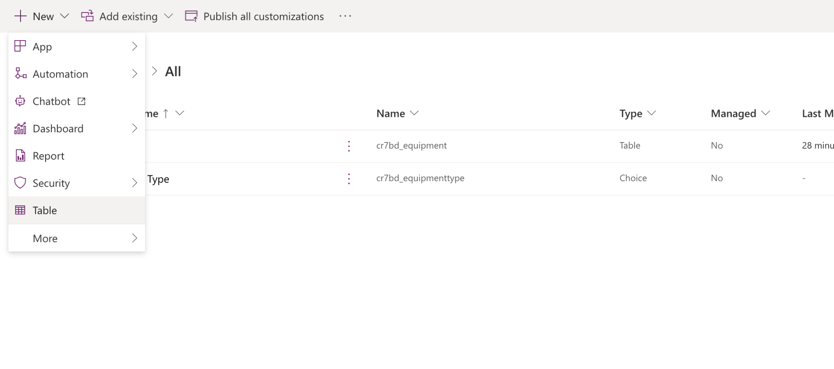

NAme your new table

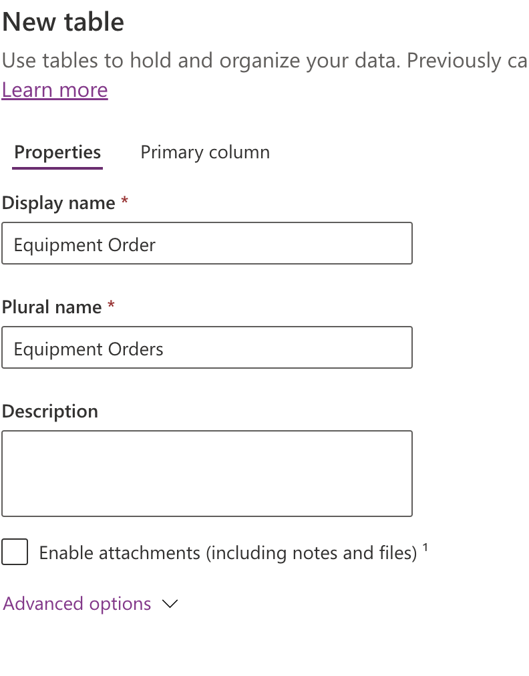

Click on the ‘Primary column’ and then name it ‘Order Ref’ and click ‘Save’

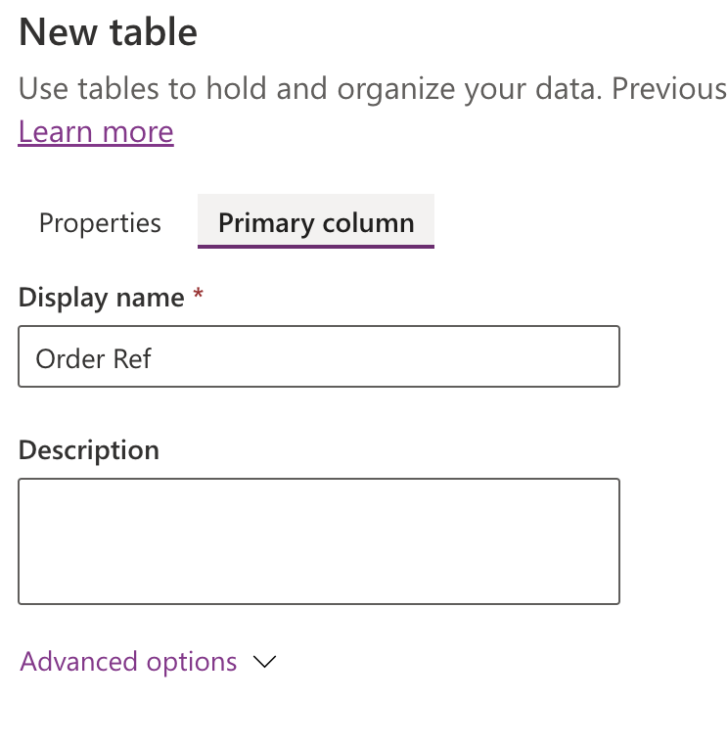

Add more fields:

Request Date: Date only

ORder Placed Date: Date only

Approval status: Choice (Approved, Rejected)

Add a lookup Field (Equipment)

To do this Click’Add column’ then give it a name.

Now select Data type: Lookup

Related Table: ‘Equipment’ (see below) and hit ‘Save Table’

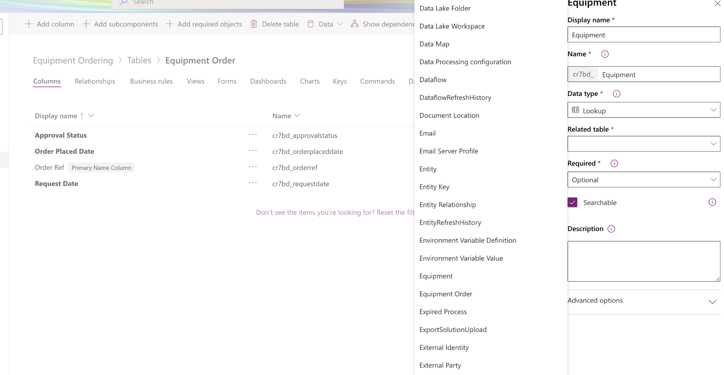

Now click on the ‘Relationships’ tab and you’ll see the relations it has created between two tables.

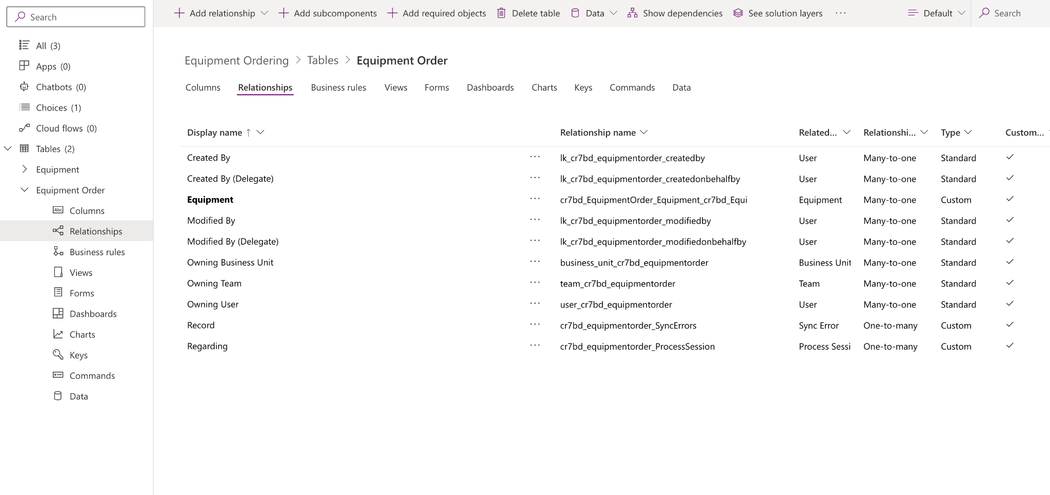

Now click on ‘Views’ and then ‘Active Equipment Orders’

And then drag the fields created from the left pane.

NOTE: Where it says ‘Search’ you can filter it by ‘Custom’ so only you created fields shows.

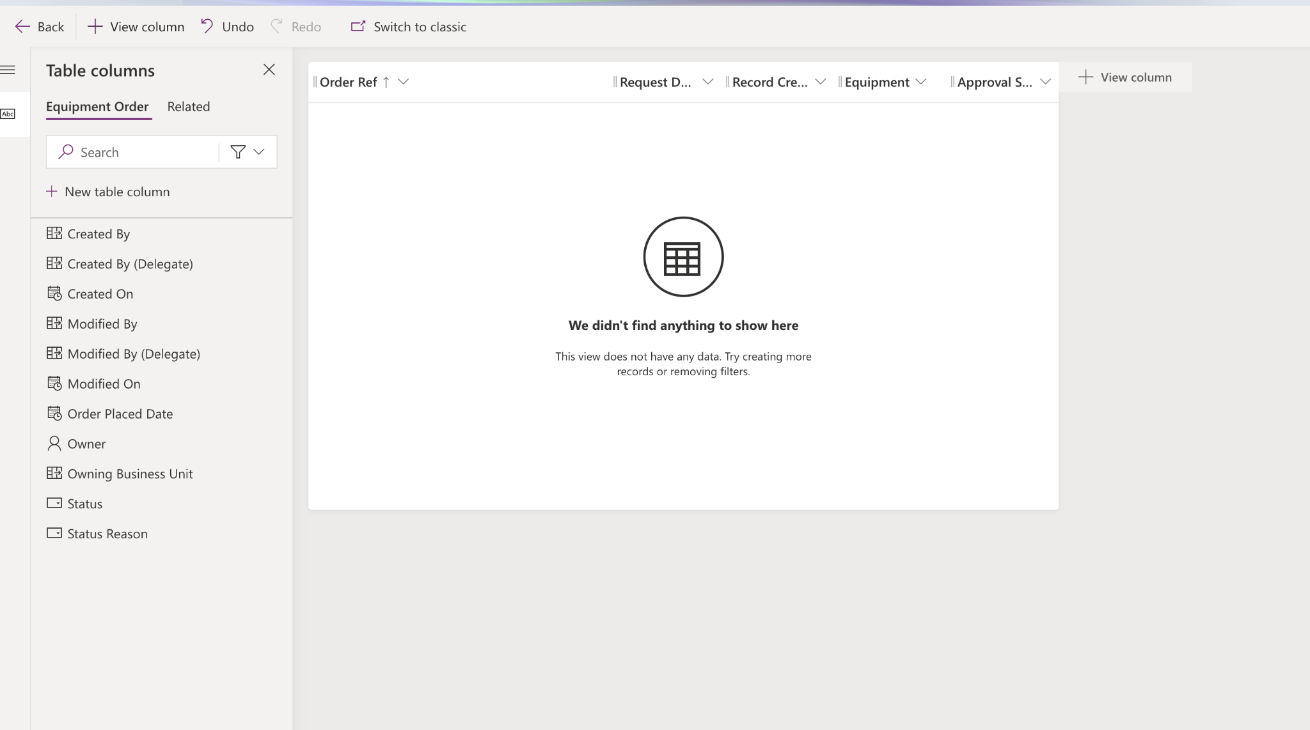

Now click on the ‘Forms’ tab and select ‘Information’ -Main

Now drag ‘Owner’ to top

Click on ‘+ Component’

Drag '2-Column section’ and name it on the right.

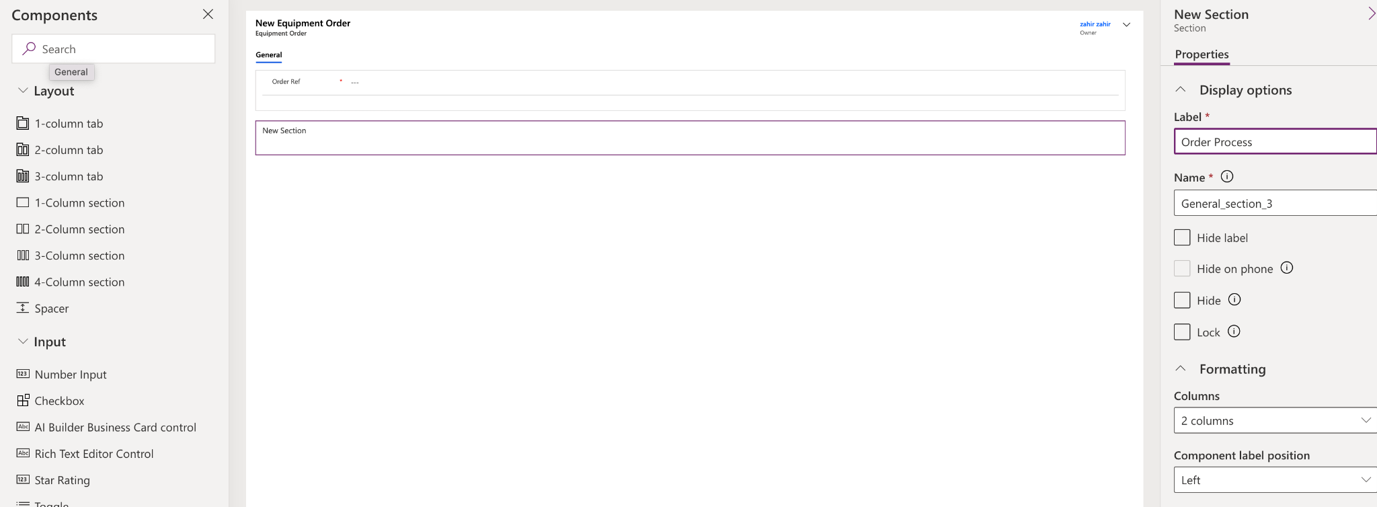

Drag your fields and then hit ‘Save’

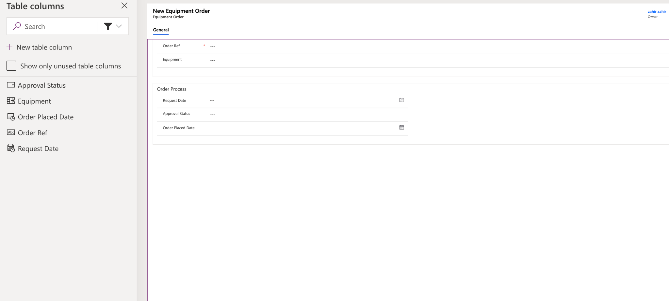

Now go back and click on the ‘Flows’ to create business process flow:

Select ‘Business process flows’ and click ‘+ New’

Choose a table: Equipment process order

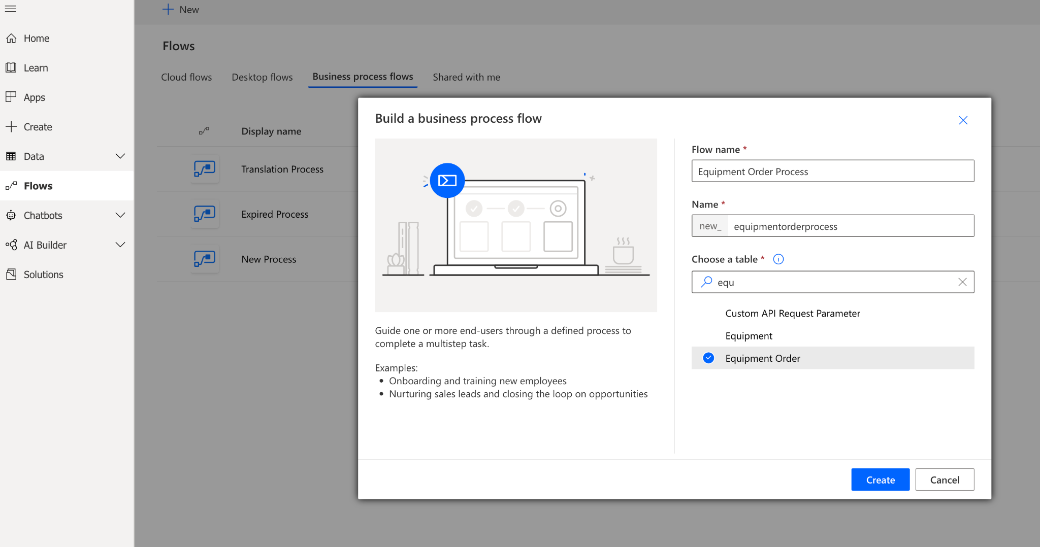

Click on the ‘Equipment Order Process’

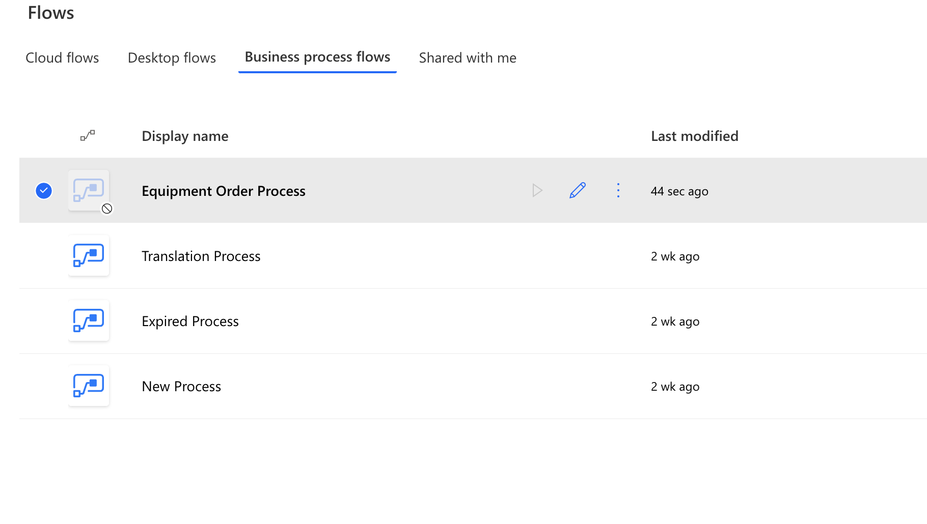

Select the first stage and call it ‘Request’ and click ‘Apply’

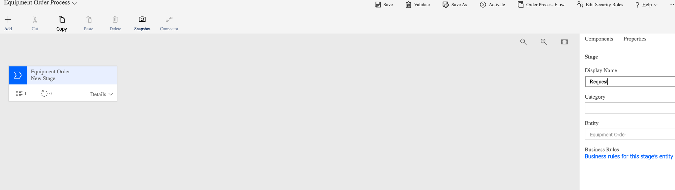

Now lets build out the other stages in that process:

Click on ‘Add’ - ‘Add Stage’

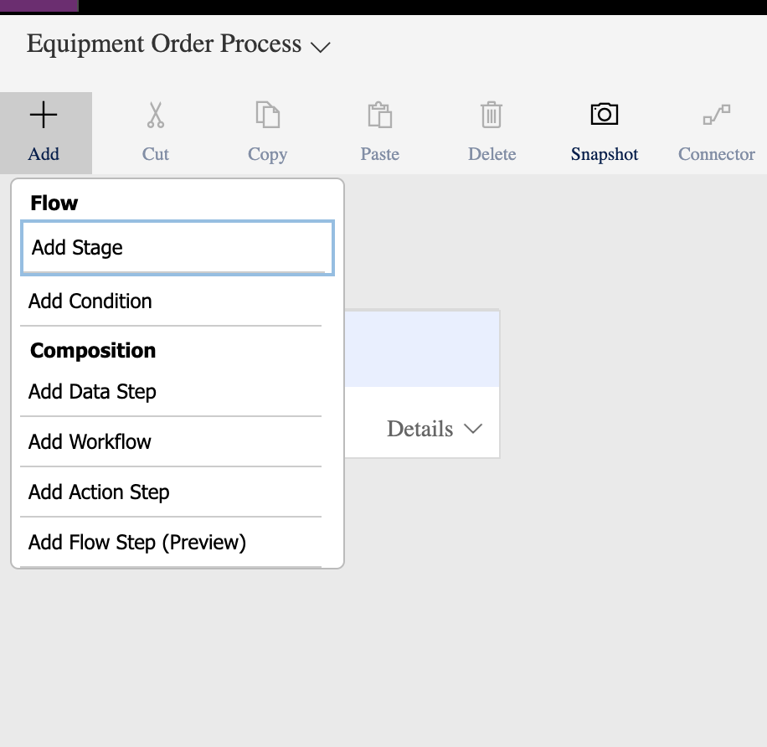

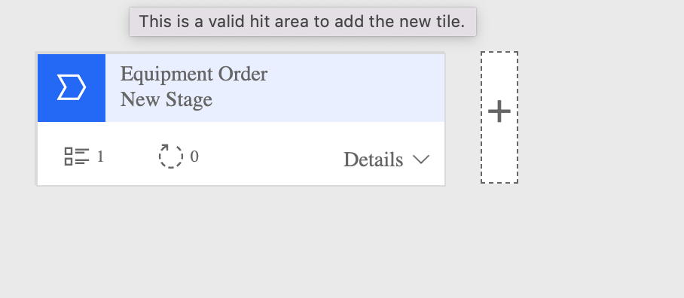

Click on the ‘+’

Now add new stages:

1.Request

2. Approval

3. Procurement

Lets say here we have got in our request were going to put in the request:

Highlight the green icon: and on the right fill in like below(Date field: Request Date) and click apply: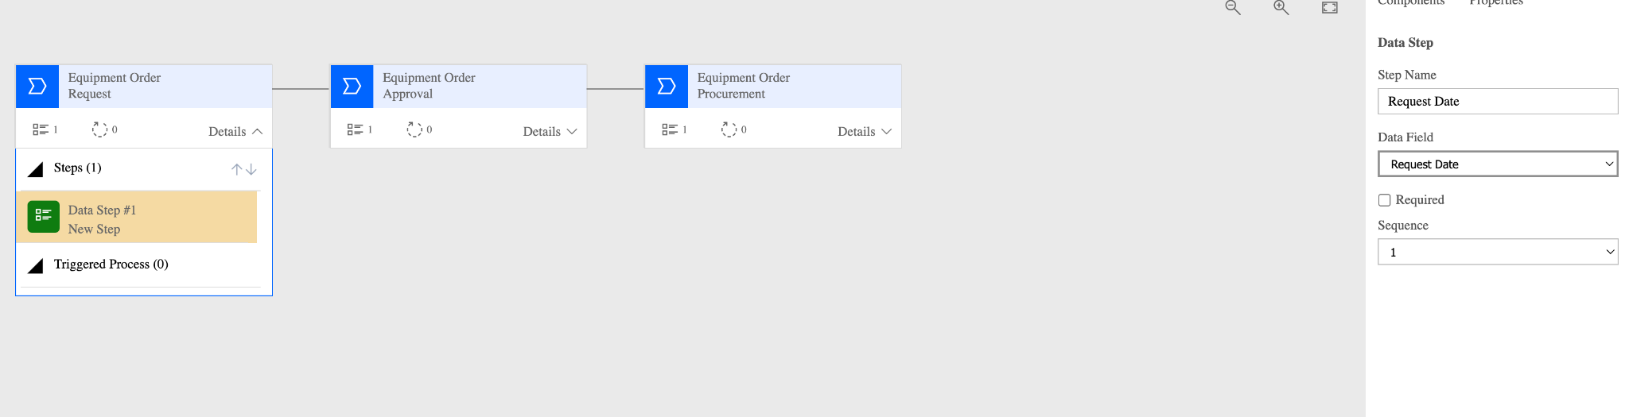

For the second stage ;

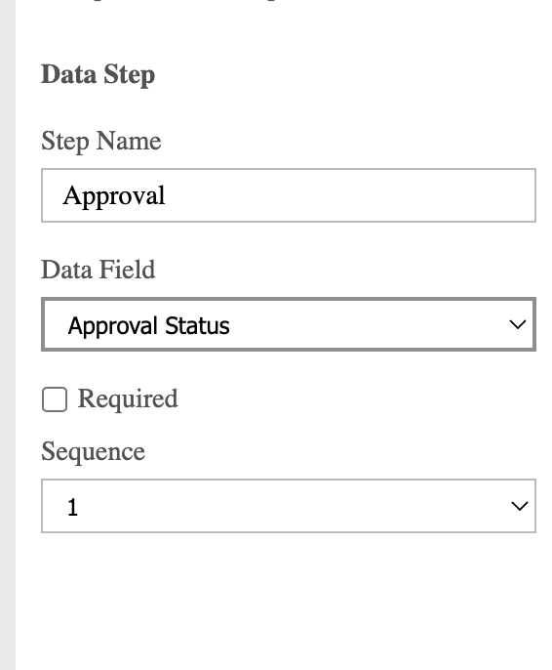

For the 3rd stage:

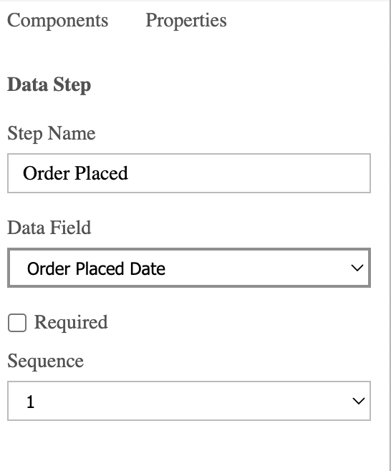

When its all done click on the ‘Save’ button:

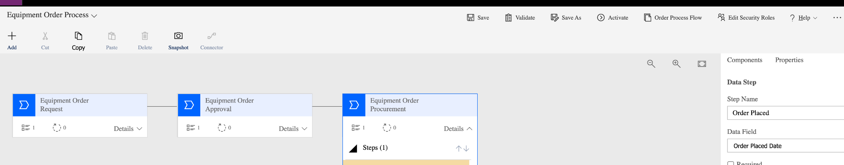

NOTE: You can click on ‘Validate’ before saving which will tell you if there's a problem. This can be done for other screens like above.



Now click on ‘Activate’ which is next to ‘Save as’. Once it has been activated you’ll see ‘Deactivate’ button.

Once the above is activated go back to the ‘Business process flow’ and click on ‘Turn on’

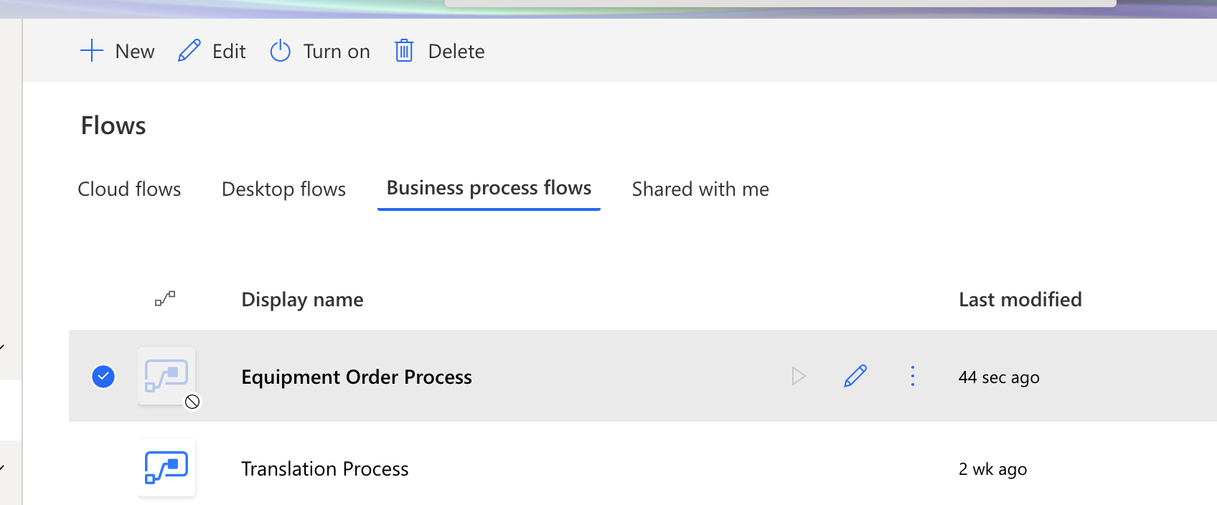

Now go to the ‘Solutions’ on the left hand side and go into ‘Equipment Ordering’ and then click on the ‘Add existing’ - ‘Automation - ‘Process’

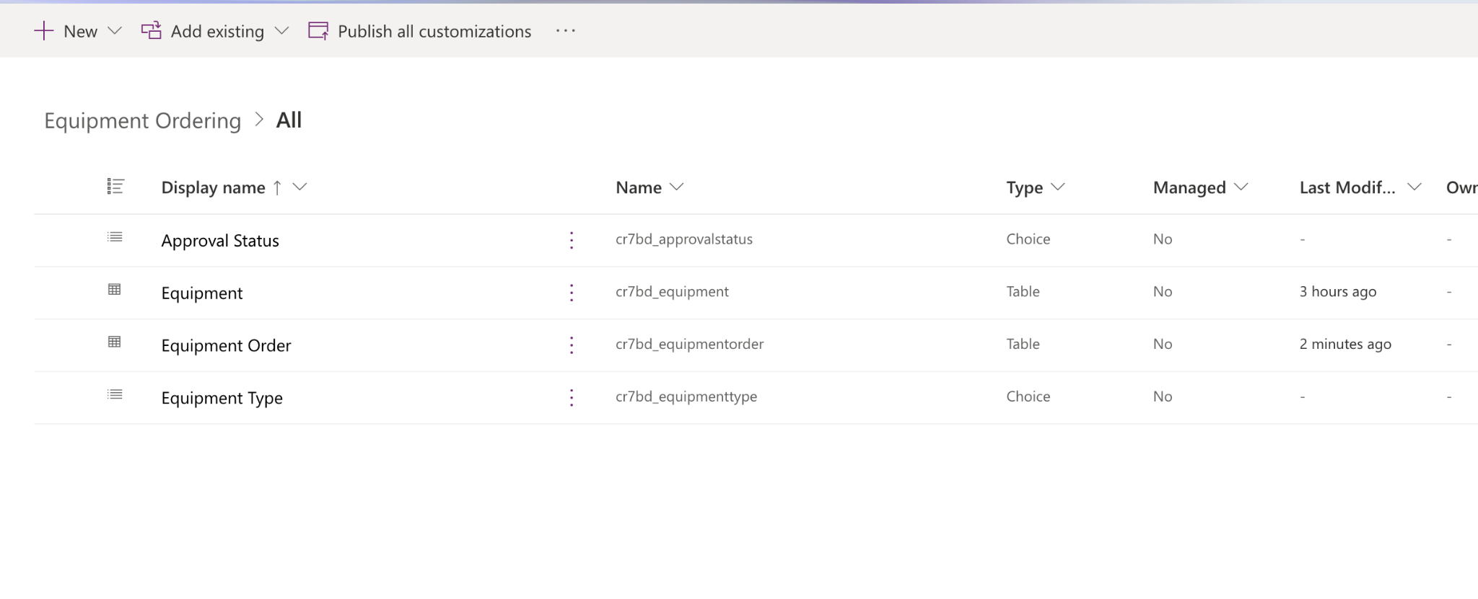

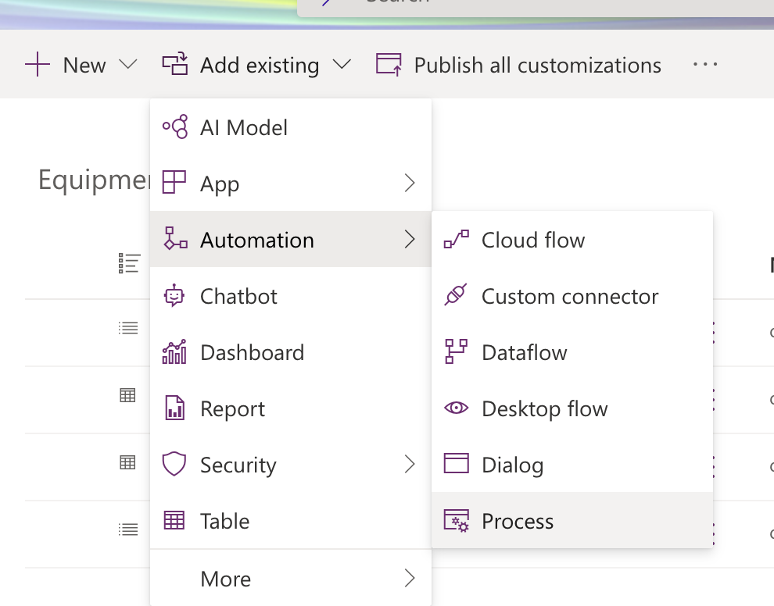

Now search and select for ‘Equipment Order Process’ and click on ‘Add’ button at the bottom

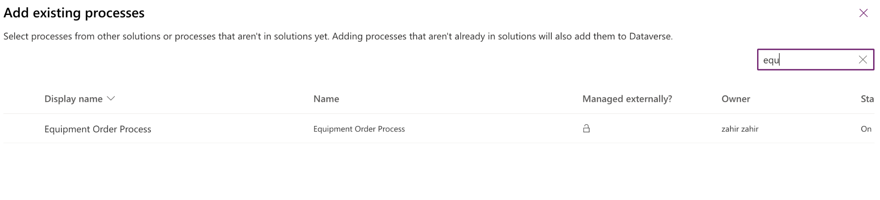

Now publish the solution by clicking on ‘Publish all customizations…’

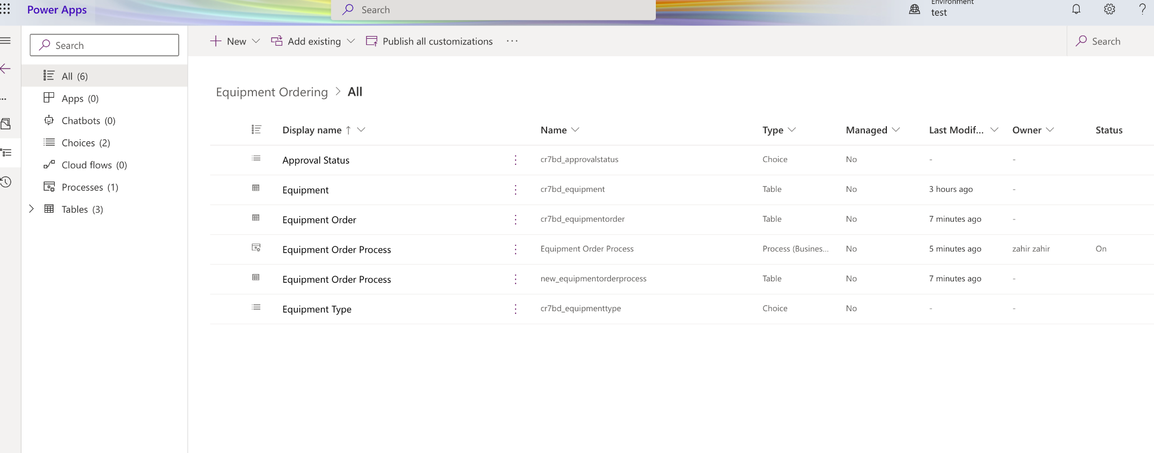

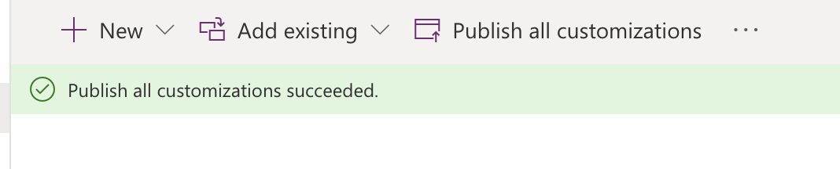

NOTE: It's a ‘SAVE’ and ‘PUBLISH’ process. I have been saving all the changes I made and then ‘Publish’ to live.

Now lets create the app which brings all of these things together into that app by going in here;

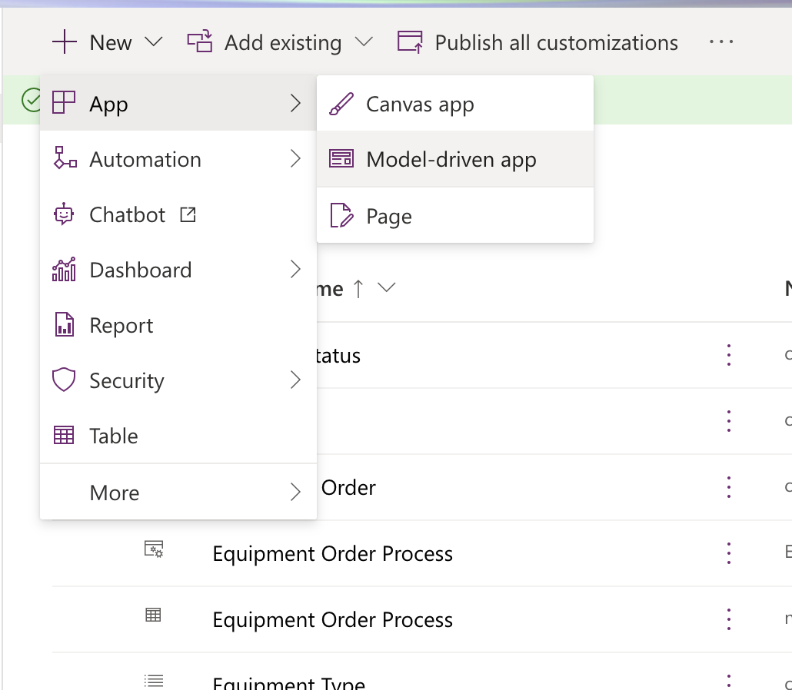

Click ‘Create’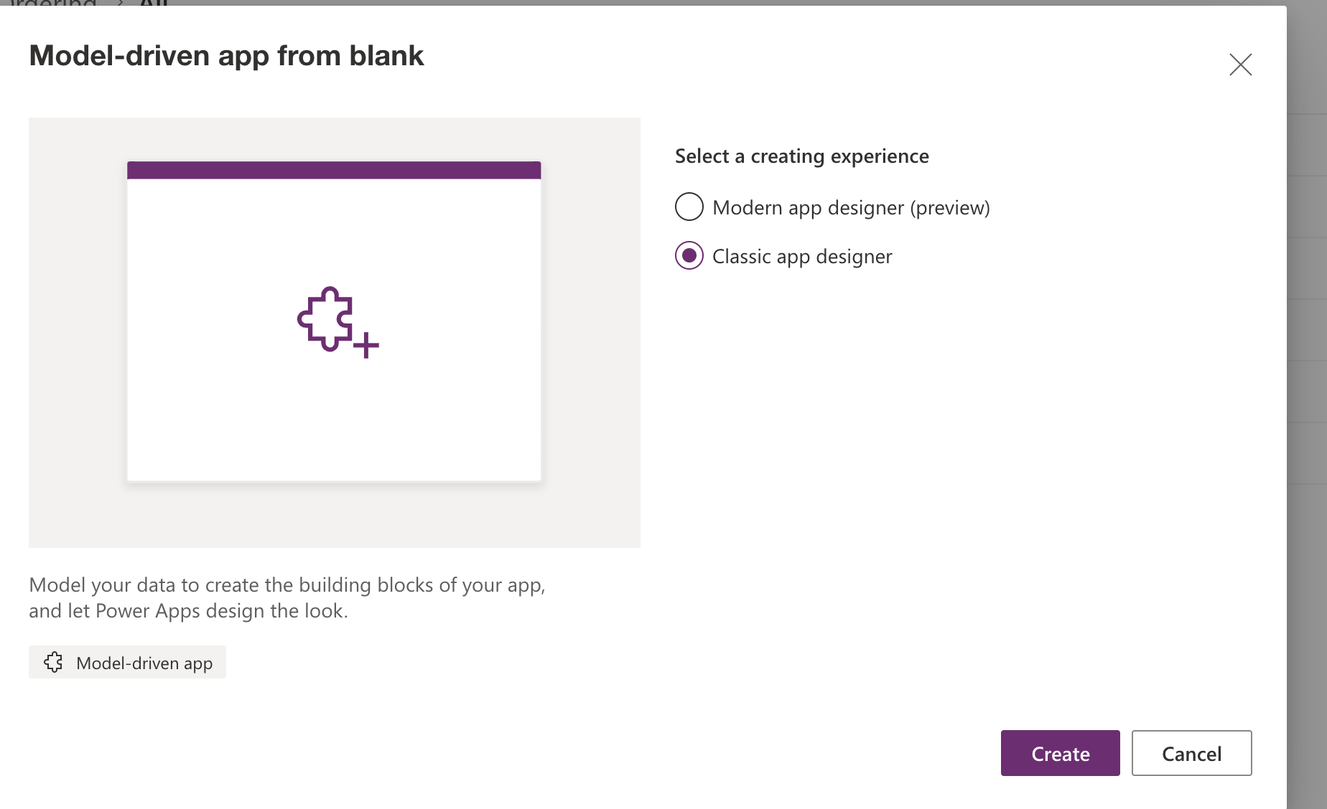

Fill in the next step like below and hit the ‘Next’ button:

NOTE: Because i’ve used a solution i can check ‘Use existing solution to create the app’

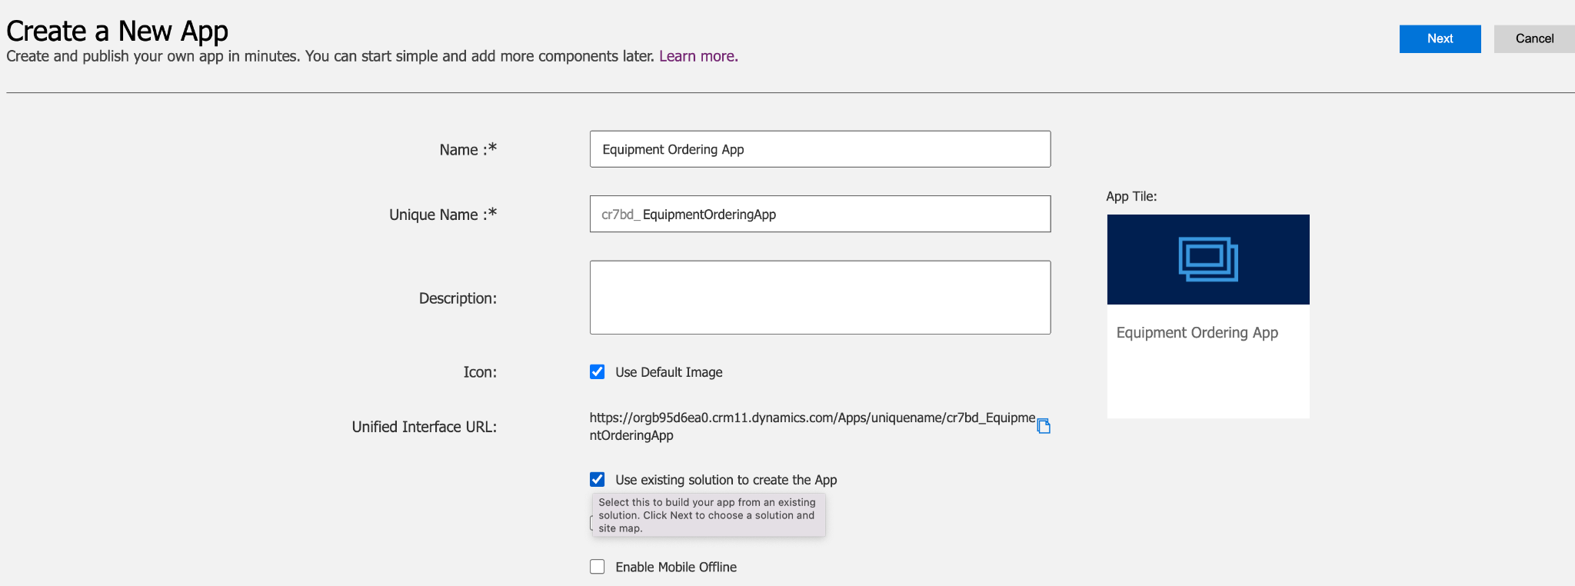

Now Select: Equipment Ordering’ and click ‘Done’

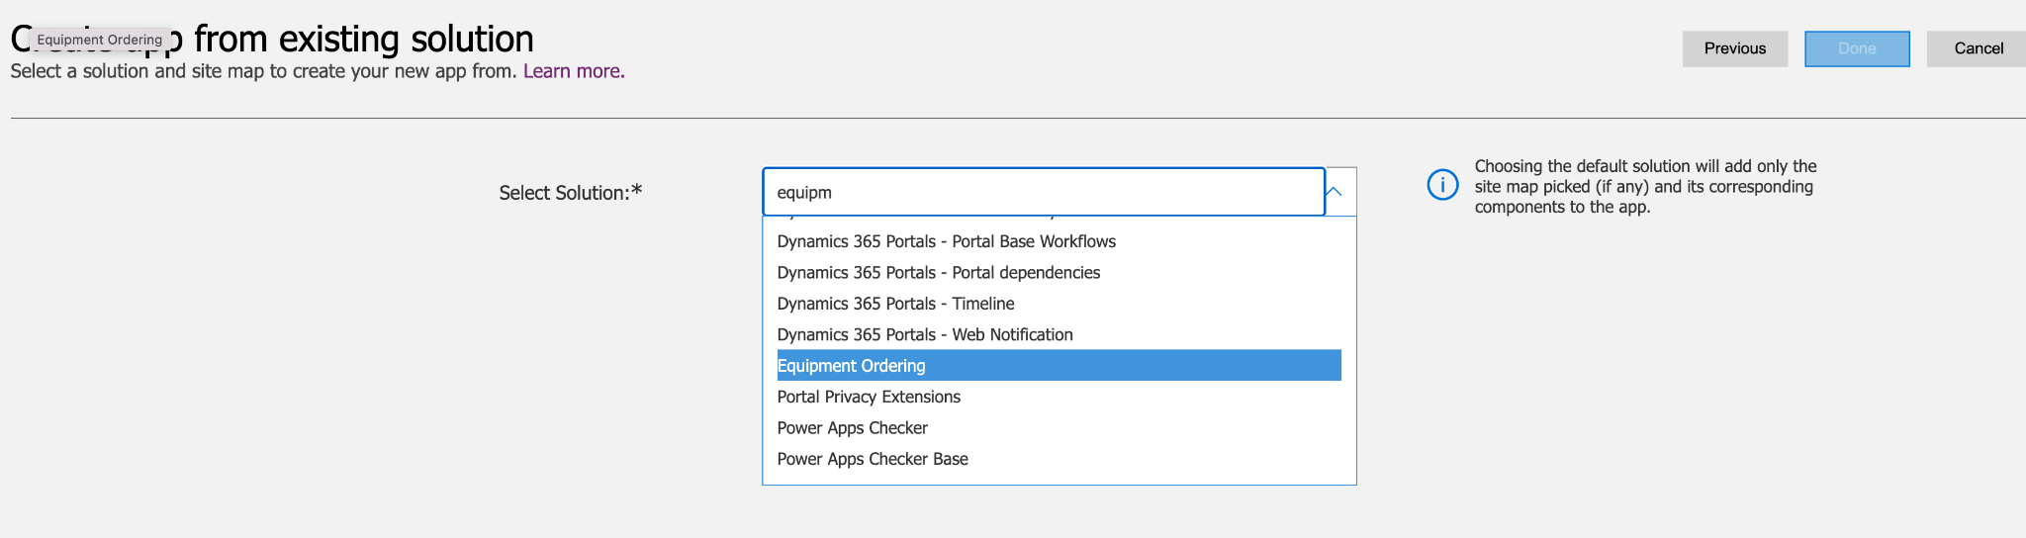

Now you’ll see this screen:

It brought in my equipment and equipment ordering tables and its brought in that business process

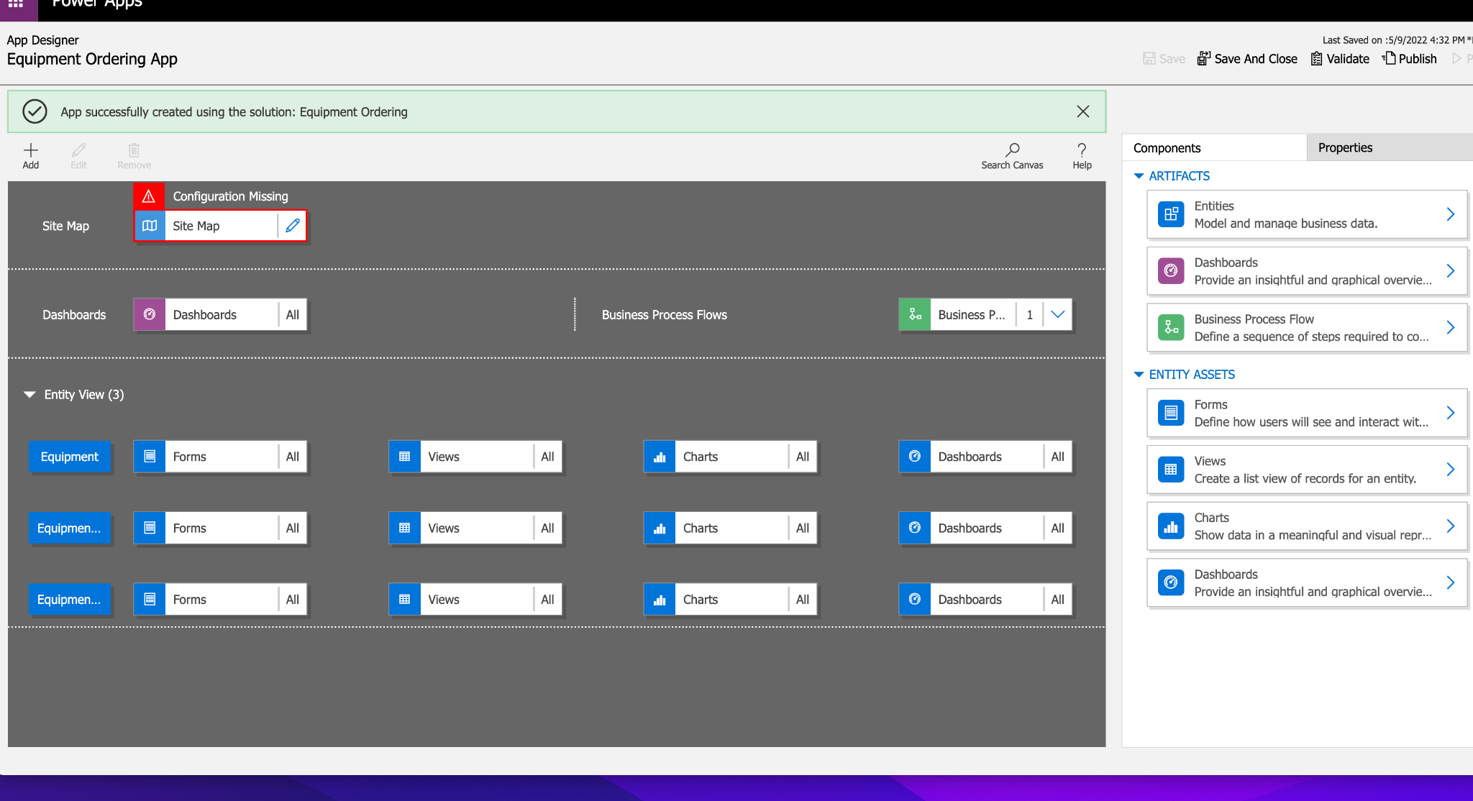

Now create the ‘Site Map’ which is flagged saying ‘Configuration Missing’. So click on the ‘Pen’ next to ‘Site Map’ and you’ll see this template below:

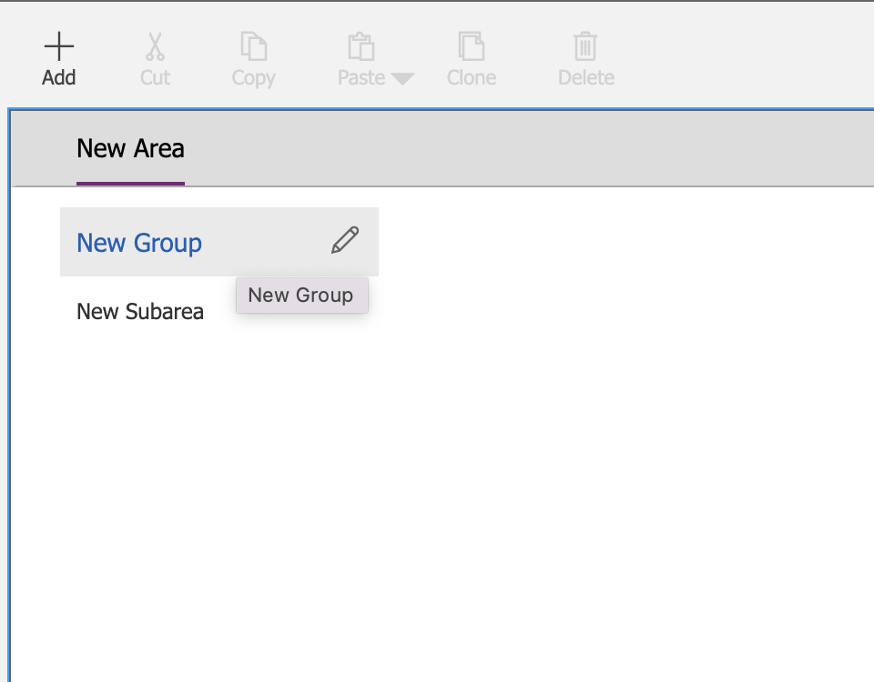

Now click on the ‘New Group’ text which is in Blue - and call it ‘Office Admin’

Now click on the ‘New Subarea’ and fill in the right hand side.

NOTE: Entity just mean ‘Table’

Type: Entity

Entity: Equipment Order

Click ‘Save’

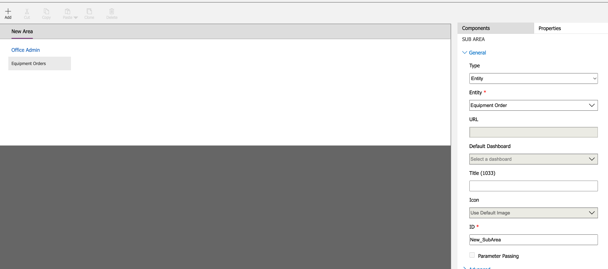

Select the last area and then click on the ‘Add’ and another ‘Subarea’:

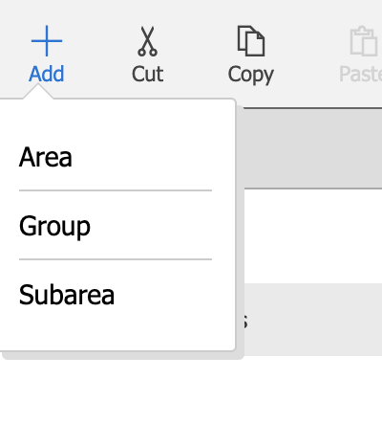

Now fill in:

Type: Entity

Entity: Equipment

Click ‘Save’

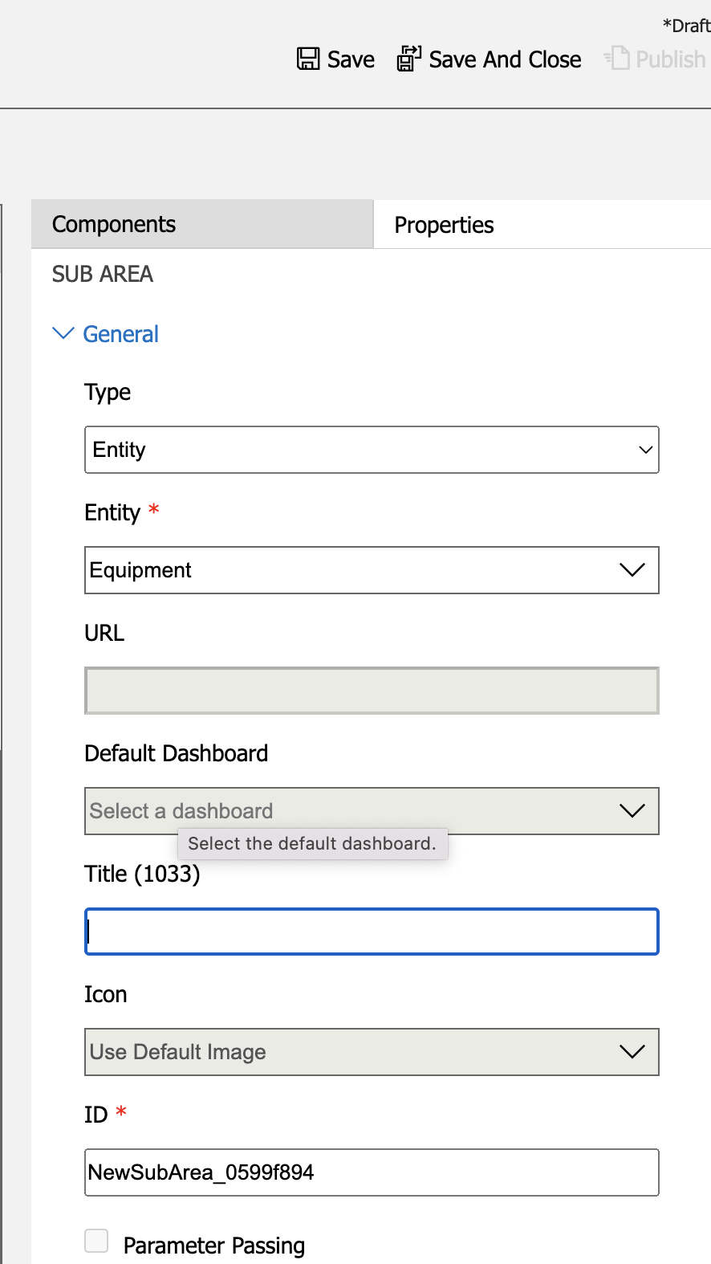

Now click on ‘Publish’

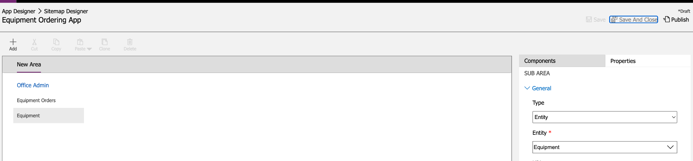

Thats now site map done, so go back to ‘App Designer’ and click ‘Save’

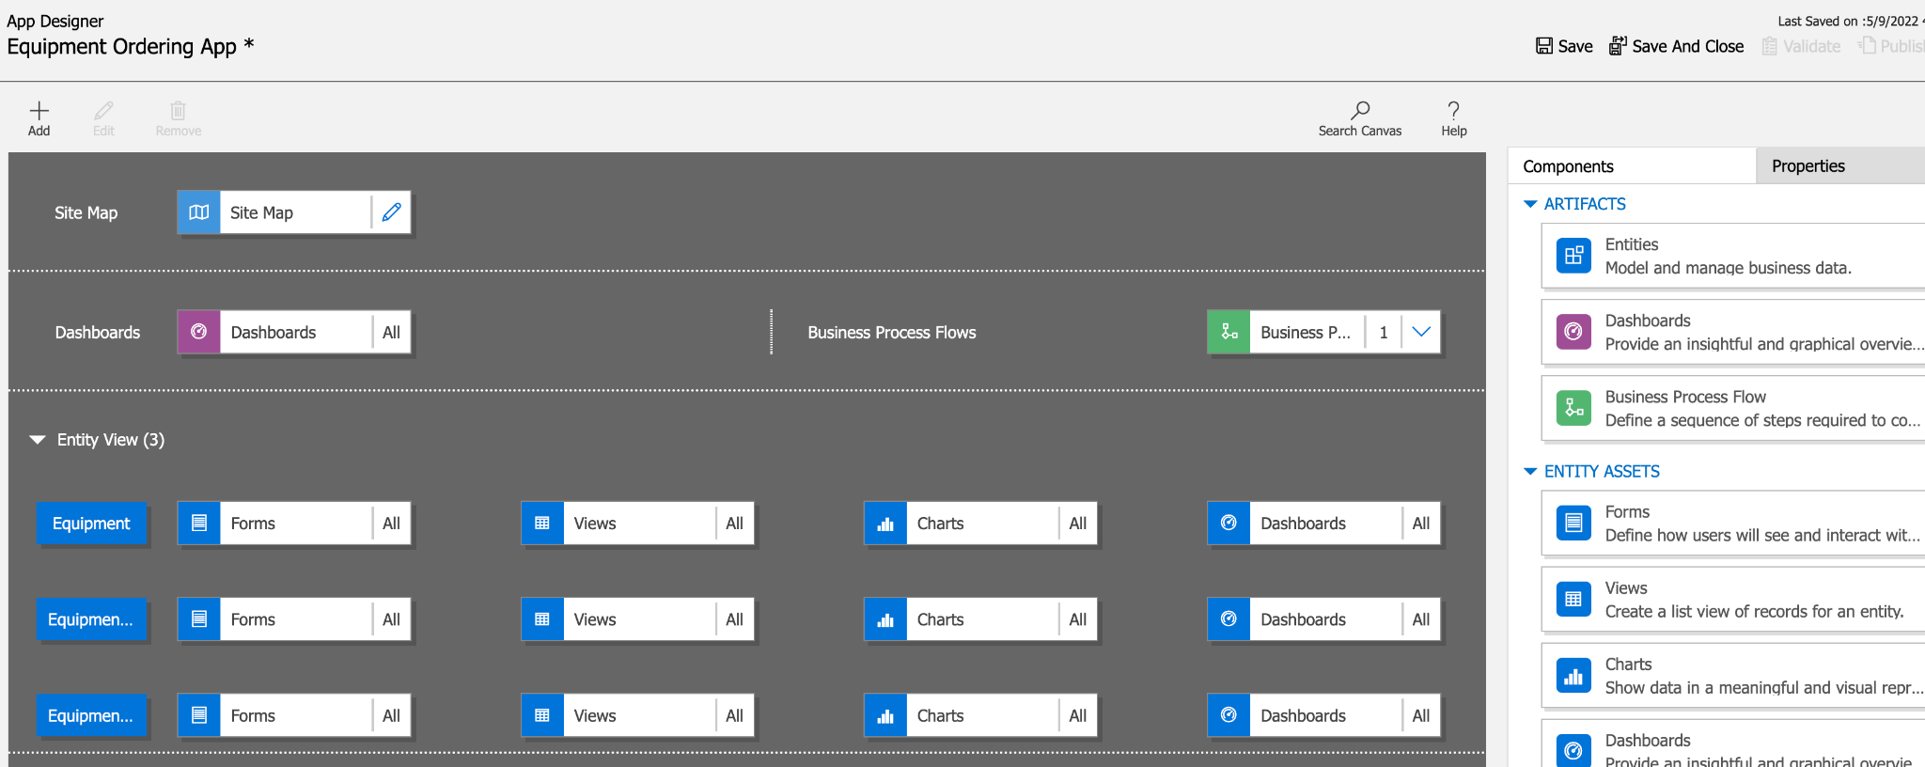

Then click ‘Validate’ and you’ll see ‘Warnings’ which can be ignored:

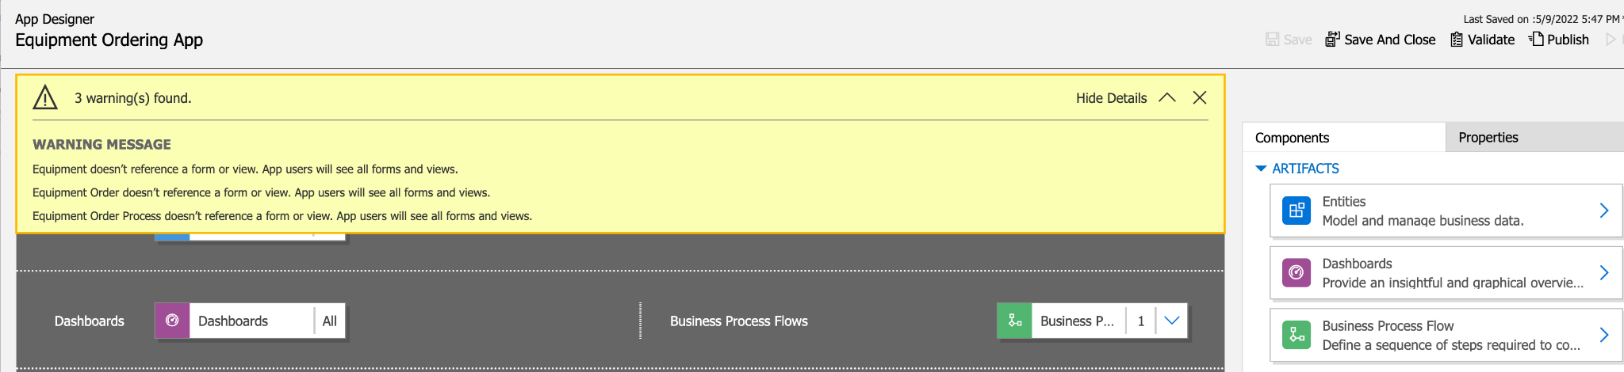

Now click ‘Publish’

And then CLICK ‘PLAY’ which is on the same page:

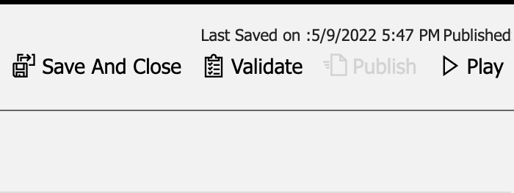

It’ll open a new tab with your app (see on left: Equipment Orders and Equipment) where you’ll see all the scaffolding like ‘Export to Excel’ etc:

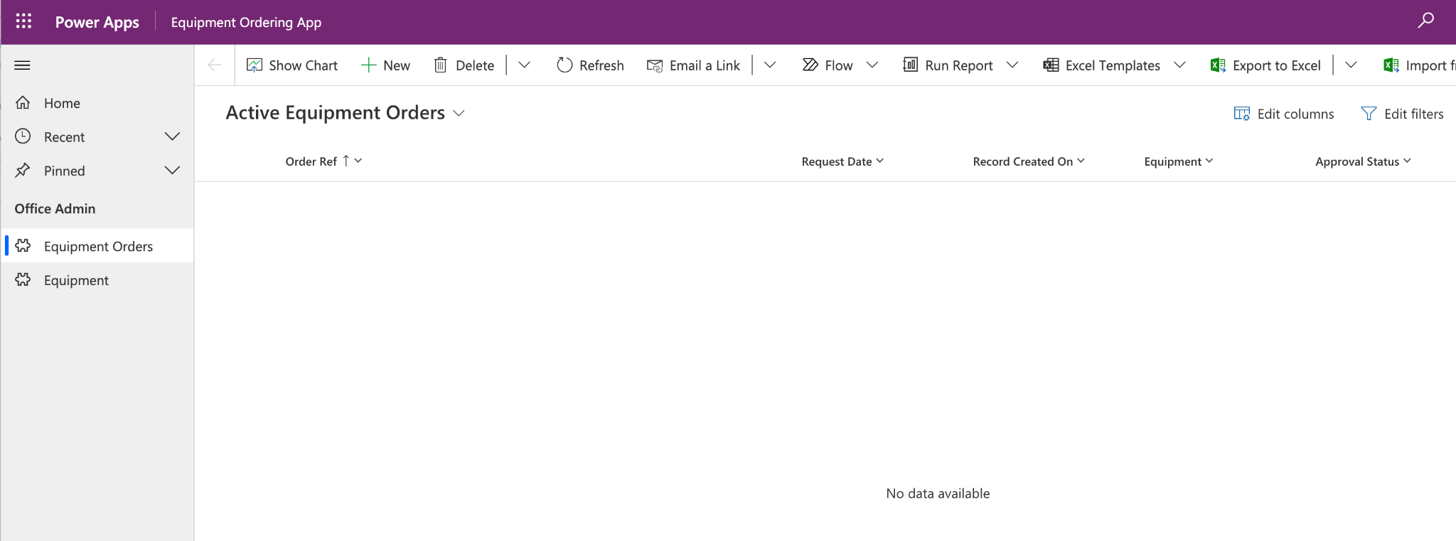

Now click on the ‘Equipment’ tab form the left and then click ‘+New’

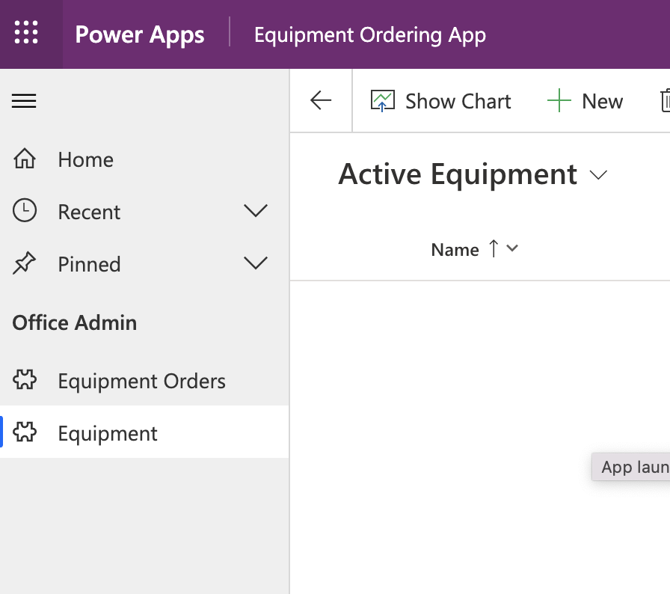

Which will open the Data Entry screen. This screen is what i created earlier on. So fill in some data and click on ‘Save’:

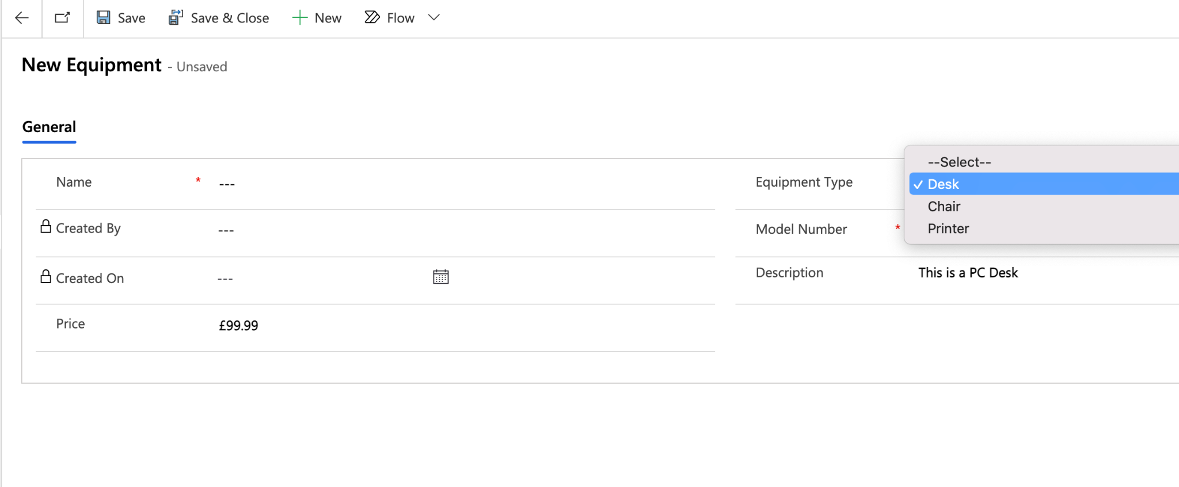

When you click on the ‘Save’ and mandatory fields are not filled in:

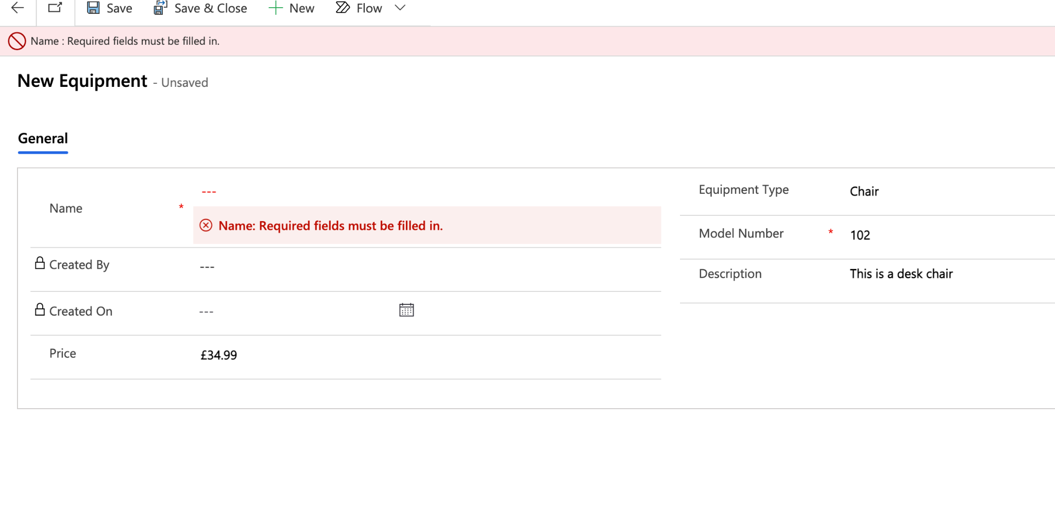

Now ‘Save and Close’ which will take you to main screen where you can see the records:

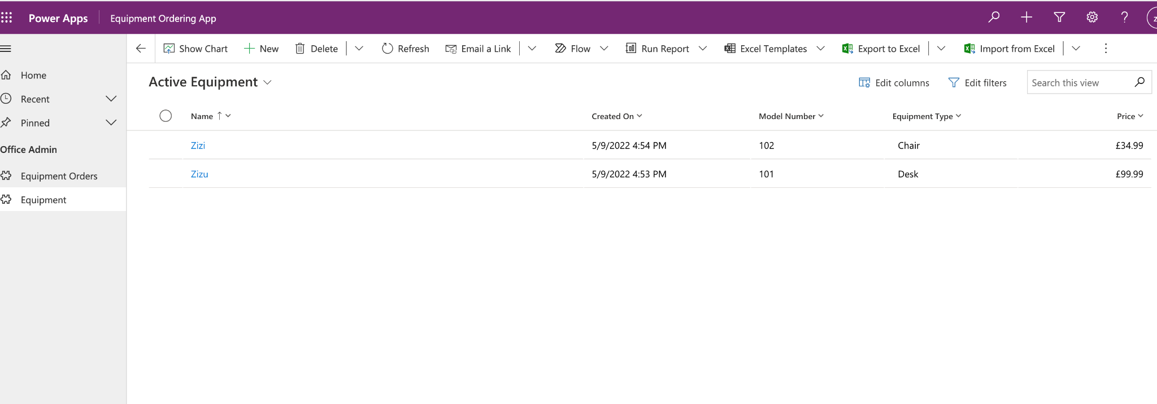

Now click on the ‘Equipment Orders’ tab form the left and then click ‘New’

Then fill in the form.

NOTE: Order ref could be AutoNumber, which means it is automatically generated. This could be done from the ‘Dataverse’ where I created the table/entity data types.

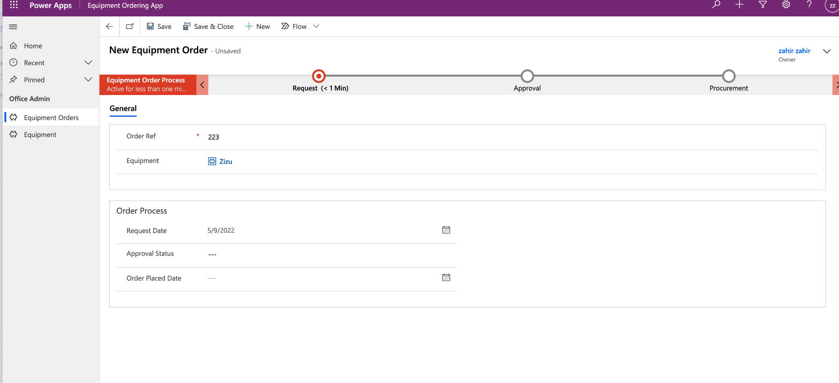

Now click on ‘Save and close’

Then go back into the record and you’ll have an option to move through those steps:

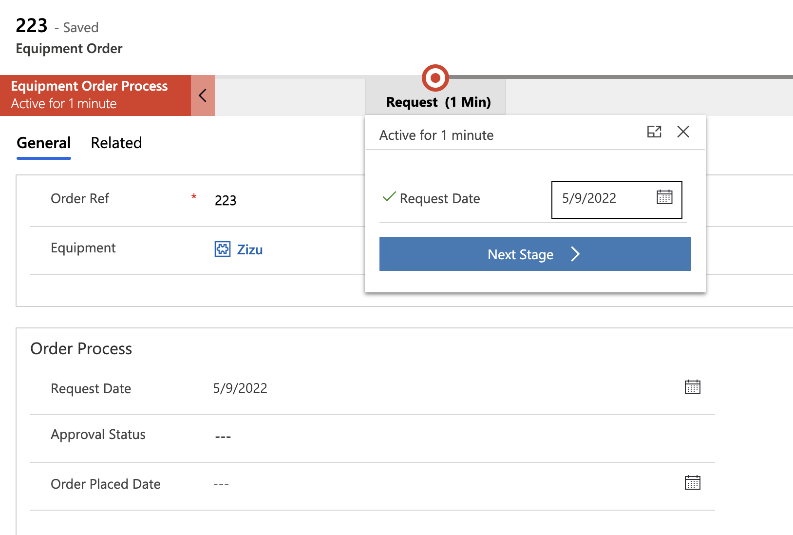

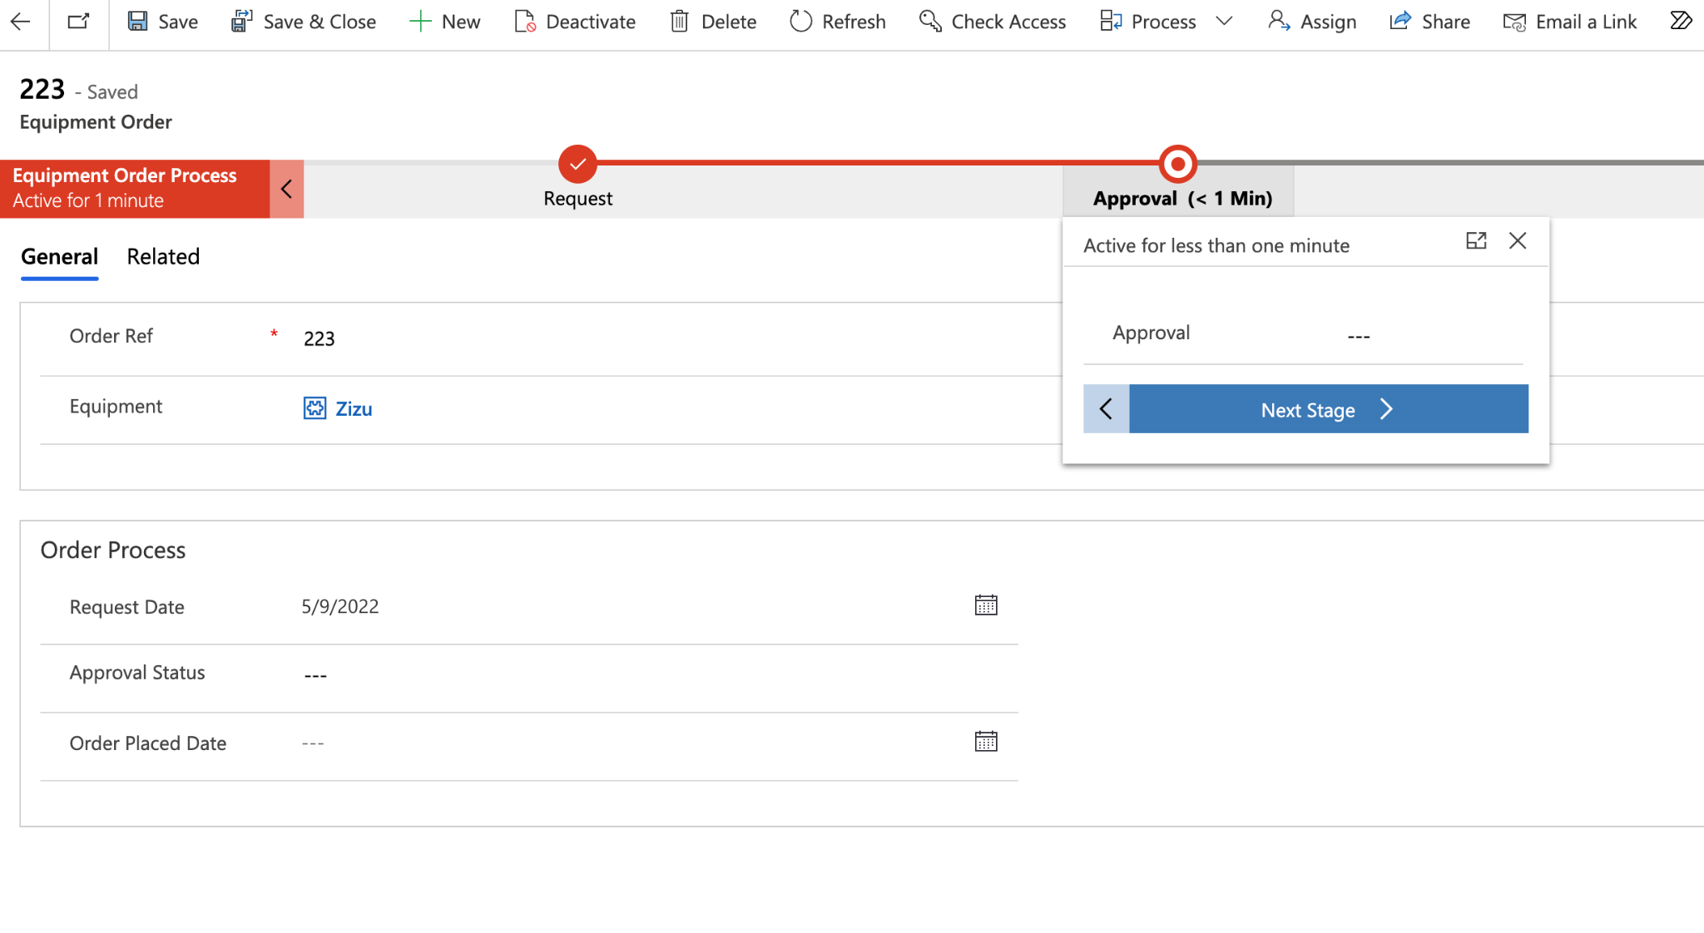

Note: These processes can be automated so after a certain period of time e.g. 3 days or if the ‘Approval Status’ is done it moves to the next step.

**Adding Image and File upload.**

Go to ‘Tables’ then ‘Add Column’

Now you’ll be able to see in ‘Data type’ there’s type ‘Image’ and ‘File’.

Create one of each.

**Image** - is an actual photo (which will show the preview after you’ve uploaded the image).

**File** - This will be in a link, for you to download. No preview. (Default file size 32MB, can set it up to 128MB).

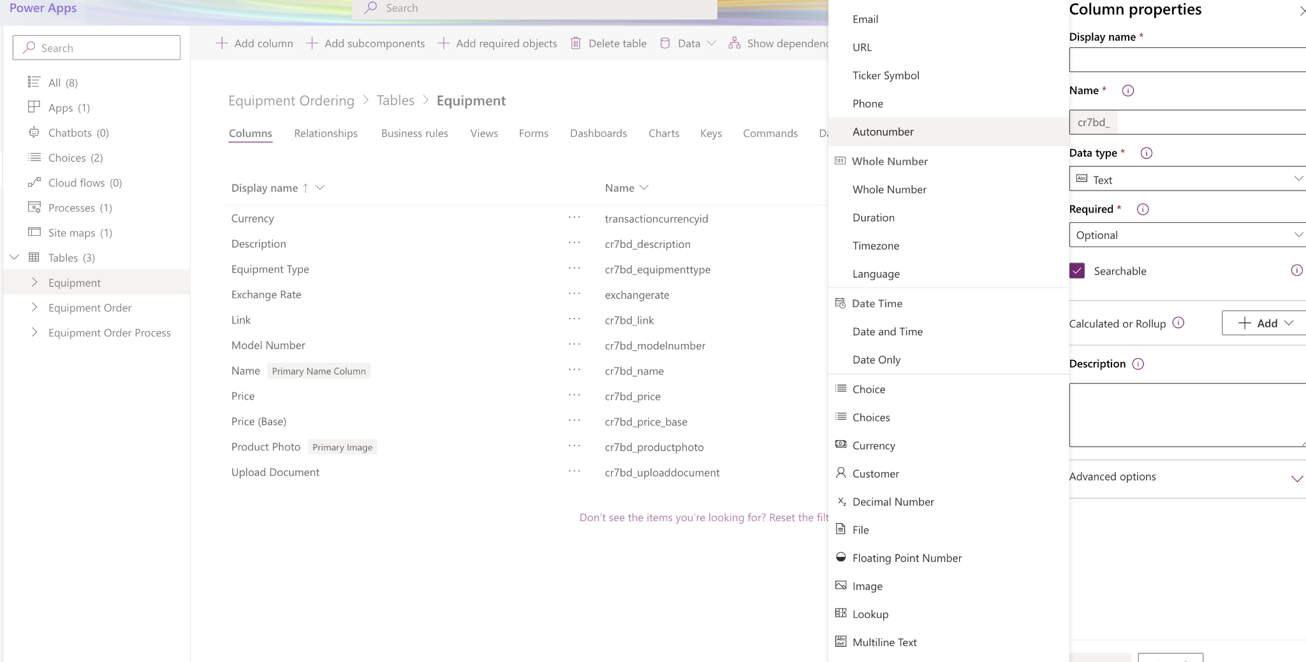

Once you’ve added those fields go to ‘Forms’ and then select ‘Information’-Main.

After that drag and drop the two newly created fields on your form(middle section).

Now click ‘Publish’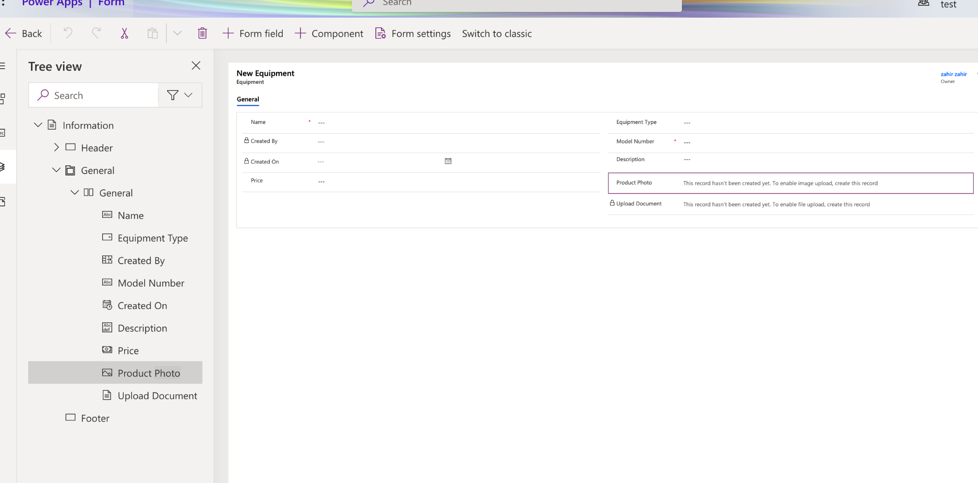

Now go to your data entry page and you’ll be able to see the newly added fields.

To activate the two new fields, first fill in the rest of the form and then click ‘Save’

Then it’ll activate the image and file upload fields.

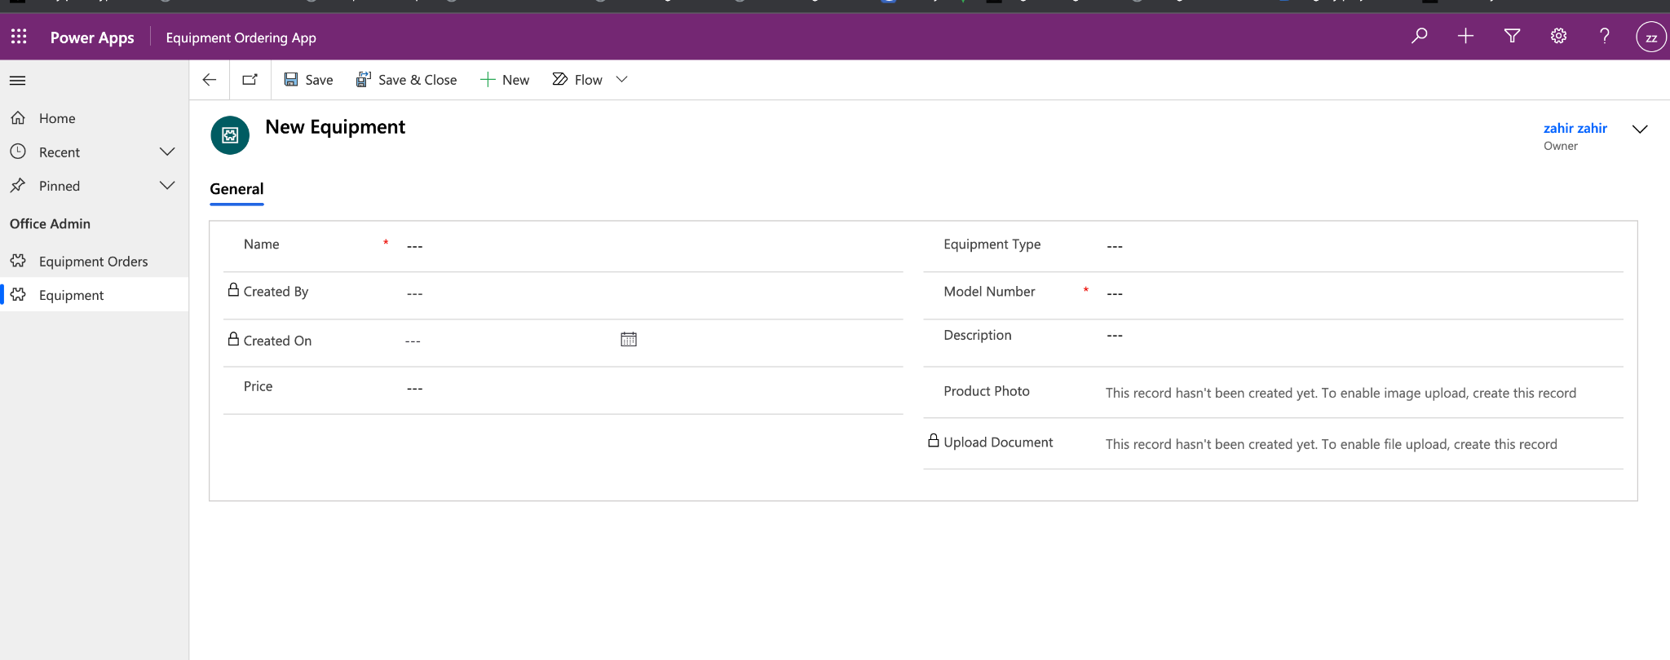

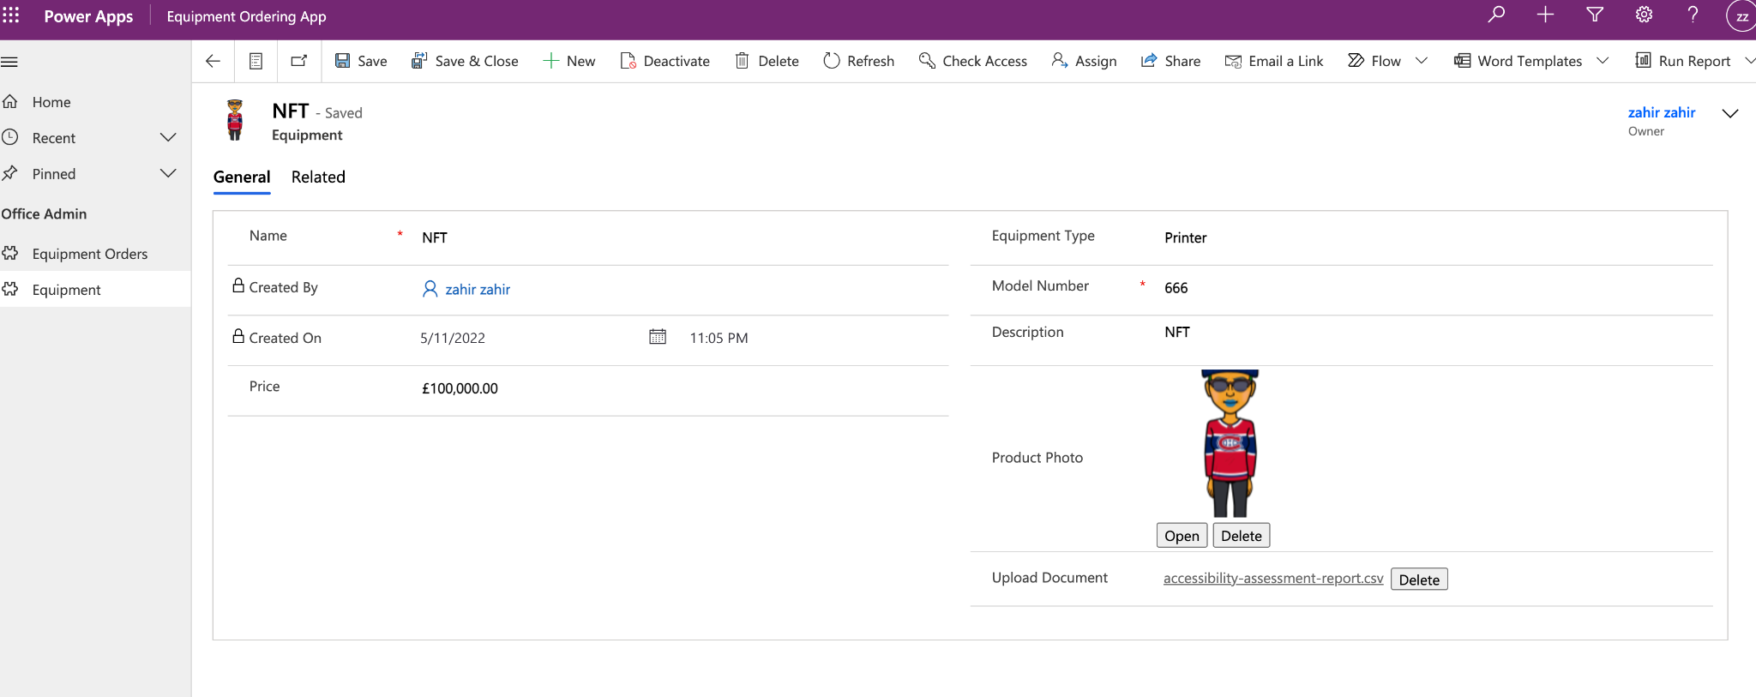

**Security on forms:**

Click on ‘Form settings’ and then you’ll have choice of making the form available to ‘Everyone’ or ‘Specific security roles’.

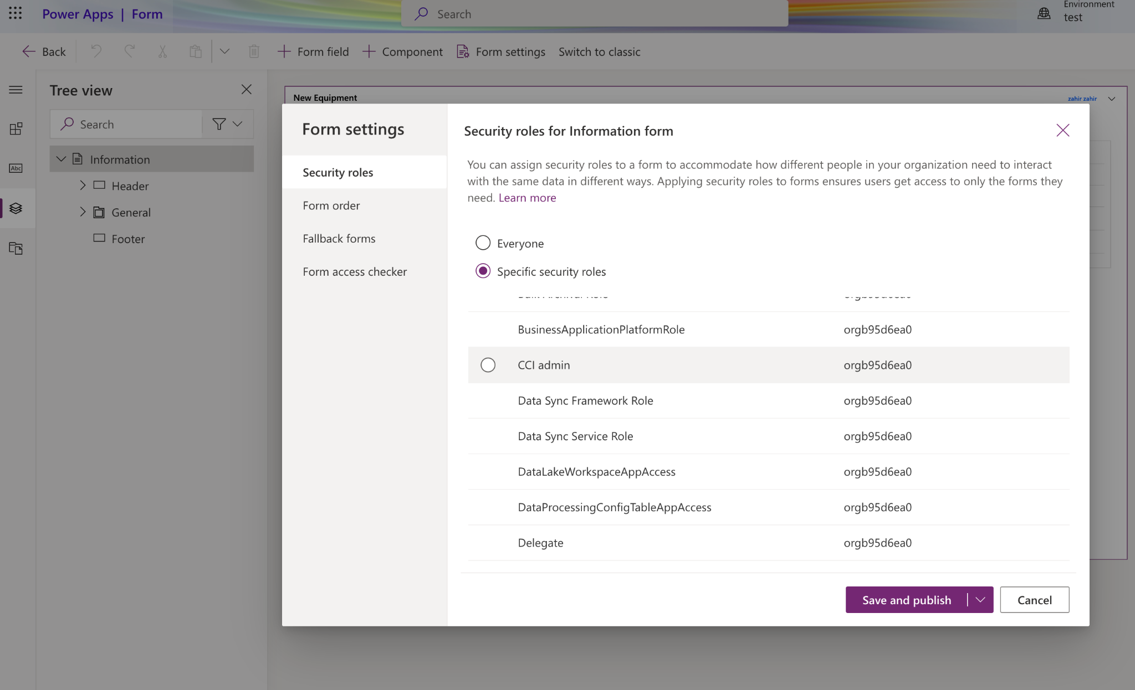

NOTE: If you have several tabs in your from you can order them by clicking on ‘Form order’

Filtering Views and adding it to your Form to compare similar items:

I’ve added Chairs which varies in price.

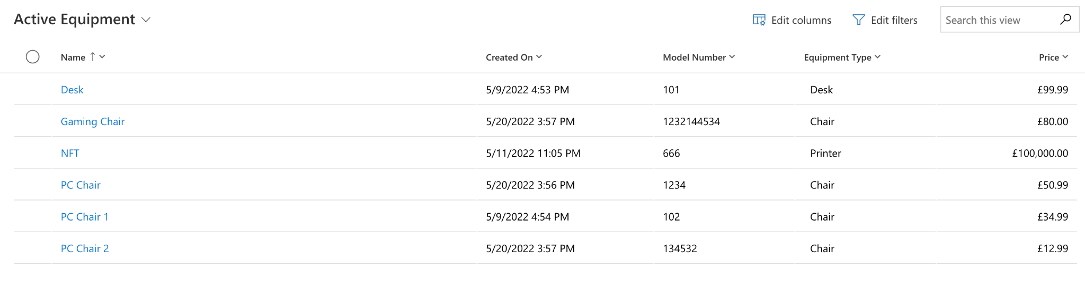

Now lets create a view to add to the form:

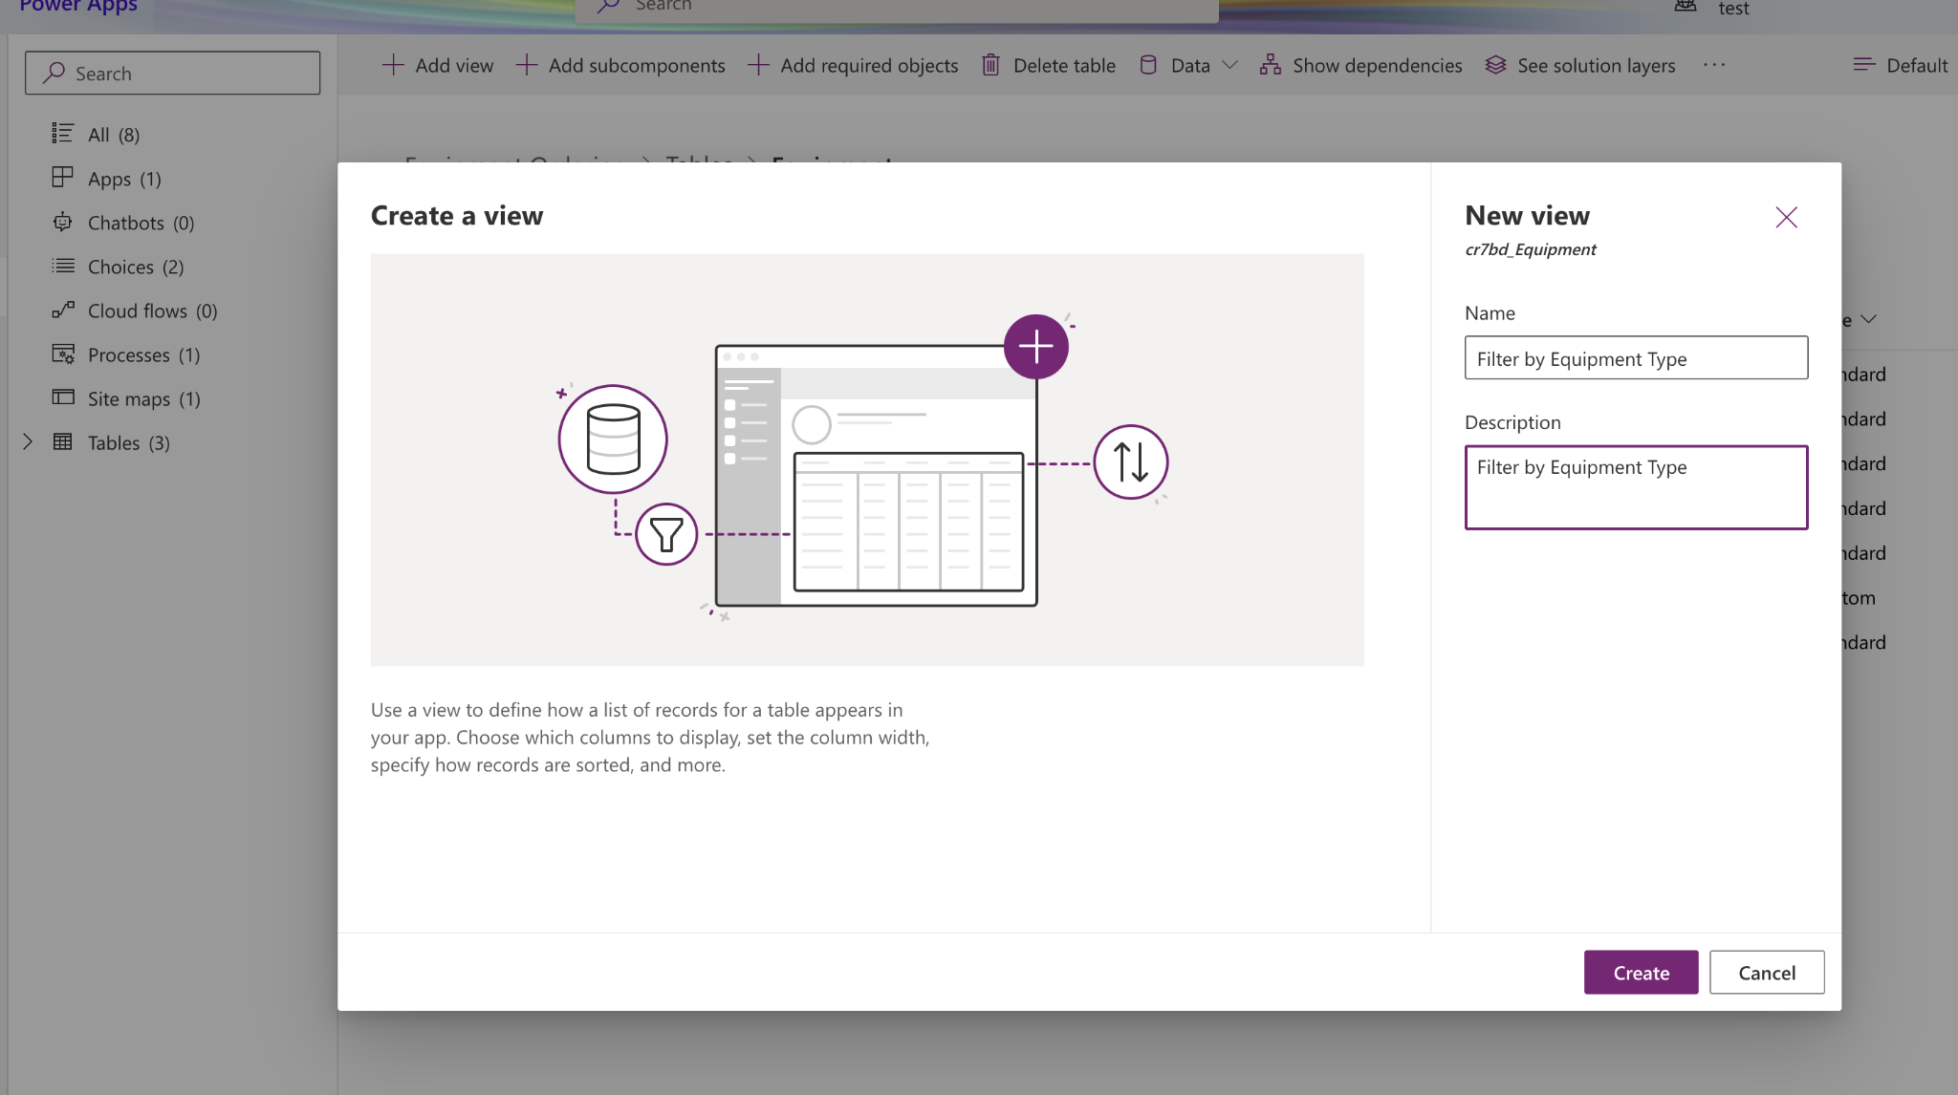

Now add ‘Price’

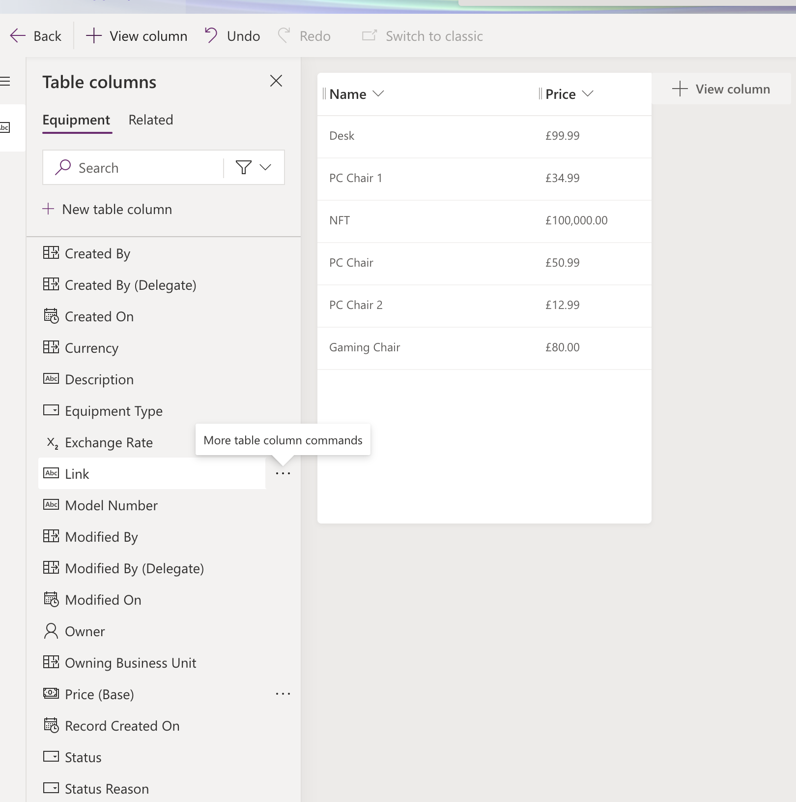

Now click on the ‘Edit filters…’ on the right hand side:

Add the filter by selecting the fields and click ok. Then click on ‘Validate’, ‘Save’ and ‘Publish’.

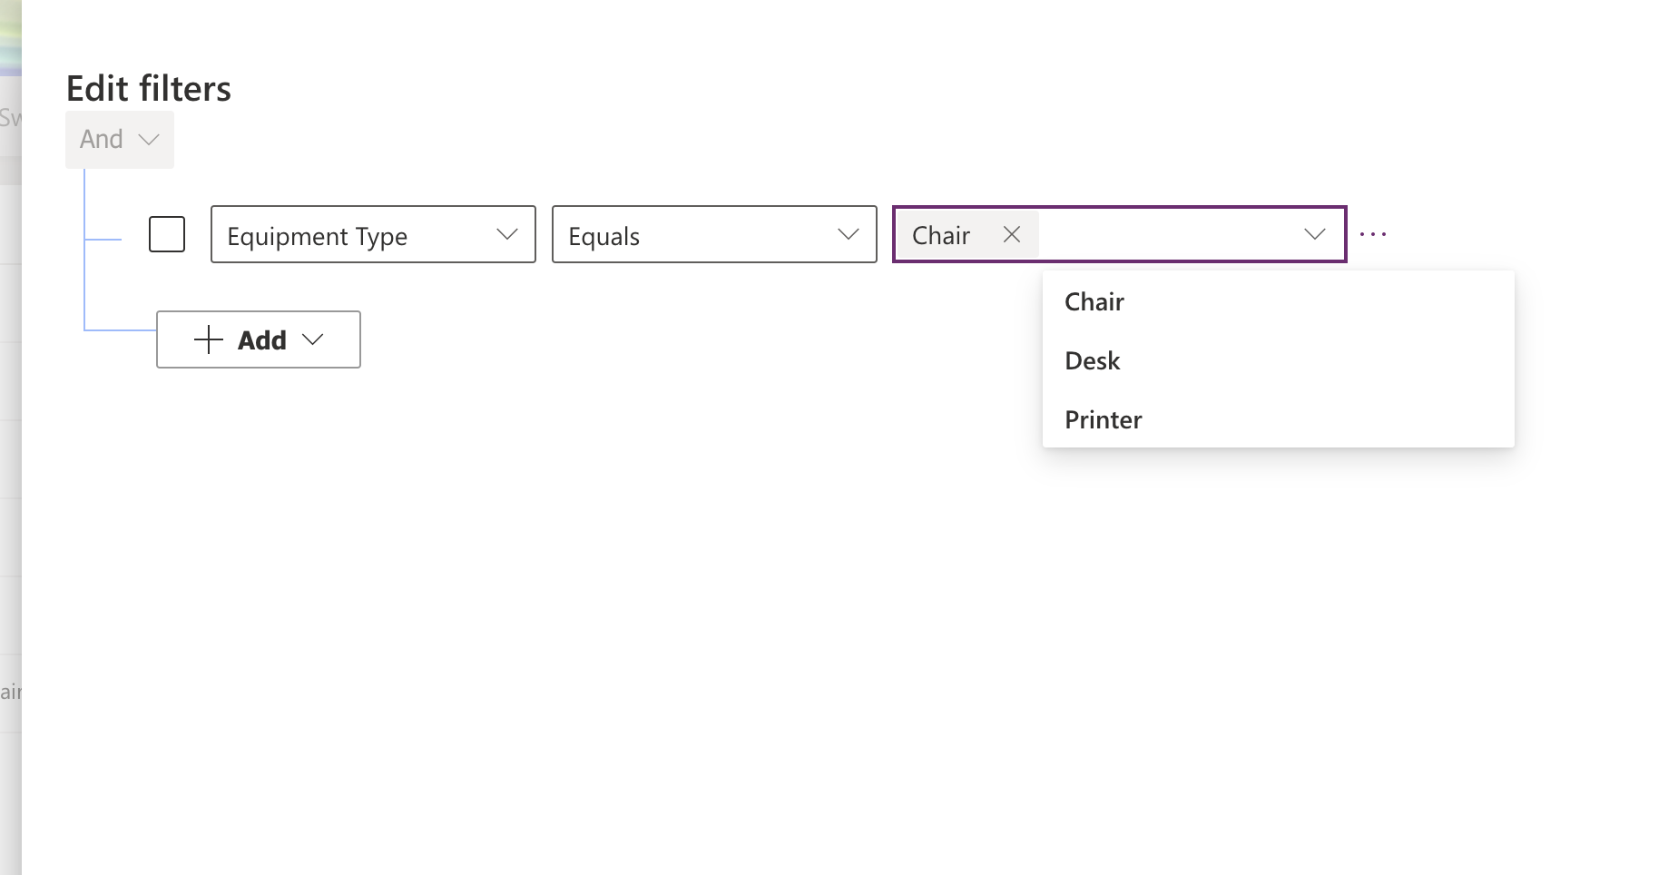

Now go to the ‘Form’ and add the ‘View’ by clicking on the ‘Subgrid’ and

Select: Table: Equipment, Default View: ‘Filter by Equipment Type’

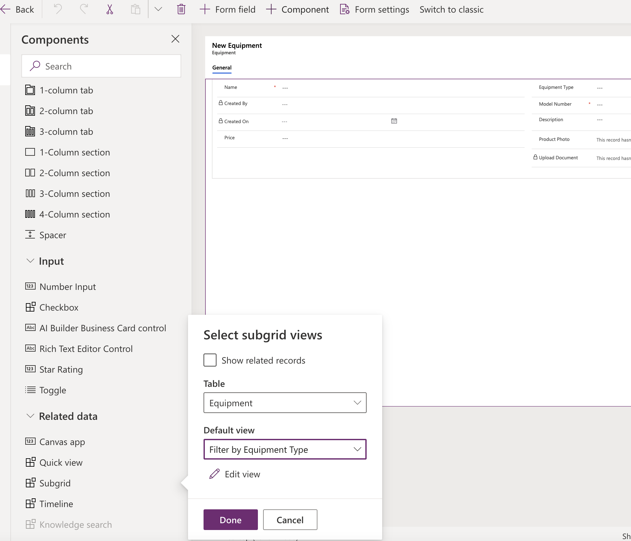

You’ll see that it has been added to the main Form. Also it can move to a new ‘Tab’. Now ‘Save’ and ‘Publish’ the form.

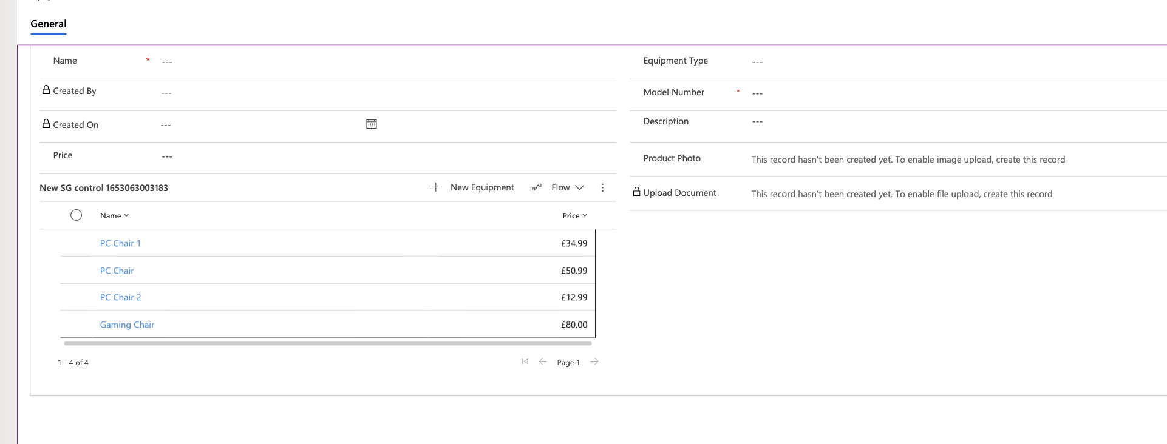

Name: Subgrid_similar_items

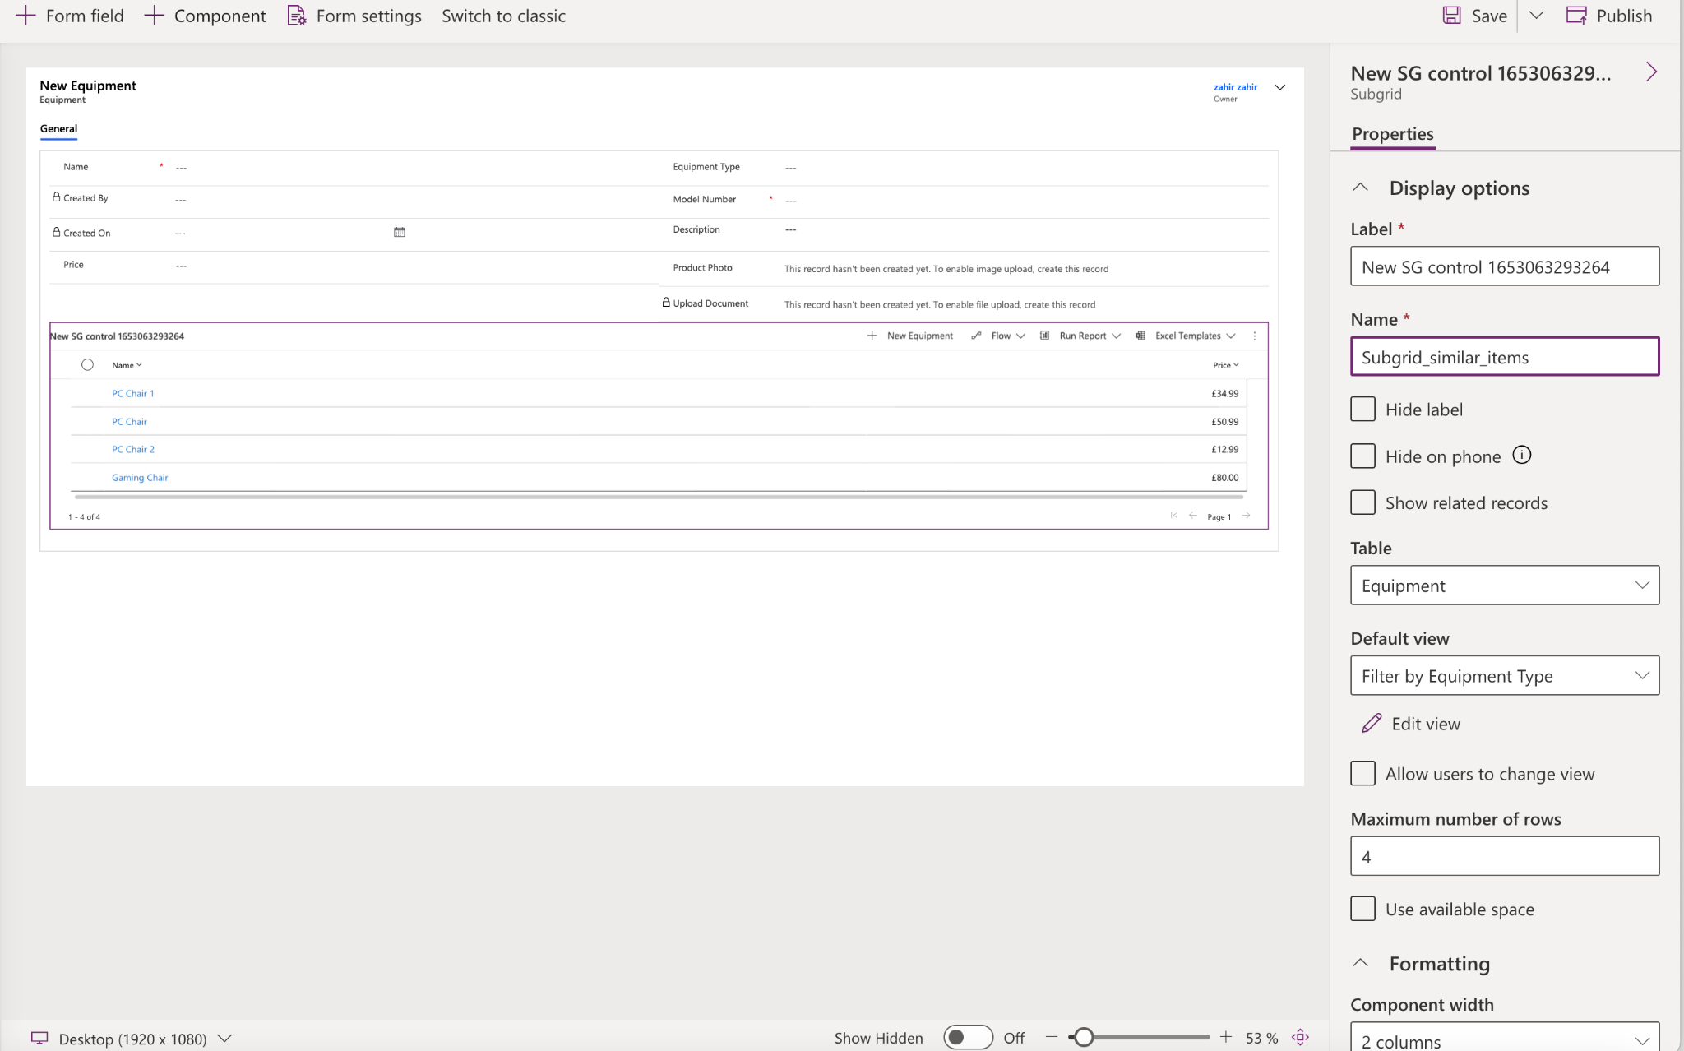

**Business process flows (This section will be updated later)**

-Stages and steps

-make a field required

-Flows on table, ordering business process flows

-set security roles for access to business process flows

-activate the business process flows

-add a business process flow to a solution

-switch processes

-business process flow across multiple tables

-business processes flow with conditions and branching

Create a ‘New’ Flow in ‘Flows’

**Creating a shopping cart**

**Create a new solution : ‘zBay’**

**Create a new Table**

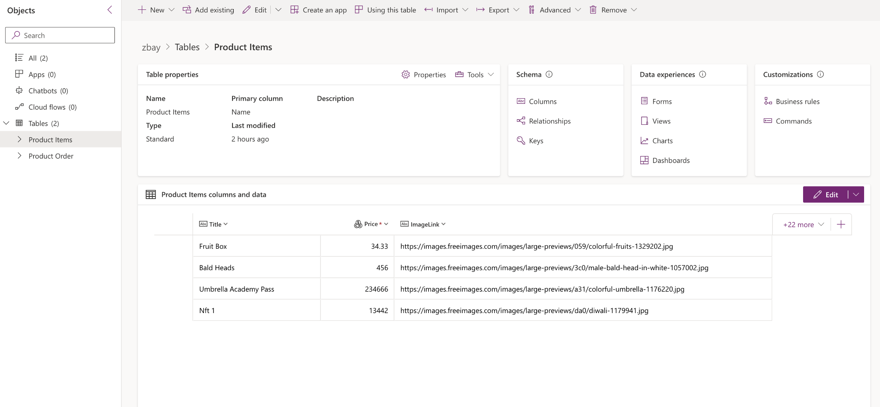

**Product Items: (Enter some data like above)**

**-ID(Autonumber), Title, Price, ImageLink**

**Product Order:**

**- OrderID, Title, Order Total, Comments**

**Now go to ‘+Create’ - ‘Blank App’**

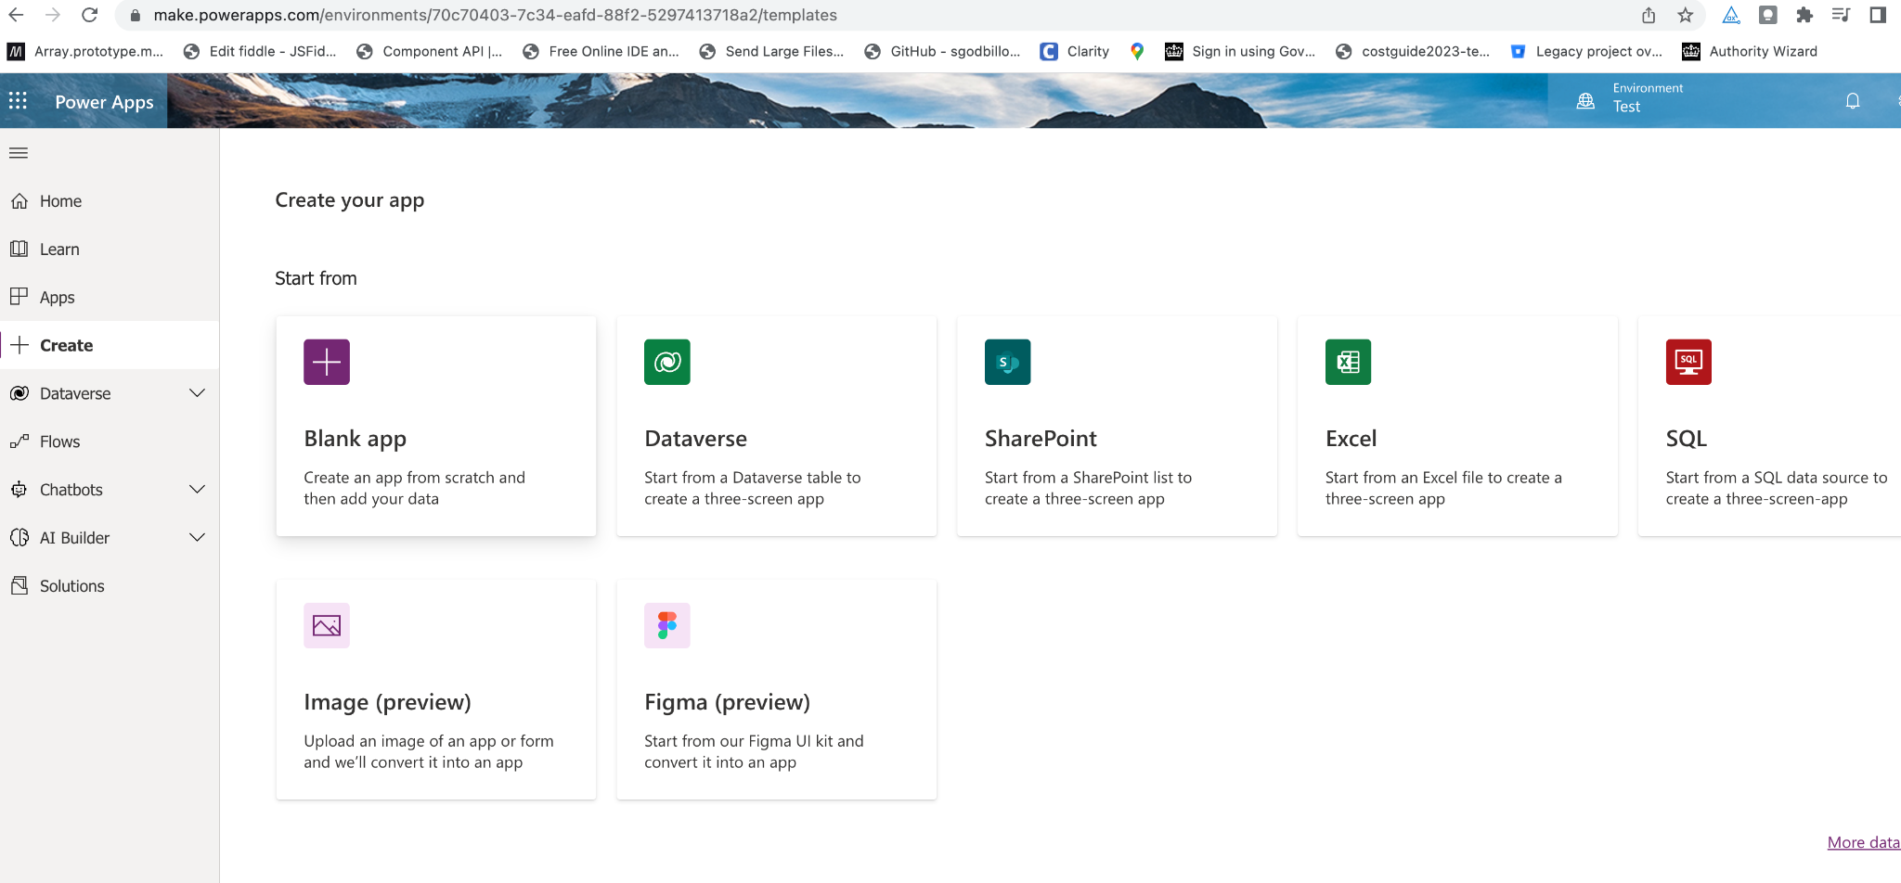

**Choose ‘Blank canvas app’**

**Now give it a name:**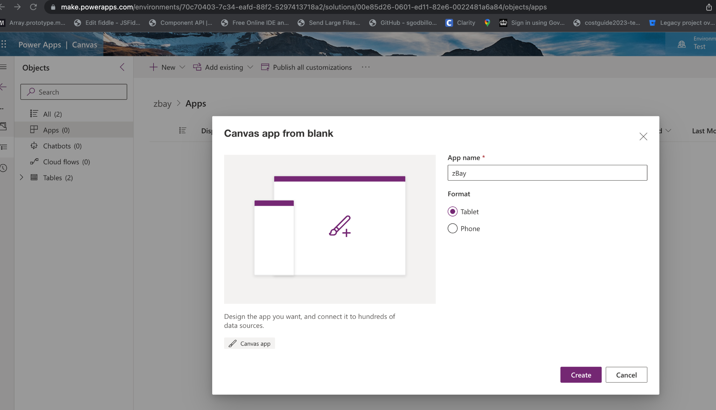

**Click on ‘Insert’ - Gallery - Vertical**

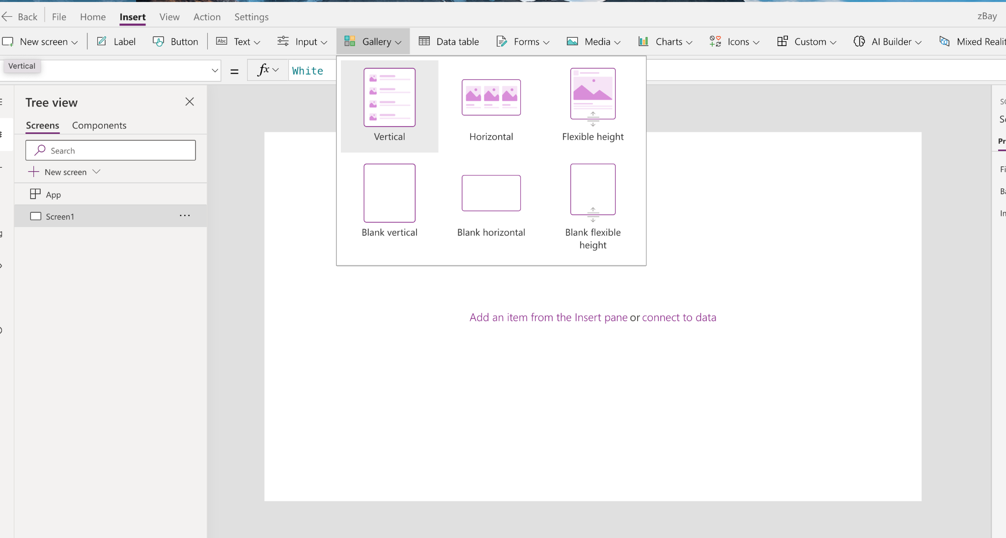

**You’ll see this on the screen: Select ‘Product Items’ table**

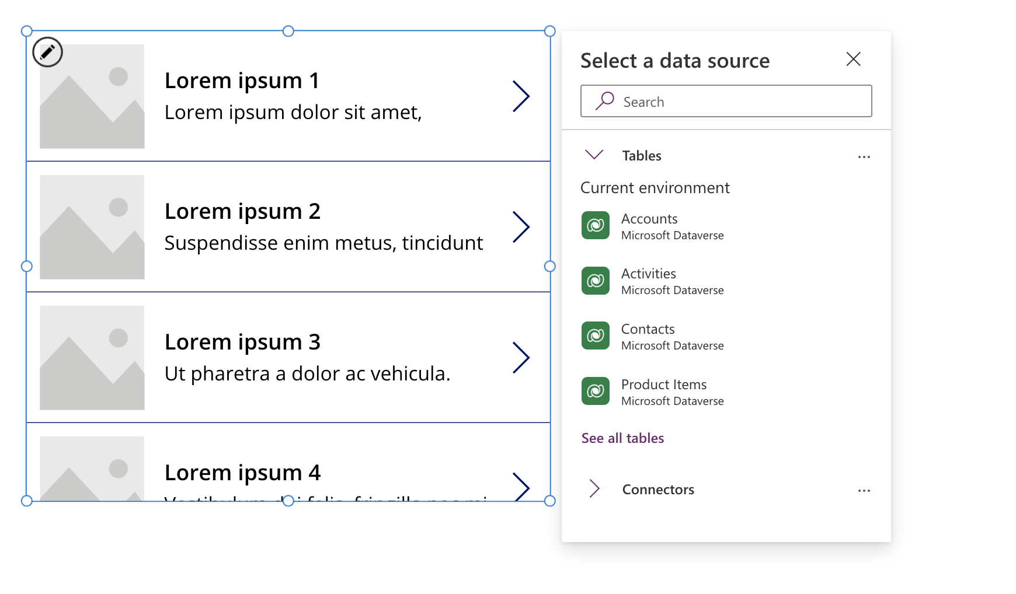

**Now Click on the ‘Fields’ - Edit**

**And for Subtitle1: ‘Price’ and Title1: ‘Title’**

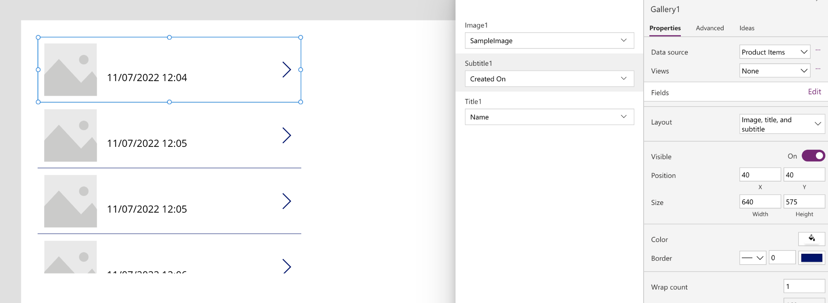

**Now prefix price with ‘£’ ("£"&ThisItem.Price)(Select Price field on the first item)**

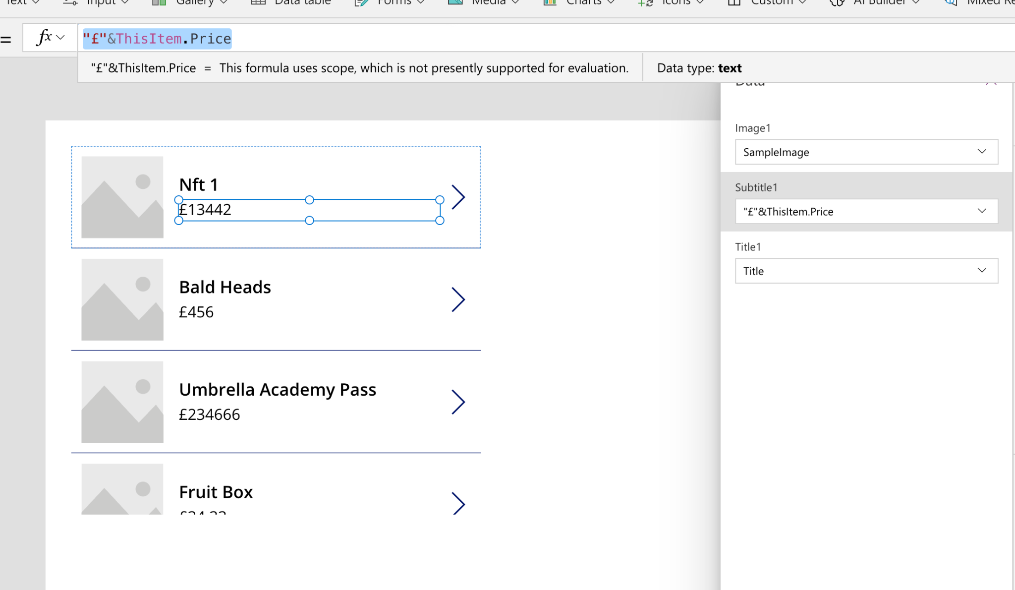

**Now click on the image and in the top formual bar put this: (ThisItem.ImageLink)**

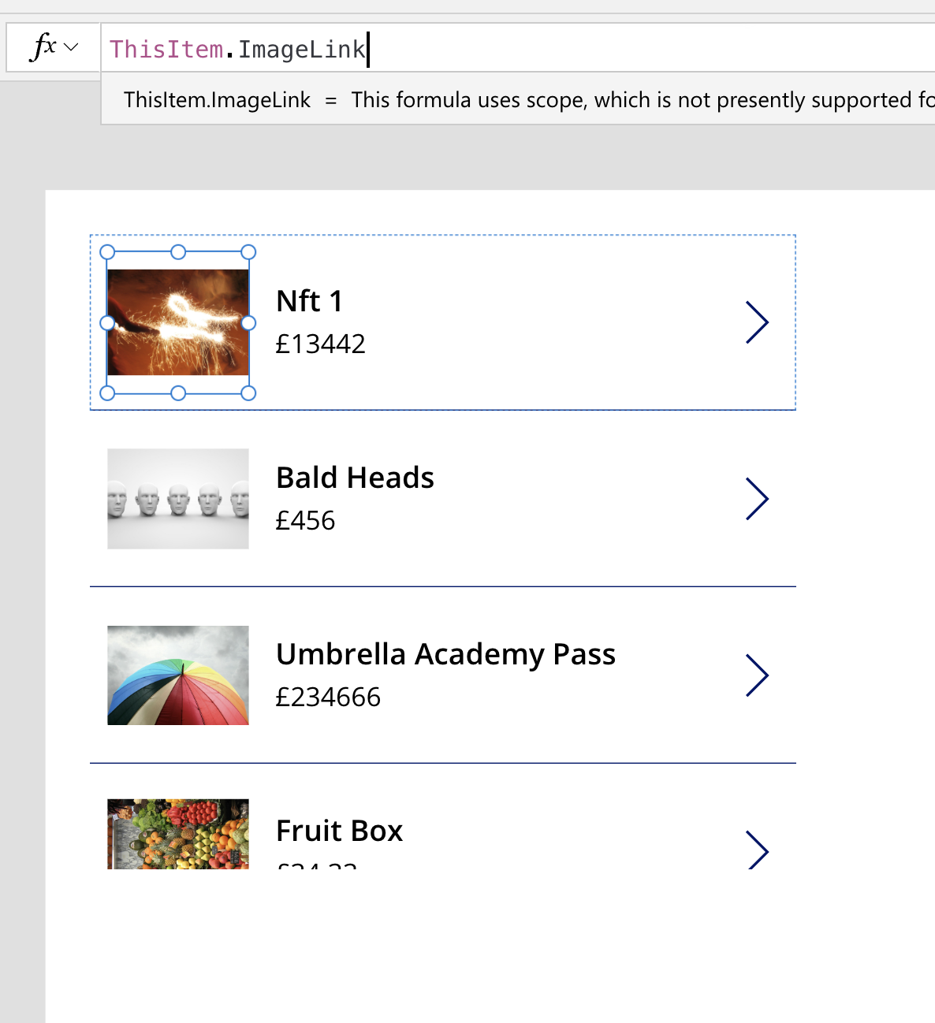

**Now lets add calculation to the ‘Total price’**

**Go back to the ‘Data verse’**

**Find and edit ‘Total price’ - Click on Edit**

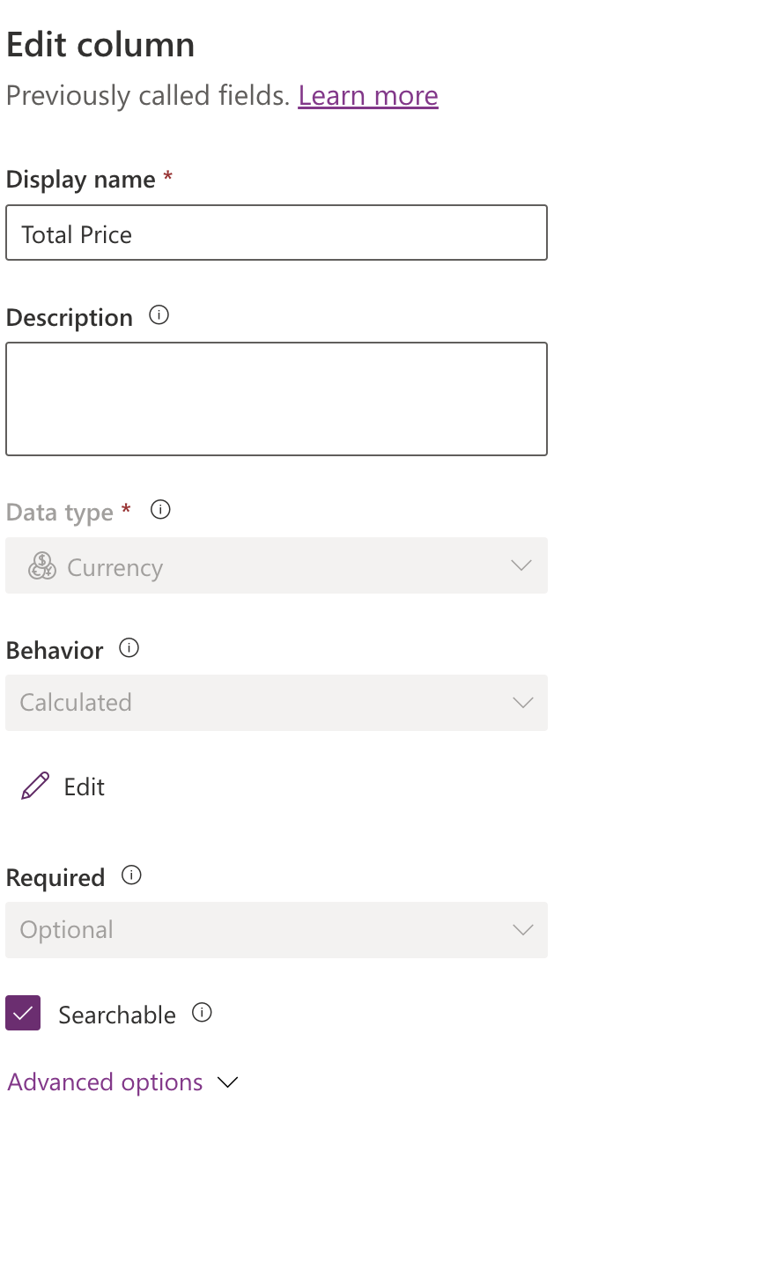

**A New pop-up will appear.**

**Click on Action: cr6a4_price.cr6a4_price * cr6a4_quantity**

**And click on the blue ‘Tick’**

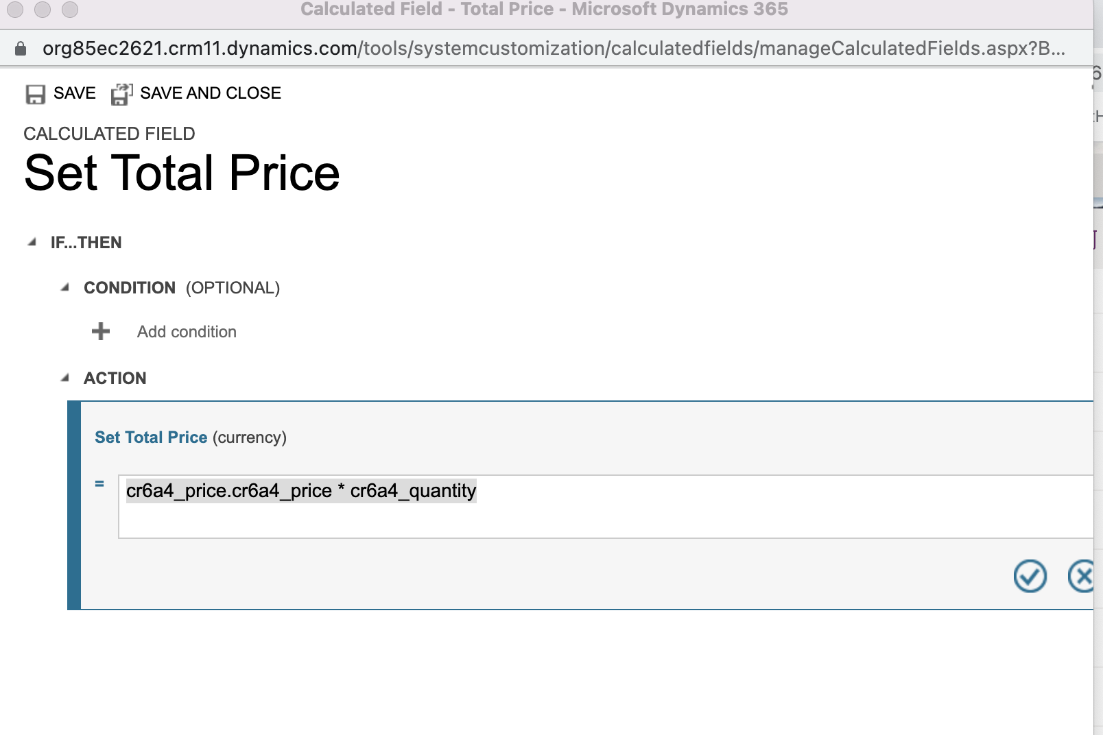

**Click on the first arrow ‘>’ (Just select the first one)**

**Then click on ‘Insert’ and ‘Button**

**Now Delete the arrow ’>’**

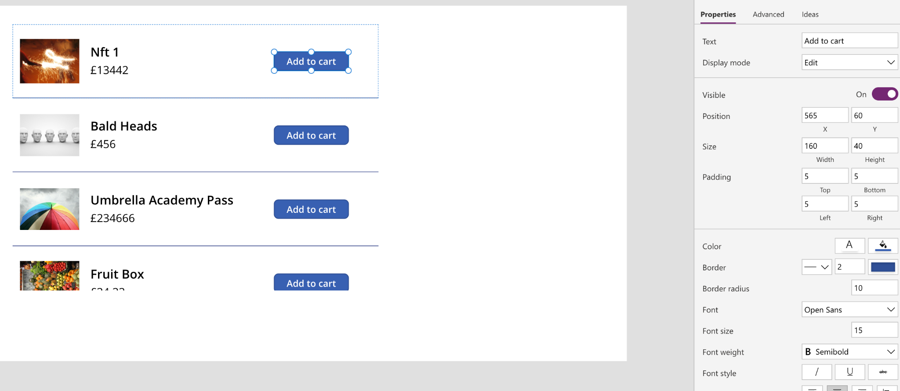

**Add a slider and set default to ‘0’**

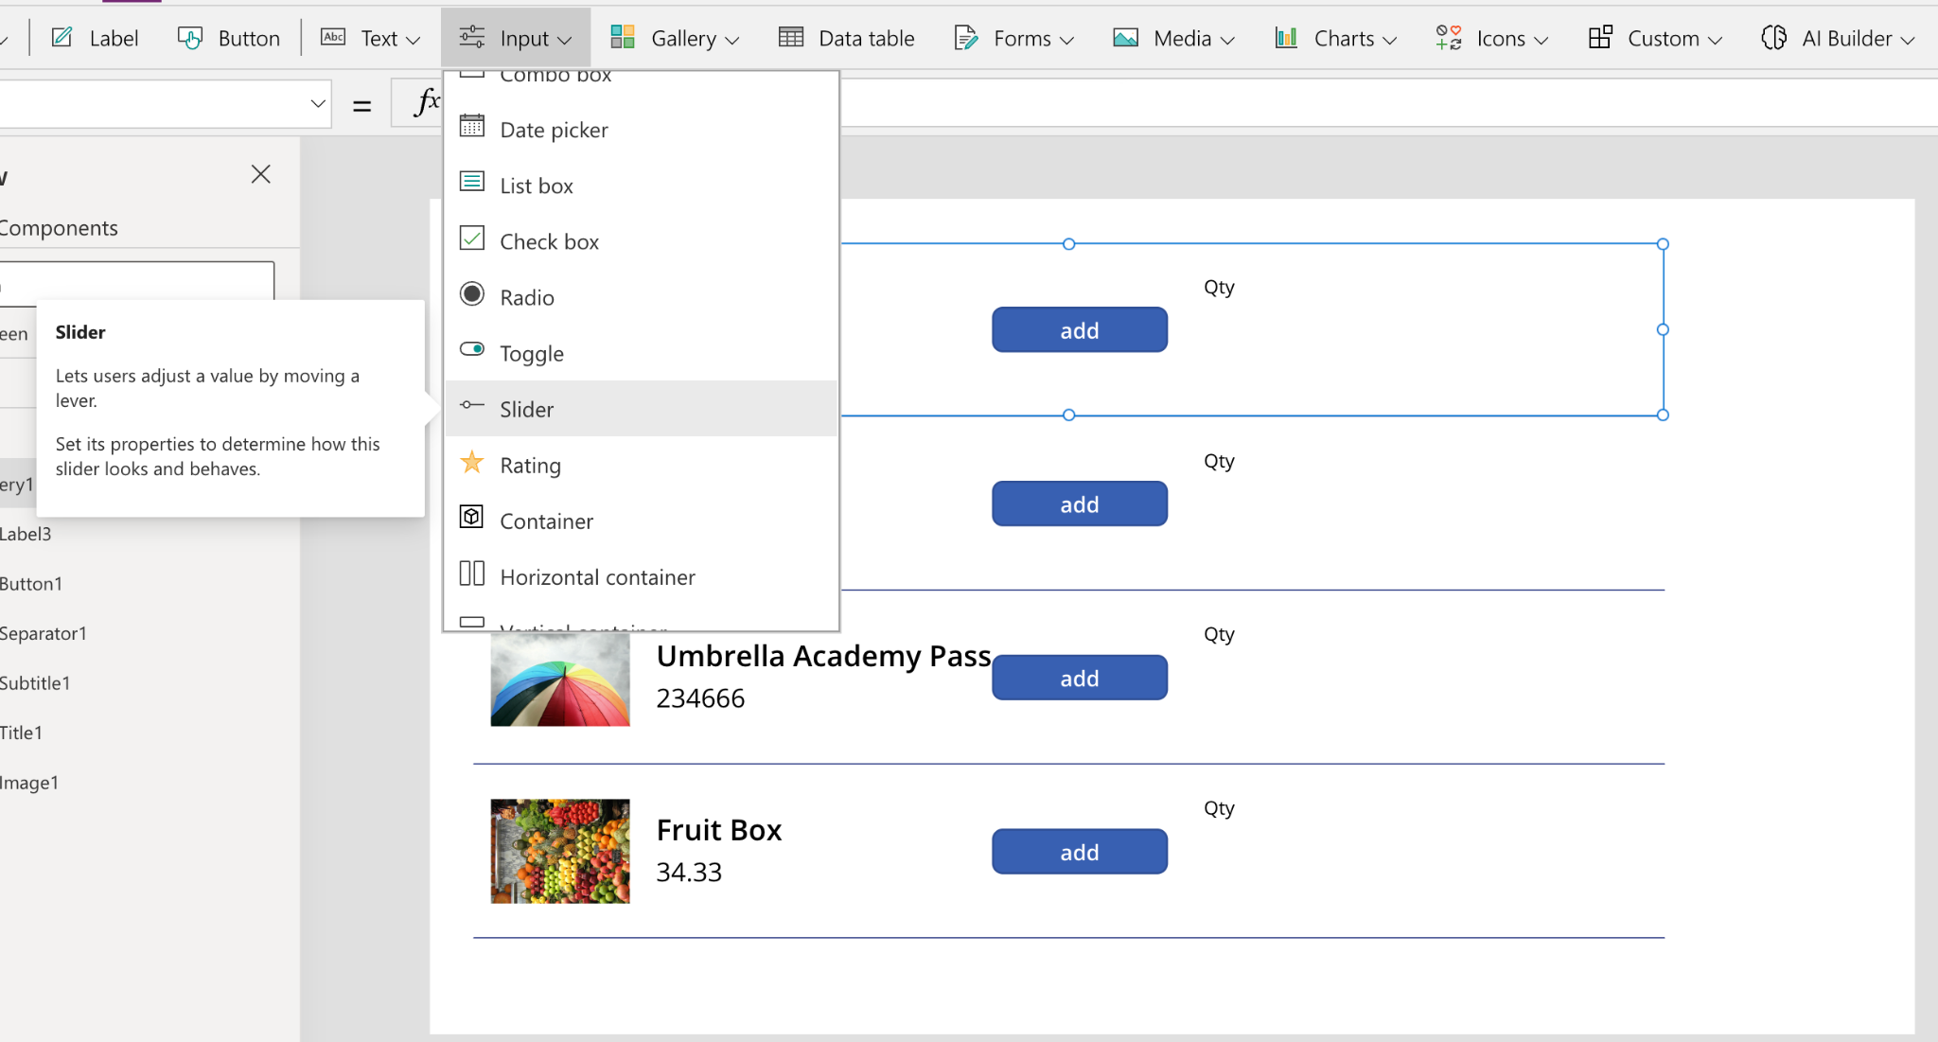

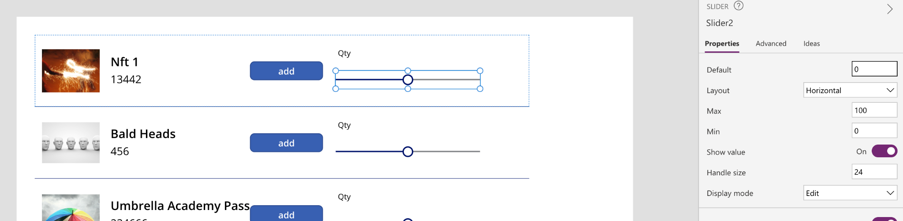

**Now Add a new Label and in the Formula add this: "Subtotal:" & ThisItem.Price * Slider2.Value**

**NOTE: Yours might be called Slider1 or Slider2, 3 etc. Check the naming.**

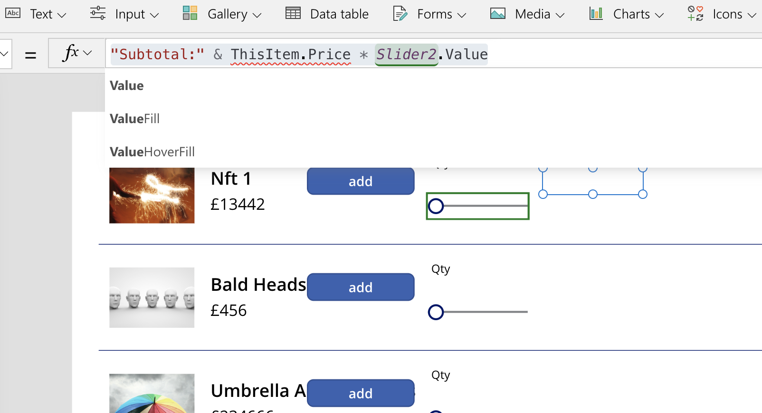

**To wrap it into a Text function update the formula: "Subtotal:" & Text(ThisItem.Price * Slider2.Value , "£#,##0.00")**

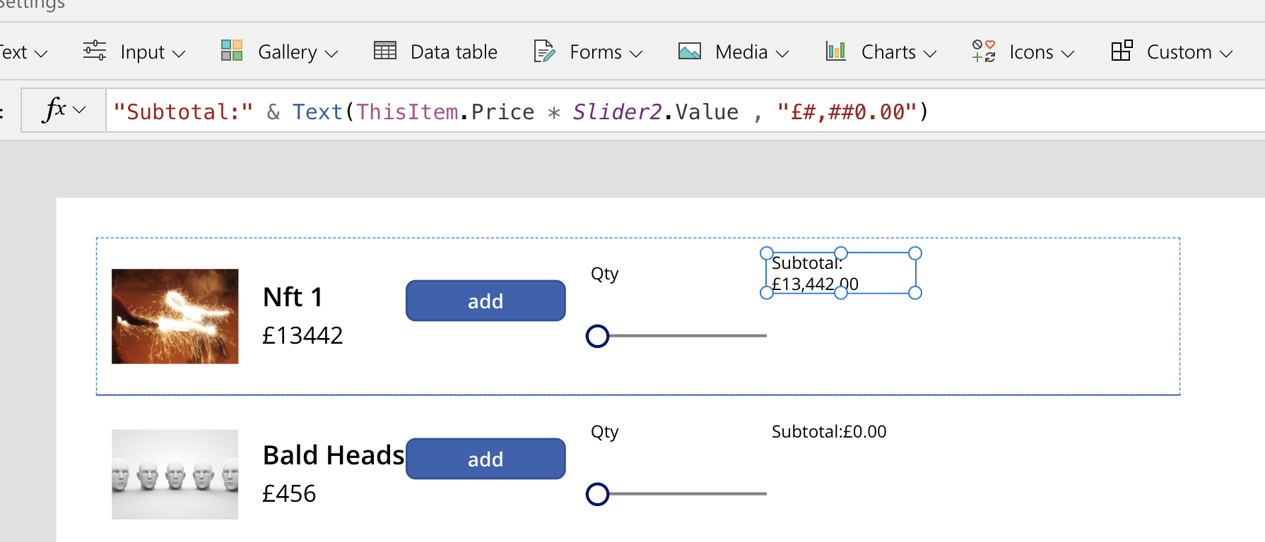

**Now add the ‘+’ button and Select ‘DisplayMode’ and update the formula: If(Slider2.Value >0, DisplayMode.Edit, DisplayMode.Disabled)**

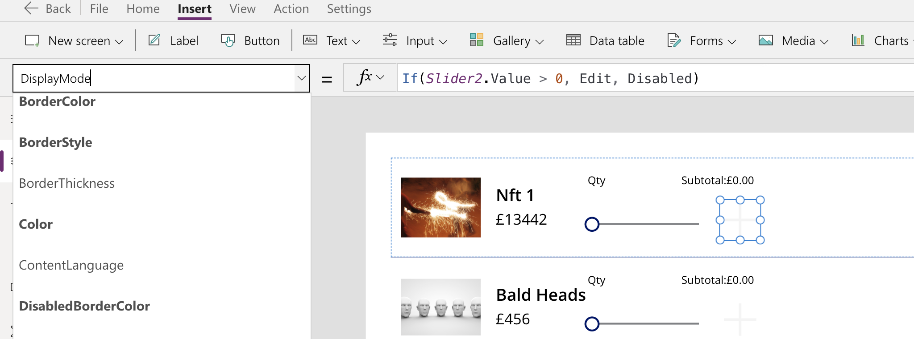

**Now do ‘OnSelect’ for the add button and enter this in the formula bar:**

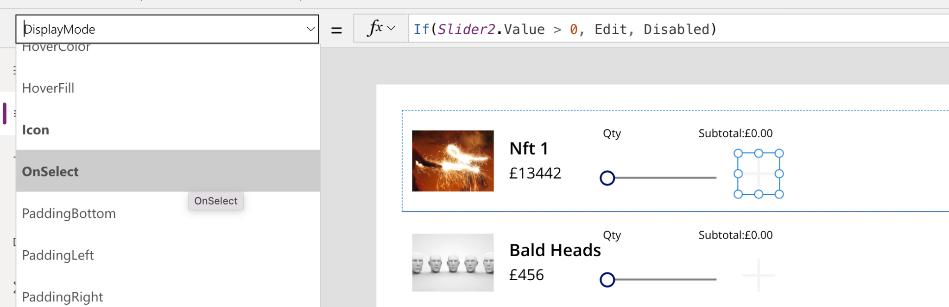

**Now add the formula:**

**Collect(colShoppingCart, {Title: ThisItem.Title, ProductPrice: ThisItem.Price, ProductID: ThisItem.ID, Qty:Slider2.Value, SubTotal:(Slider2.Value * ThisItem.Price)});Reset(Slider2);**

**Set(varShowSuccess, true)**

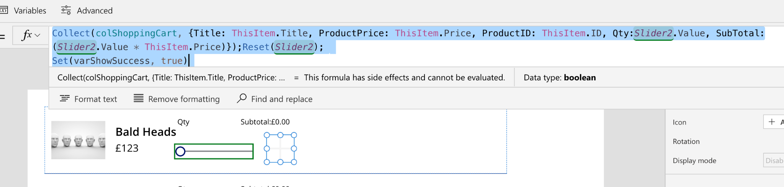

**Now ‘Run’ the app by pressing ‘F5’ and add few items and then click on the ‘View’ - ‘Collections’ menu to see what's added:**

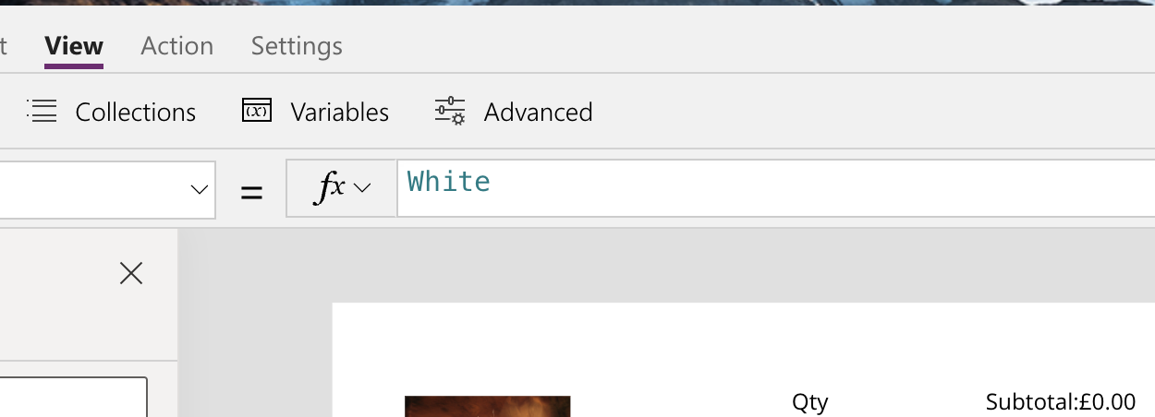

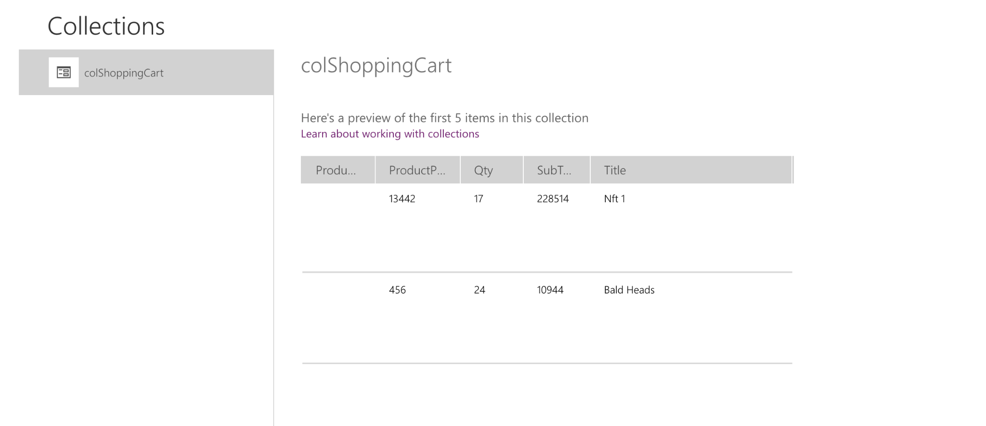

**Now click on Insert - Icons - Rectangle**

**Now select ‘Fill’ from the top left corner and in Formula enter RGBA(169, 169, 169, .75)**

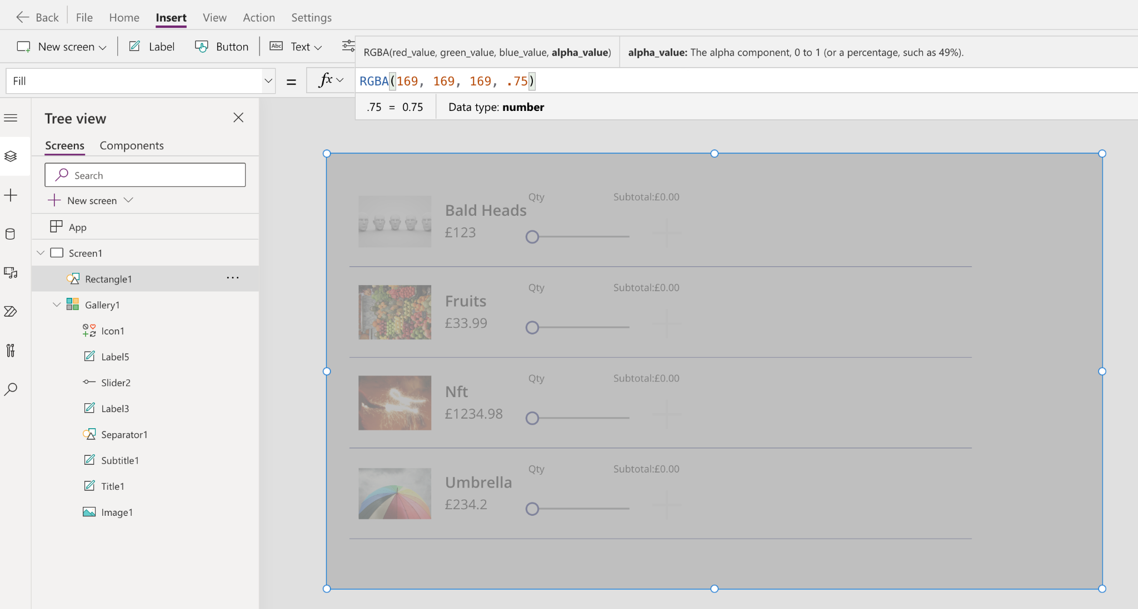

**Now add another ‘Rectangle’ but white colour**

**Add a Label to the new ‘Rectangle’ and two Buttons**

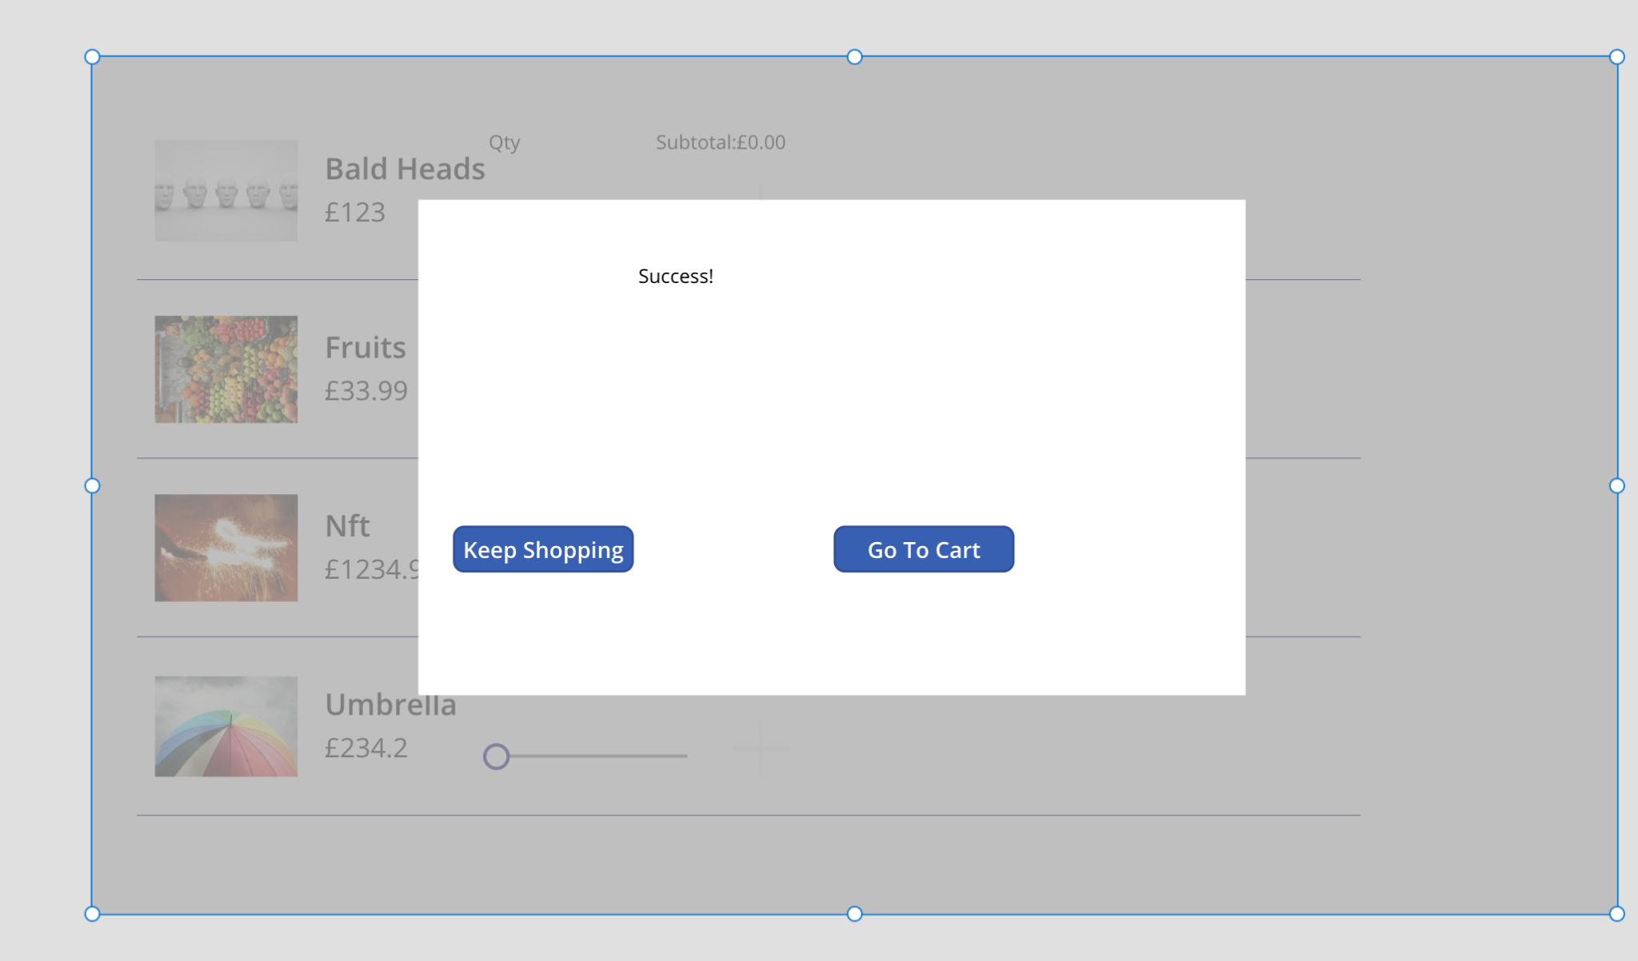

**Now group the 5 items(2 rectangles, label and 2 buttons) by selecting them on the left hand side:**

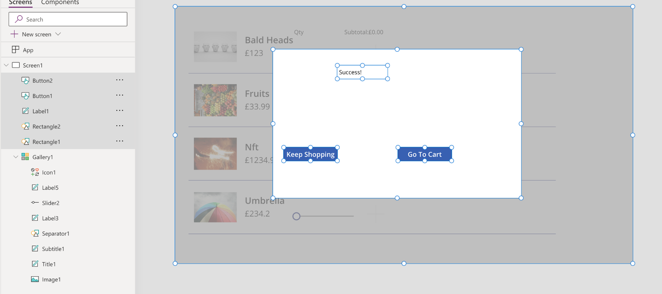

**Right clock and ‘Group’**

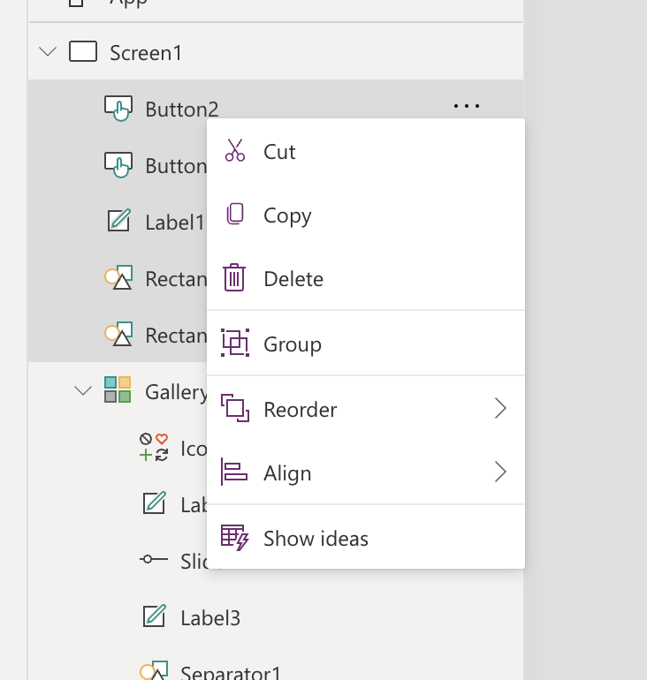

**Now rename the Group to ‘Success Message’**

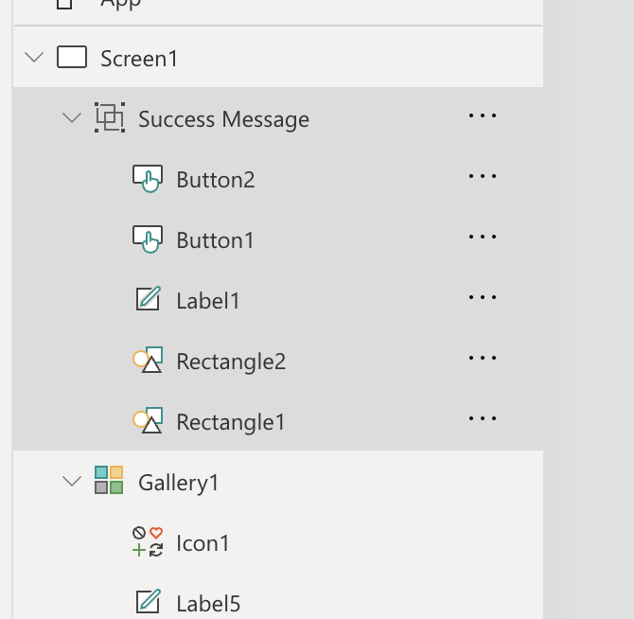

**Now select ‘Visible’ on the top left side and then in Formula bar enter: ‘varShowSuccess’**

**Now add another Gallery-Vertical**

**Select: ‘colShoppingCart’**

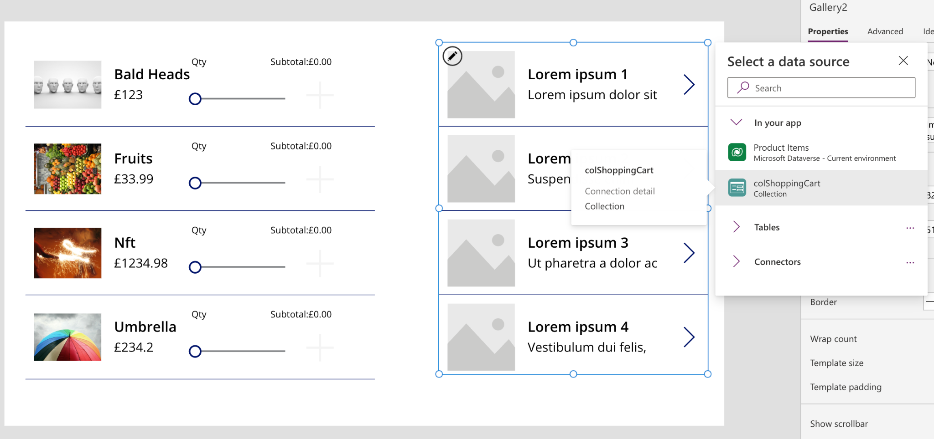

**Then click on the arrow and then select Icons-Trash**

**And delete the arrow**

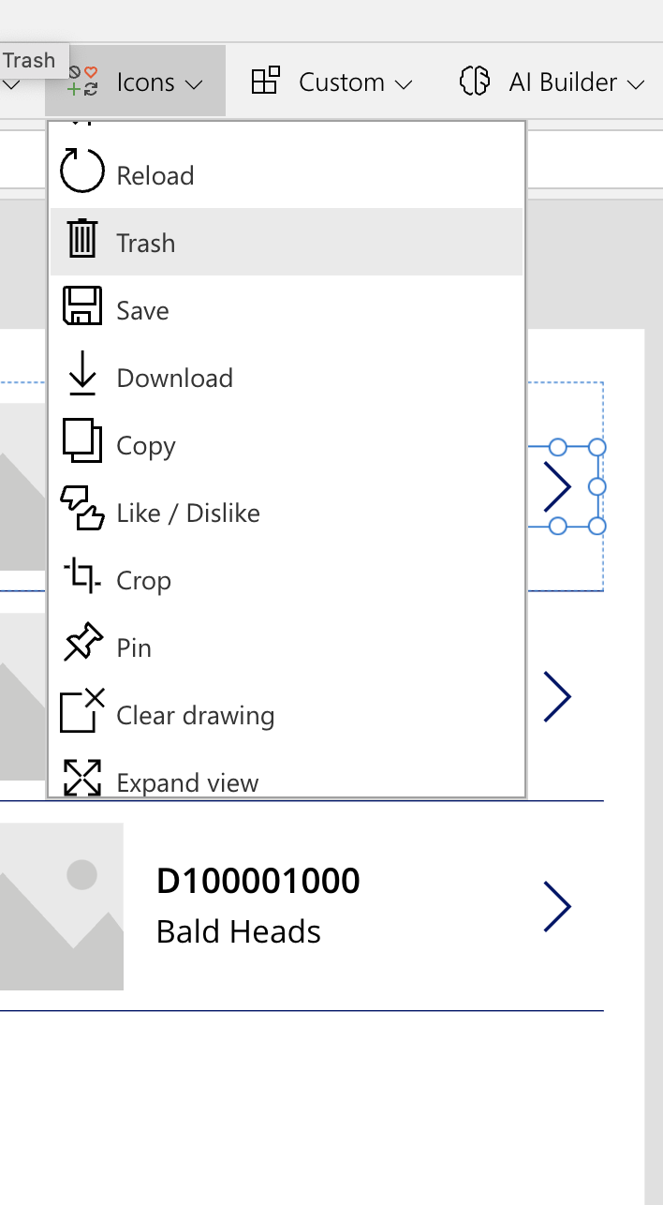

**Now select the ‘Trash’ icon and add : Remove(colShoppingCart, ThisItem)**

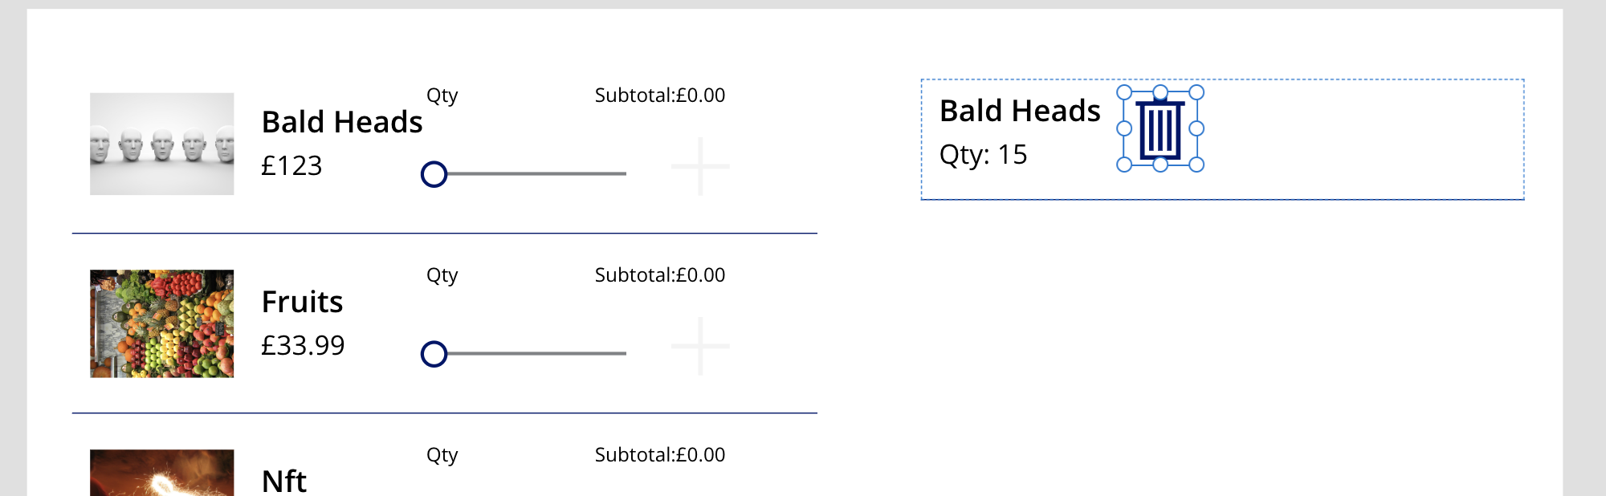

**For Subtitle and Tile: "Qty: " & ThisItem.Qty and ThisItem.Tile**

**Now add a Label below the right gallery and add the following:**

**With({ST: Sum(colShoppingCart, SubTotal)}, "Item Total: " & Text(ST, "$#,##0.00") & "**

**VAT: 20%**

**Shipping: £5.99**

**Total: " & Text(ST+ST*.20 + 5.99, "£#,##0.00"))**

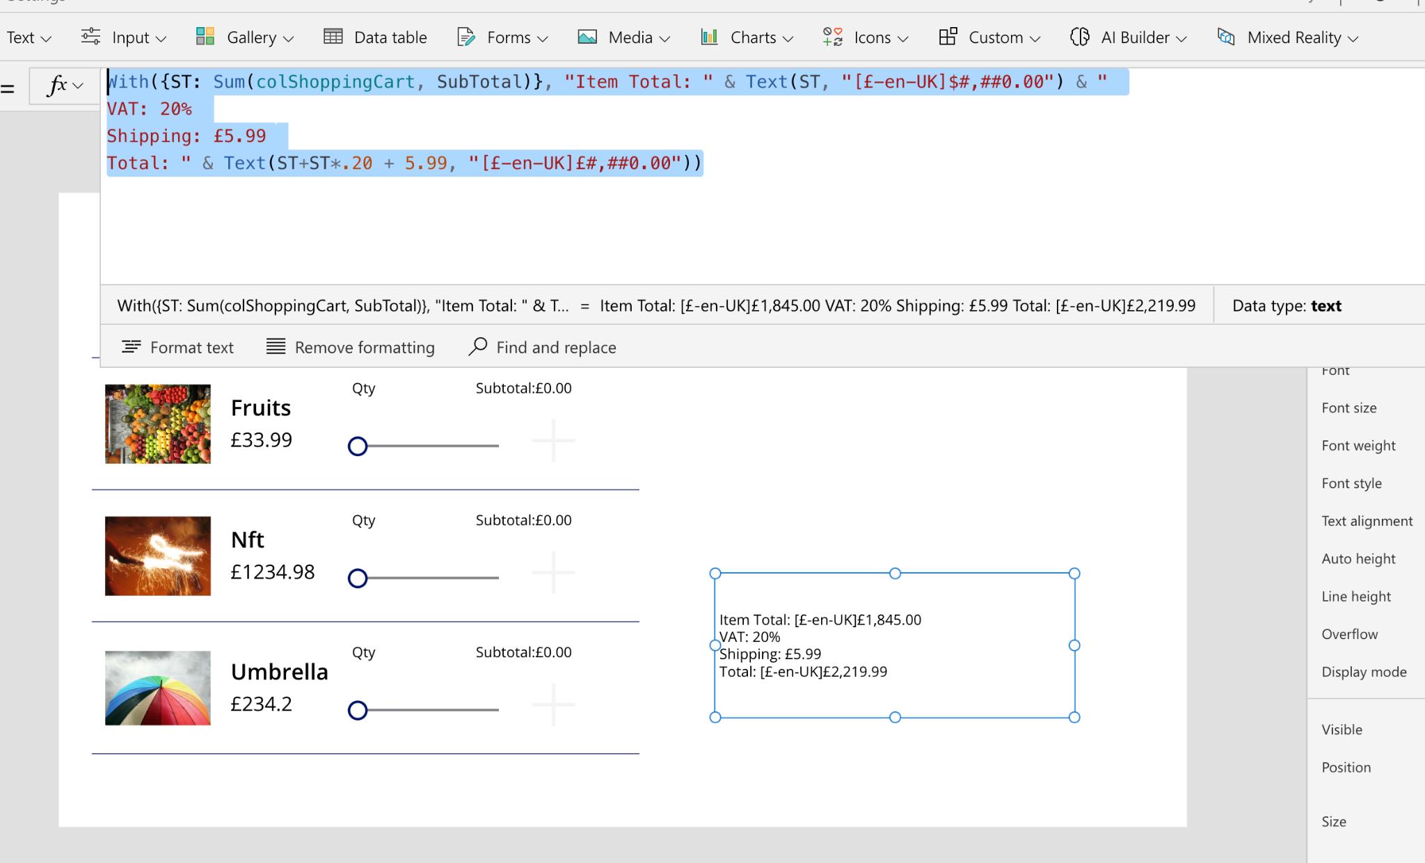

**Once its done hit the ‘Play’ button**

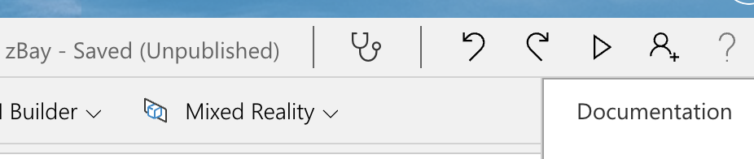

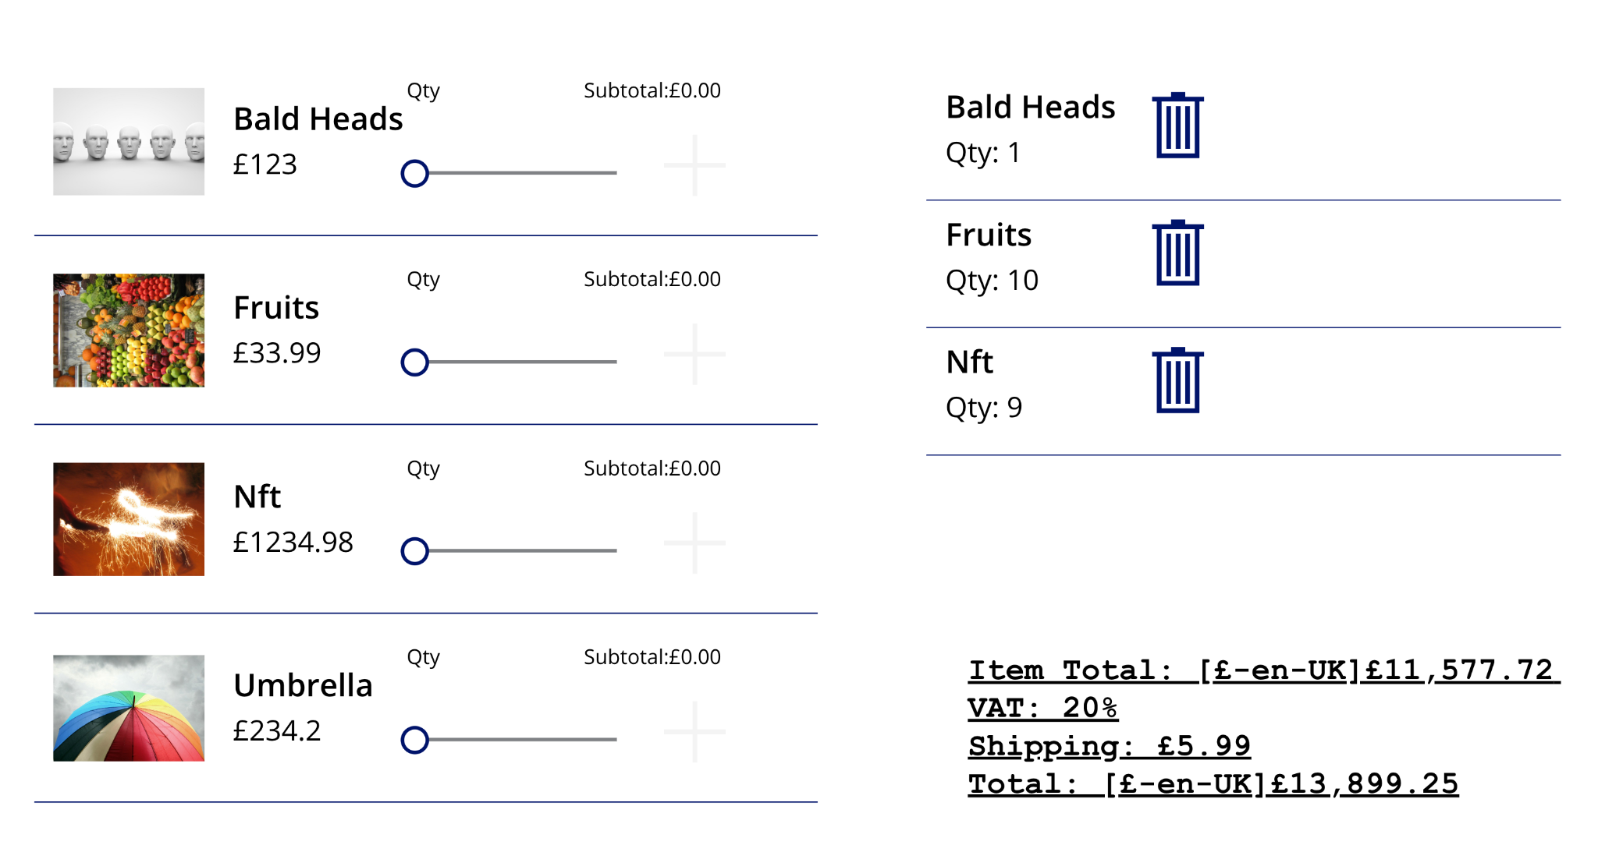

**You must have noticed that if there are no orders it still adds shipping to the total, so lets remove it by updating the formula:**

**With({ST: Sum(colShoppingCart, SubTotal)}, "Item Total: " & Text(ST, "£#,##0.00") & "**

**VAT: 20%**

**Shipping: £5.99**

**Total: " & Text(ST + ST * .20 + If(IsBlank(First(colShoppingCart)),"", 5.99), "£#,##0.00"))**

**Now add a Button called ‘Checkout’**

**And then add a ‘+ New Screen’ on the lefthand side:**

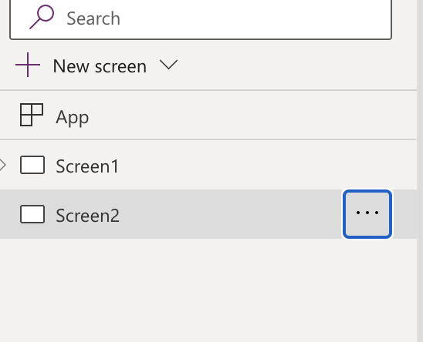

**Rename ‘Screen2’ to ‘Check Out’**

**Now go back to screen1 and the ‘Check Out’ button formula add this:**

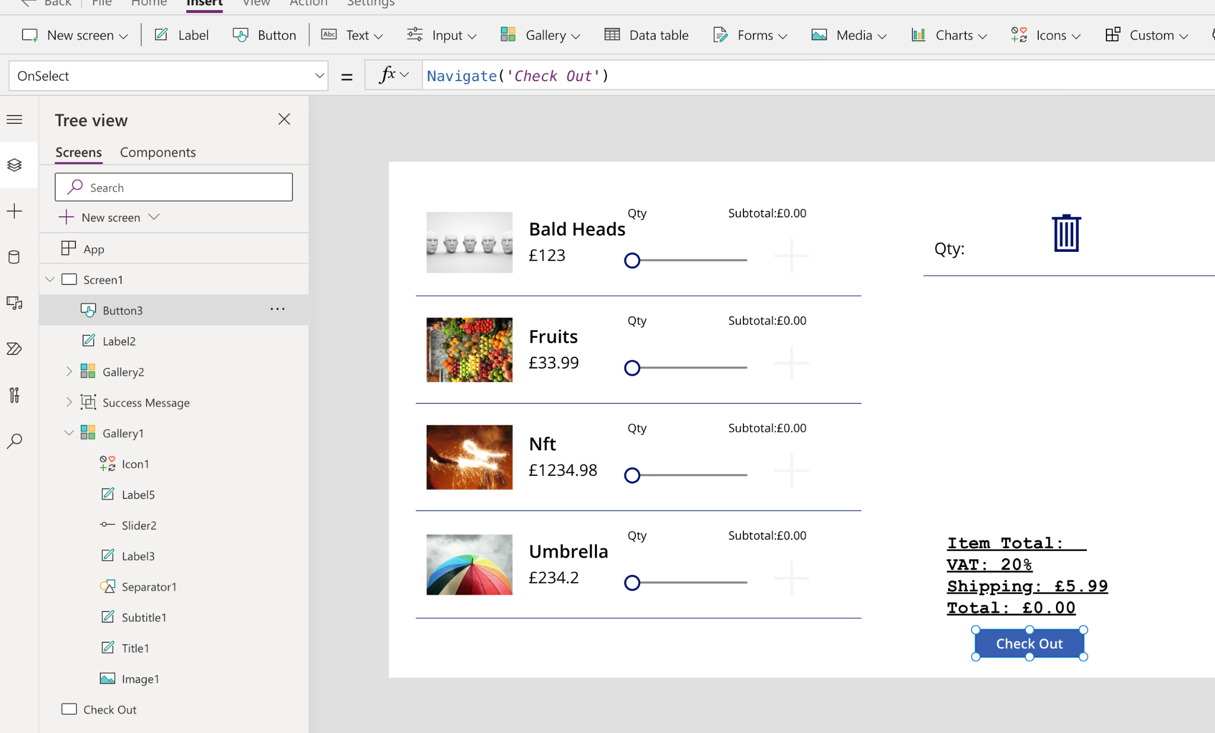

**Now select ‘DisplayMode’ on left corner and add this:**

**If(IsEmpty(colShoppingCart), DisplayMode.Disabled, DisplayMode.Edit)**

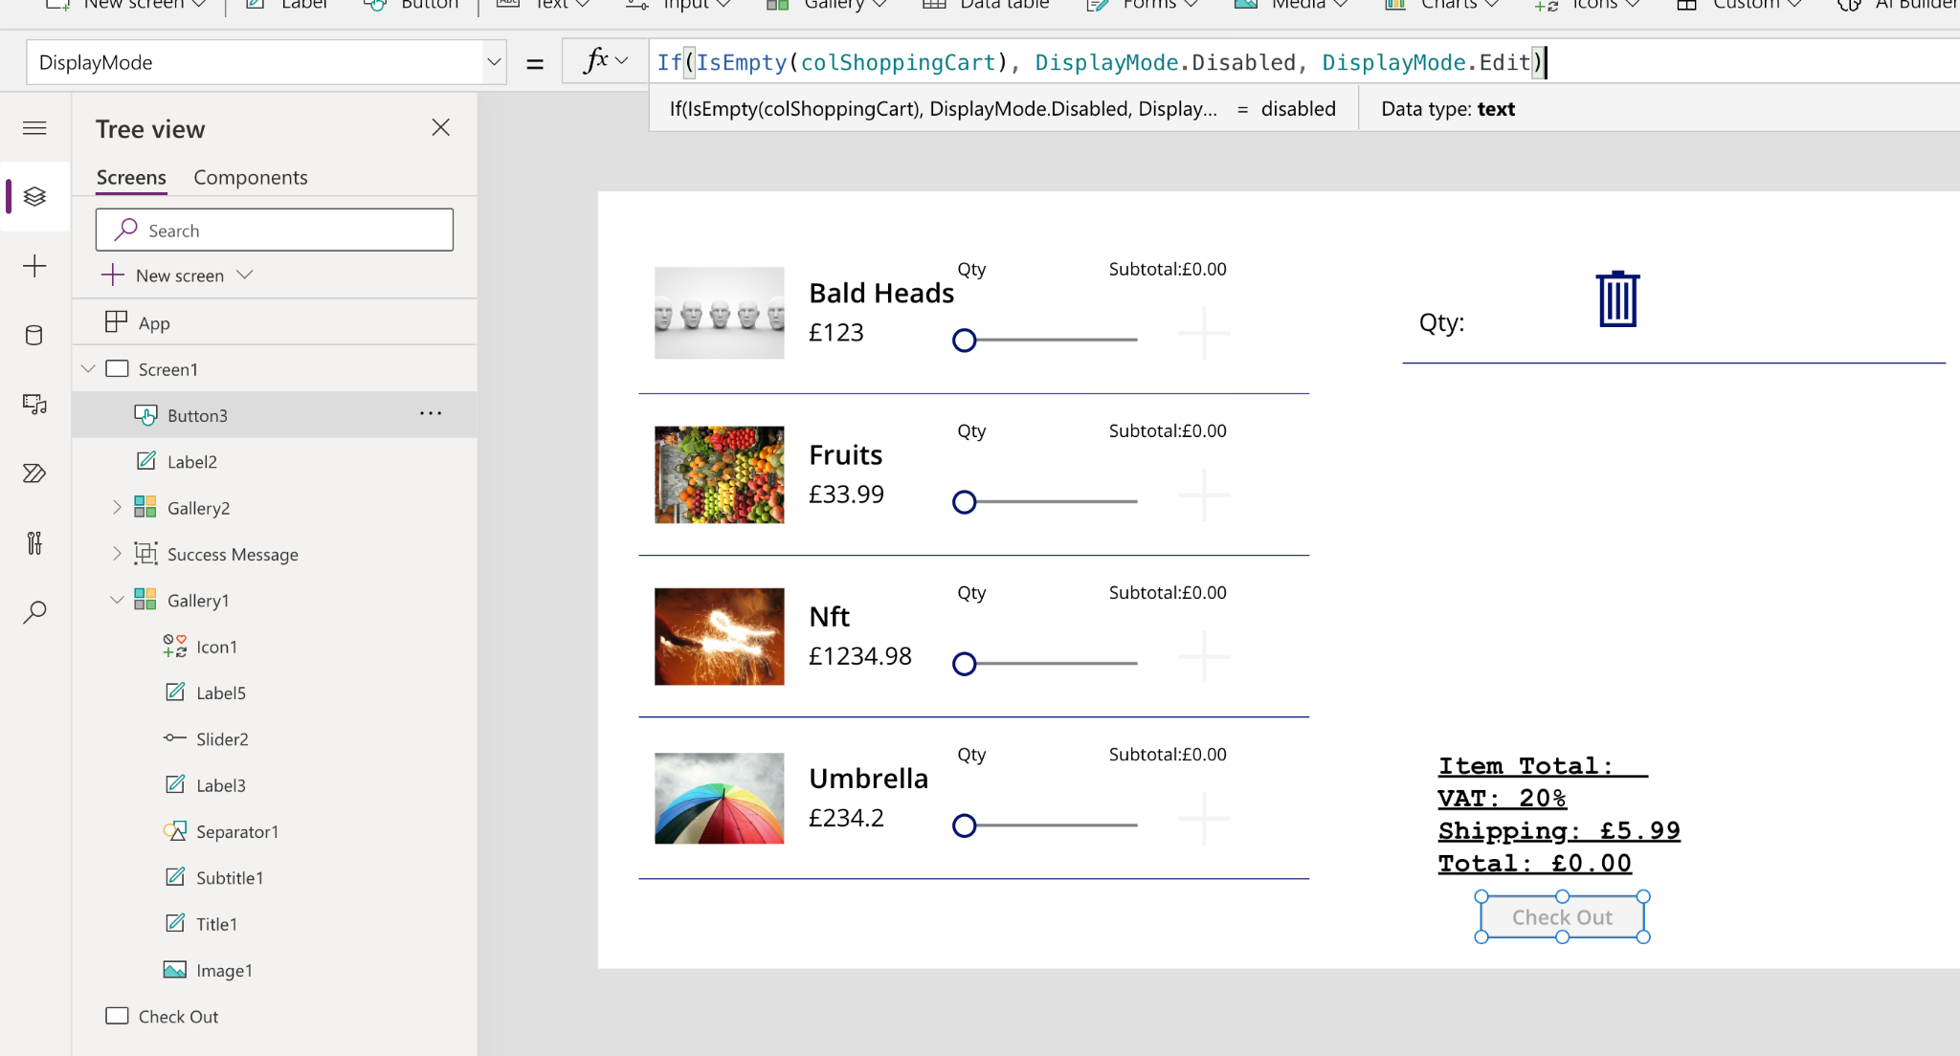

**On the ‘Check Out’ screen add a new Vertical Gallery and select ‘colShoppingCart’**

**Then click on the right arrow and swap it with ‘Trash’ icon**

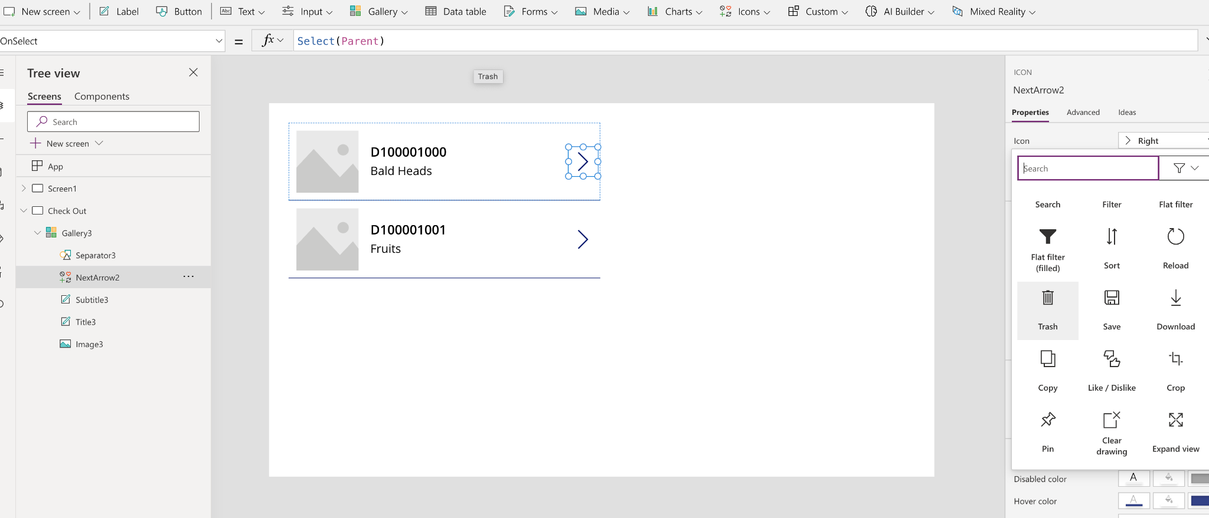

**Now insert ‘Text Input’**

**Title formula: ThisItem.Title &"- £" &ThisItem.ProductPrice**

**Subtitle formula: "£" & ThisItem.SubTotal**

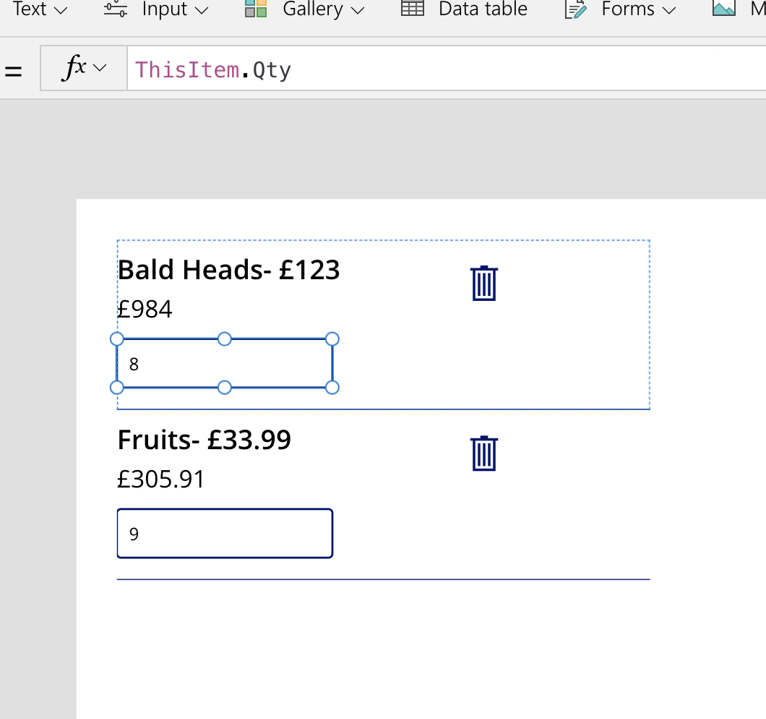

**Now change to ‘OnChange’ for the Qty text box:**

**Patch(colShoppingCart, ThisItem, {Qty: Value(Self.Text), SubTotal:Value(Self.Text) * ThisItem.ProductPrice})**

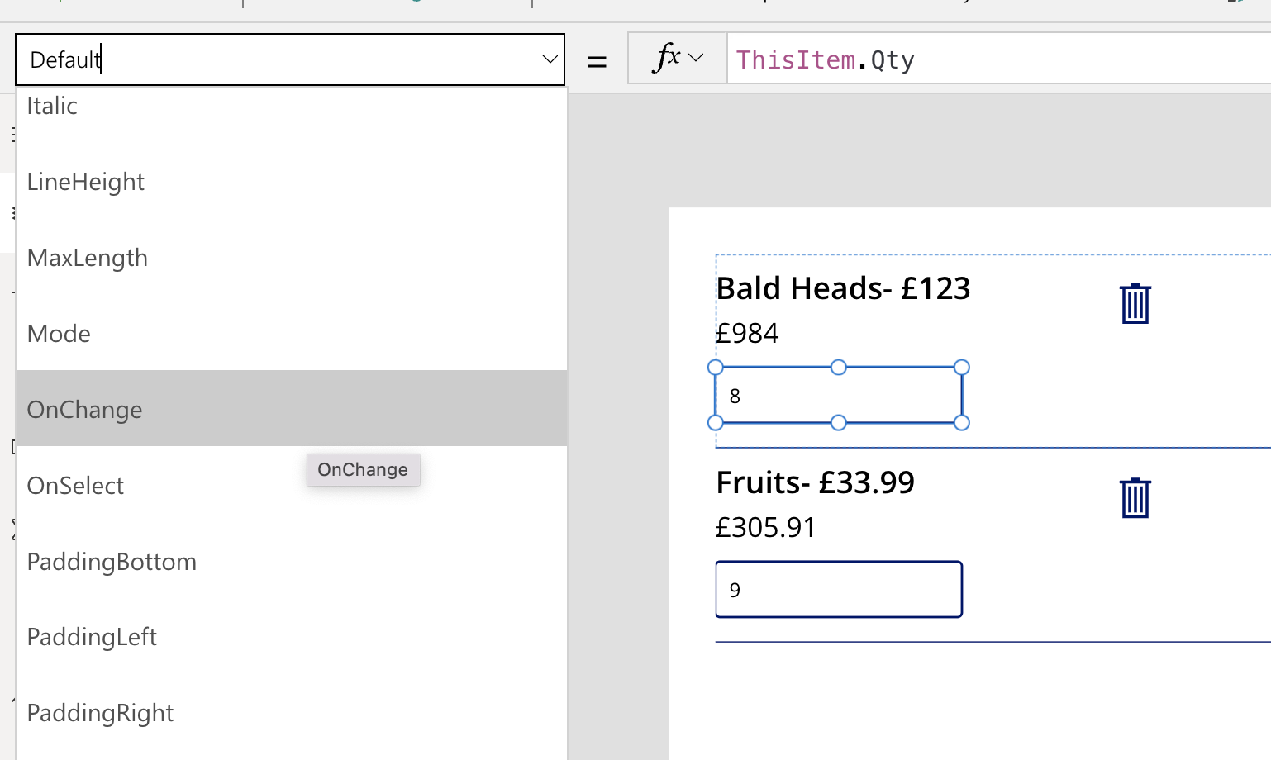

**Now Move the Label from First screen to second (you can cut and paste)**

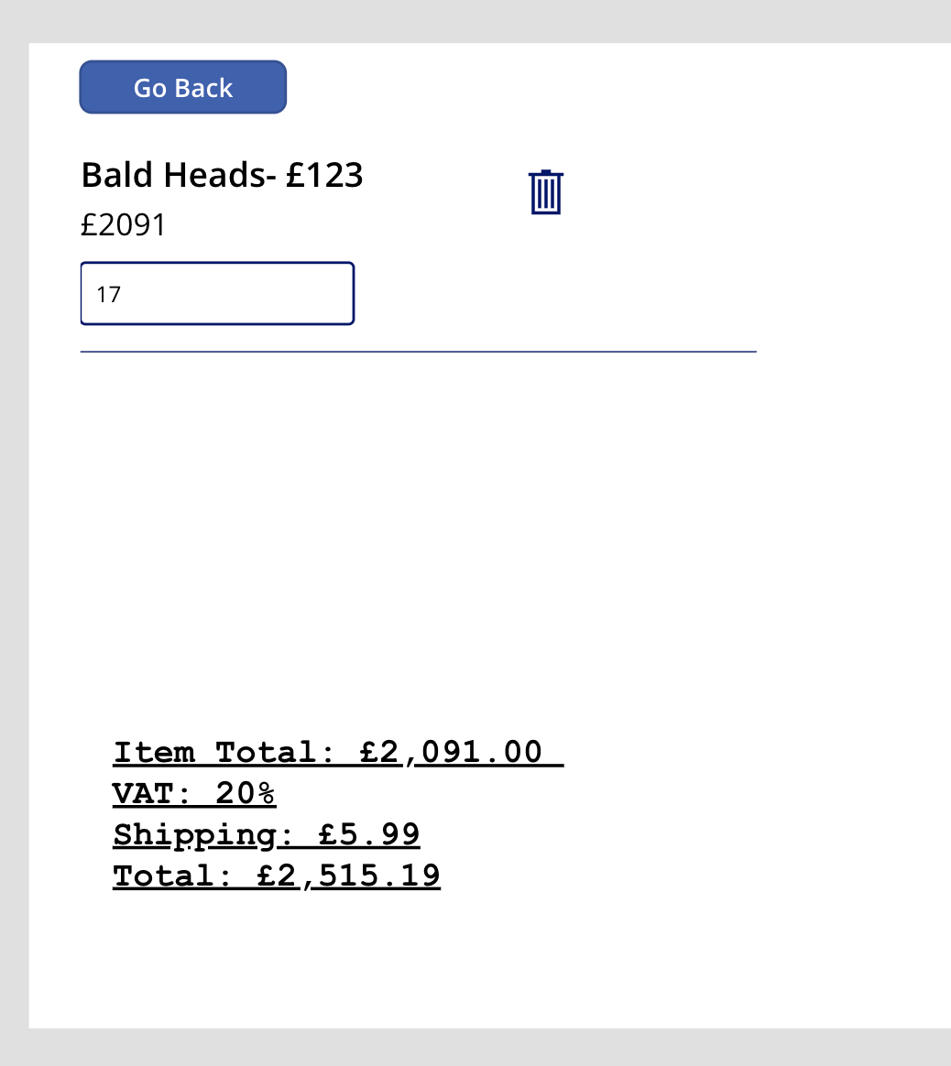

**Now Add a button called ‘Place Order’ and add this in formula(check your components IDs and make sure it correspondence to it:**

**Set(**

**varRecordID,**

**Patch(**

**'Shopping Cart Orders',**

**Defaults('Shopping Cart Orders'),**

**{**

**Name: TextInput4.Text,**

**'Order Total (cr6a4_ordertotal)': With(**

**{**

**ST: Sum(**

**colShoppingCart,**

**SubTotal**

**)**

**},**

**ST + ST * 0.20 + 5.99**

**),**

**'Order Comments': TextInput3.Text & ",<br>" & Concat(**

**colShoppingCart,**

**"Title:" & ThisRecord.Title & "- Product ID: " & ThisRecord.ProductID & "- Prodcut Price: " & ThisRecord.ProductPrice & "- Quantity:" & ThisRecord.Qty & "- SubTotal:" & ThisRecord.SubTotal & ";" & ",<br>"**

**)**

**}**

**).OrderID**

**);**

**Clear(colShoppingCart);**

**Reset(TextInput3);**

**Reset(TextInput4);**

**Navigate(Screen1);**

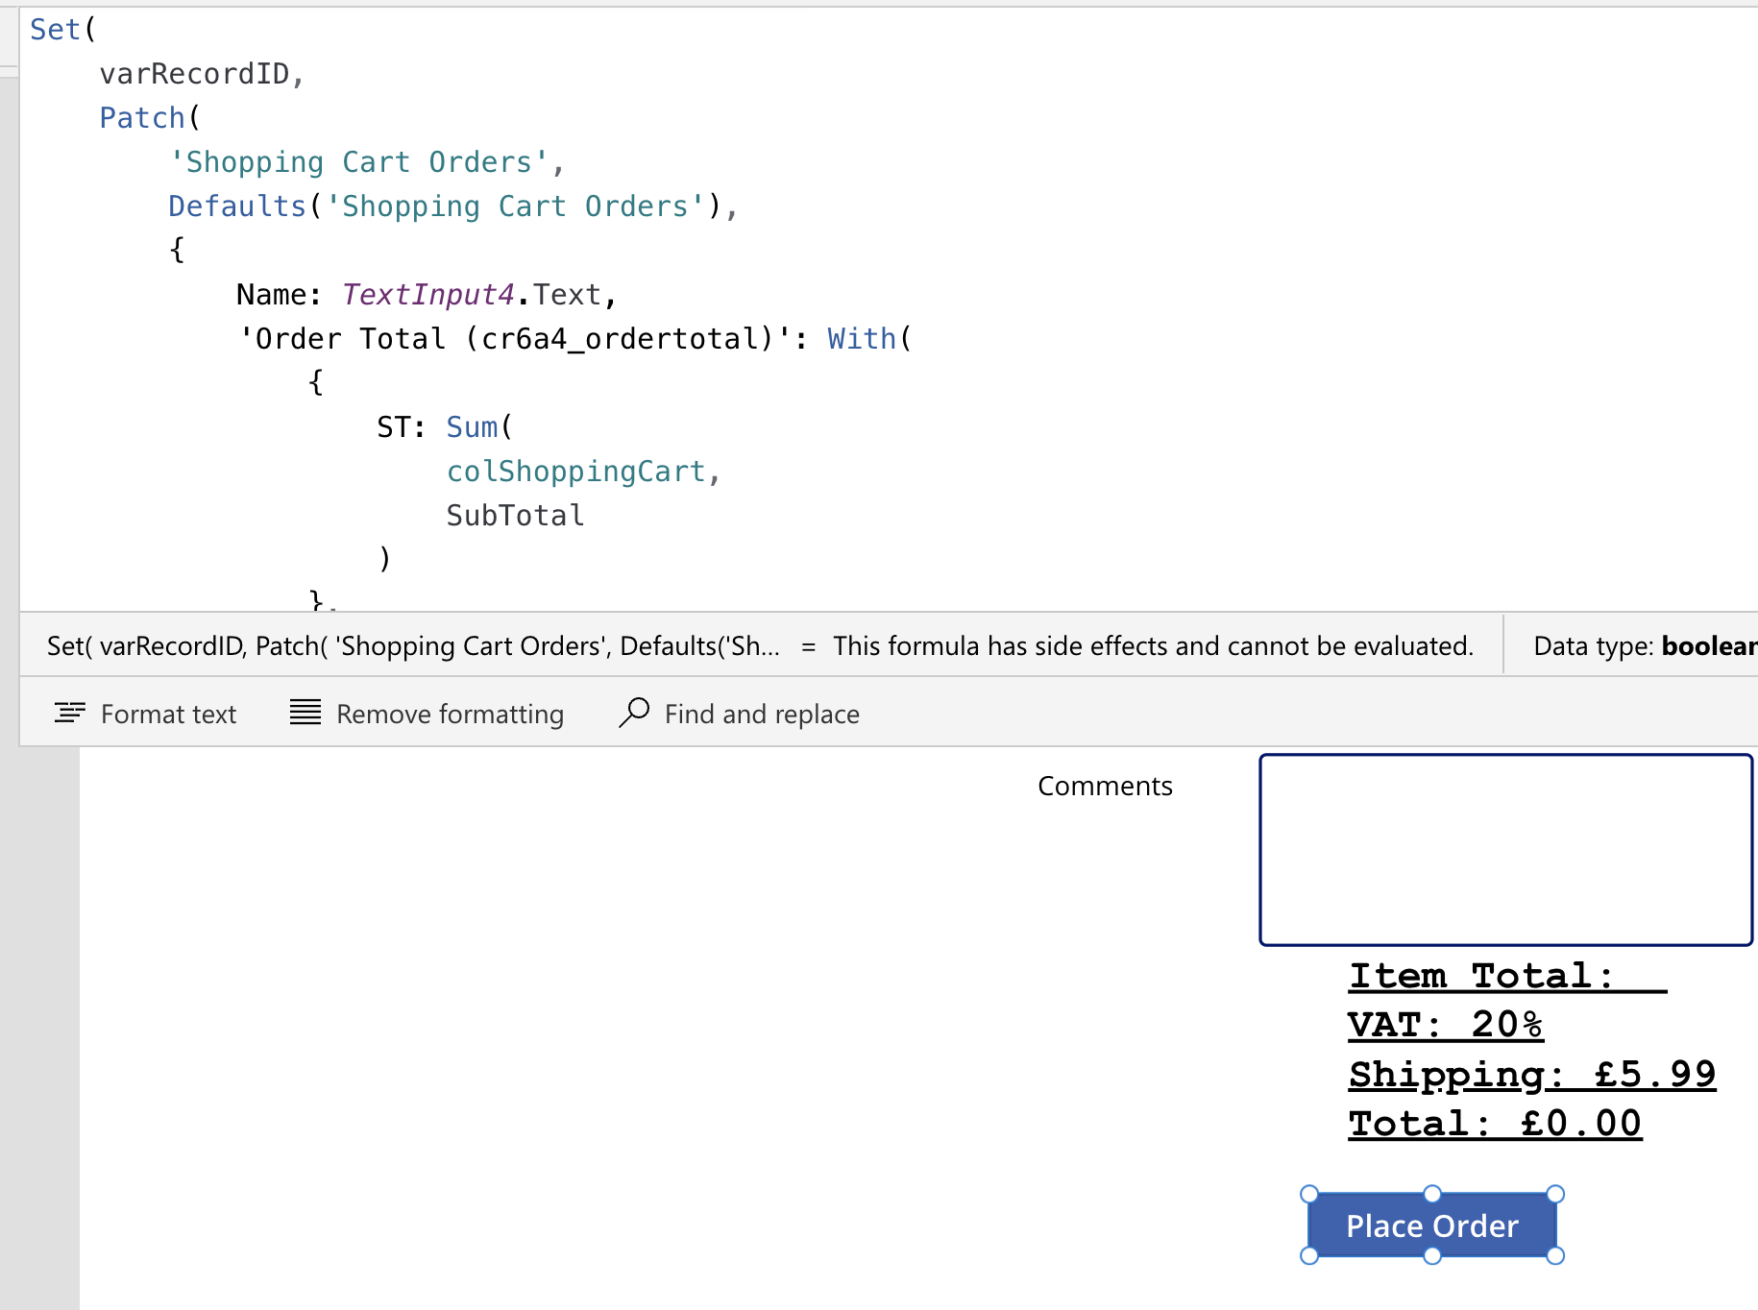

**So now when you run the app it should look like this:**

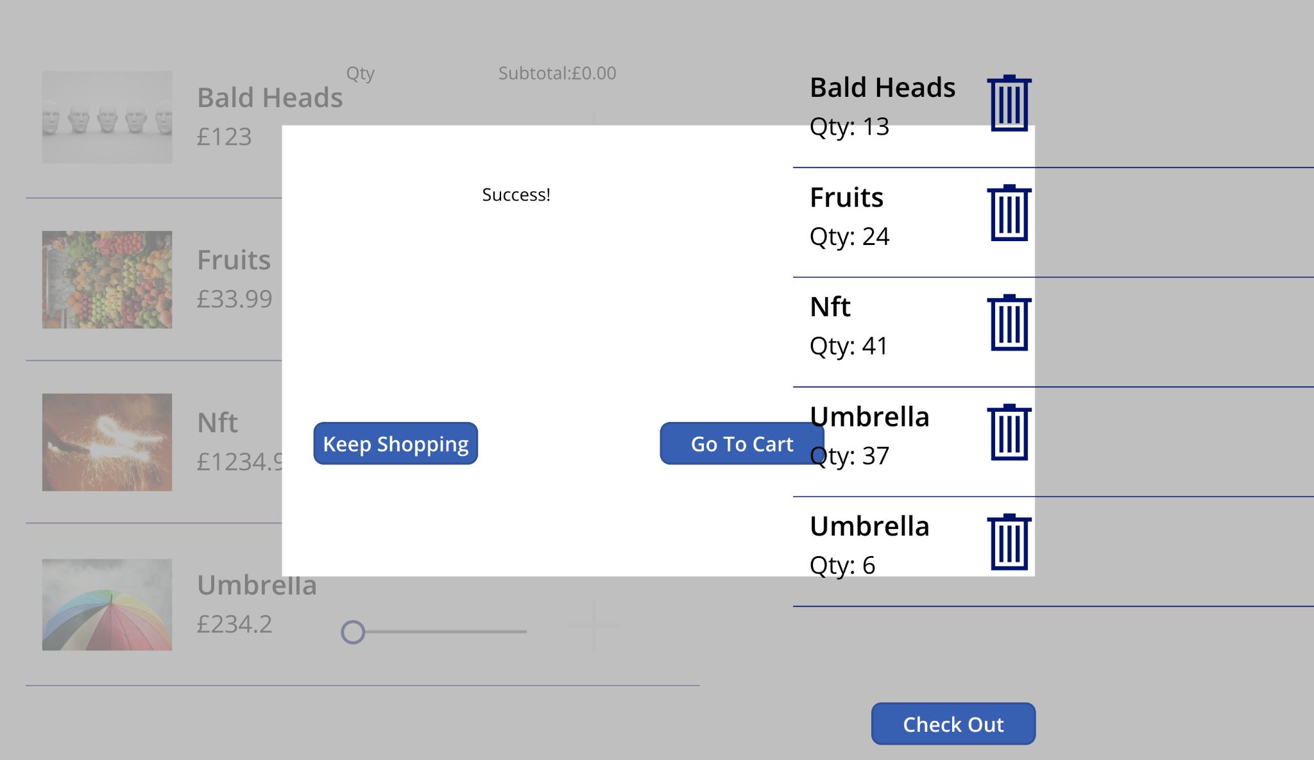

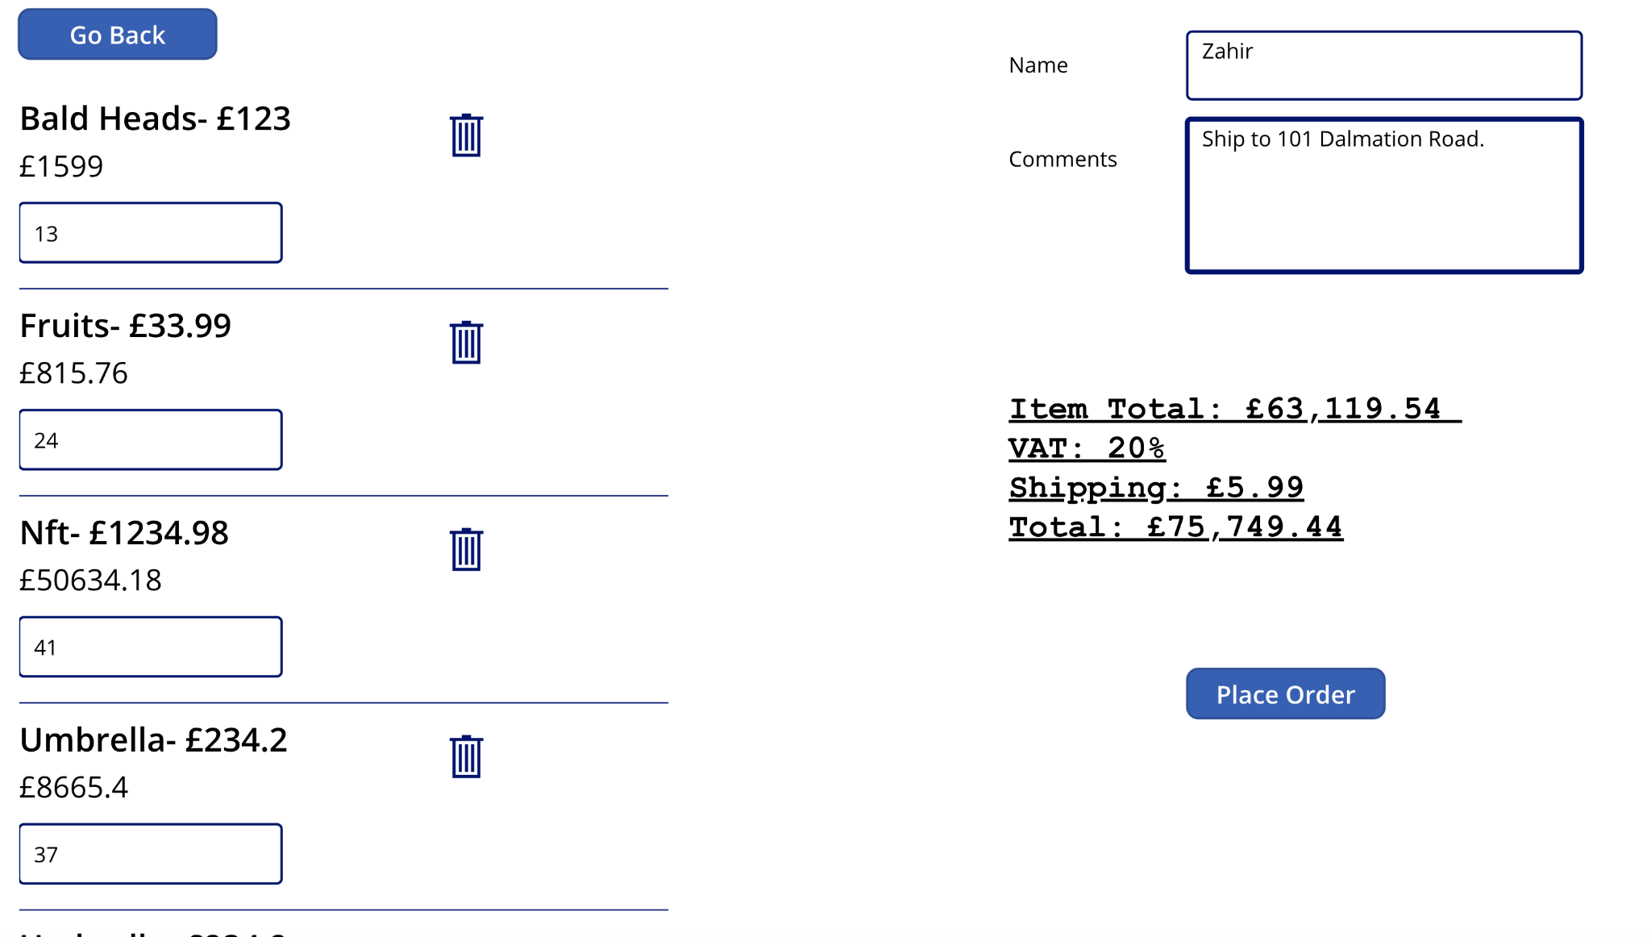

**Now if you check your dataverse table: ‘Shopping Cart Orders’ the order is there with an OrderID and also in the comments it adds all the shipping address and items purchased:**

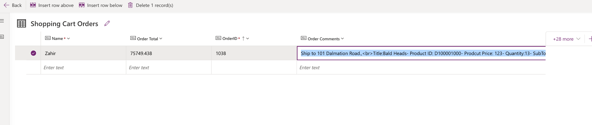

**Ship to 101 Dalmation Road.,**

**<br>Title:Bald Heads- Product ID: D100001000- Product Price: 123- Quantity:13- SubTotal:1599;,**

**<br>Title:Fruits- Product ID: D100001001- Product Price: 33.99- Quantity:24- SubTotal:815.76;,**

**<br>Title:Nft- Product ID: D100001002- Product Price: 1234.98- Quantity:41- SubTotal:50634.18;,**

**<br>Title:Umbrella- Product ID: D100001004- Product Price: 234.2- Quantity:37- SubTotal:8665.4;,**

**<br>Title:Umbrella- Product ID: D100001004- Product Price: 234.2- Quantity:6- SubTotal:1405.2;,<br>**